The William Ransom Primary School
Hitchin
Herts.
Accessibility Plan

Mission Statement

The William Ransom School aims to provide all its pupils with the highest possible educational opportunities. We believe that the best education is the entitlement of every child and this is realised at this School within a structured, disciplined, caring and safe environment where expectations are high.

This Accessibility Plan is drawn up in compliance with current legislation and requirements as specified in Schedule 10, relating to Disability, of the Equality Act 2010. School Governors are accountable for ensuring the implementation, review and reporting of progress of the Accessibility Plan over a prescribed period.

The Equality Act 2010 replaced all existing equality legislation, including the Disability Discrimination Act. The effect of the law is the same as in the past, meaning that “schools cannot unlawfully discriminate against pupils because of sex, race, disability, religion or belief and sexual orientation”.

According to the Equality Act 2010 a person has a disability if:

- He or she has a physical or mental impairment, and

- The impairment has a substantial and long-term adverse effect on his or her ability to carry out normal day-to-day activities.

The Accessibility Plan is structured to complement and support the school’s Equality Objectives. We understand that the Local Authority will monitor the school’s activity under the Equality Act 2010 (and in particular Schedule 10 regarding Accessibility) and will advise upon the compliance with that duty.

Objectives

William Ransom Primary School is committed to providing an environment that enables full curriculum access that values and includes all pupils, staff, parents and visitors regardless of their education, physical, sensory, social, spiritual, emotional and
cultural needs. We are committed to taking positive action in the spirit of the Equality Act 2010 with regard to disability and to developing a culture of inclusion, support and awareness within the school.

The school recognises and values parent’s knowledge of their child’s disability and its effect on their ability to carry out everyday activities and respects the parent’s and child’s right to confidentiality.

The William Ransom Primary School Accessibility Plan shows how access is to be improved for disabled pupils, staff and visitors to the school within a given timeframe and anticipating the need to make reasonable adjustments to accommodate their needs where practicable.

The Accessibility Plan contains relevant and timely actions to:-

- Increase access to the curriculum for pupils with a physical disability and/or sensory impairments, expanding the curriculum as necessary to ensure that pupils with a disability are as equally prepared for life as the able-bodied pupils; (If a school fails to do this they are in breach of their duties under the Equalities Act 2010); this covers teaching and learning and the wider curriculum of the school such as participation in after-school clubs, leisure and cultural activities or schools visits – it also covers the provision of specialist or auxiliary aids and equipment, which may assist these pupils in accessing the curriculum within a reasonable timeframe;

- Improve and maintain access to the physical environment of the school, adding specialist facilities as necessary – this covers improvements to the physical environment of the school and physical aids to access education within a reasonable timeframe;

- Improve the delivery of written information to pupils, staff, parents and visitors with disabilities; examples might include hand-outs, timetables, textbooks and information about the school and school events; the information should be made available in various preferred formats within a reasonable timeframe.

The William Ransom Primary School Accessibility Plan relates to the key aspects of physical environment, curriculum and written information.

Whole school training will recognise the need to continue raising awareness for staff and governors on equality issues with reference to the Equality Act 2010.

This Accessibility Plan should be read in conjunction with the following school policies, strategies and documents:

- Behaviour & Discipline Policy
- Curriculum Policies
- Health & Safety Policy
- School Development Plan
- Special Educational Needs Policy
- Teaching and Learning Policy

The Accessibility Plan for physical accessibility relates to the Accessibility Audit of the School, which remains the responsibility of the governing body. An accessibility audit will be completed by the school prior to the end of each period covering this plan in order to inform the development of a new Accessibility Plan for the ongoing period.

The Accessibility Plan will be published on the school website.

The Accessibility Plan will be monitored through the Governor Premises Committee.

The Accessibility Plan may be monitored by Ofsted during inspection processes in relation to Schedule 10 of the Equality Act 2010.

Following the school expansion in September 2016 the school is accessible for both children and adults and is DDA compliant.

It is a requirement that the school’s accessibility plan is resourced, implemented, reviewed and revised as necessary and reported on annually. Attached is a set of action plans showing how the school will address the priorities identified in the plan.

The priorities for the Accessibility Plan for our school were identified by:

The Governing Body
- Head Teacher
- SENCo
- Site Manager

A plan of the school buildings showing areas of accessibility is shown below

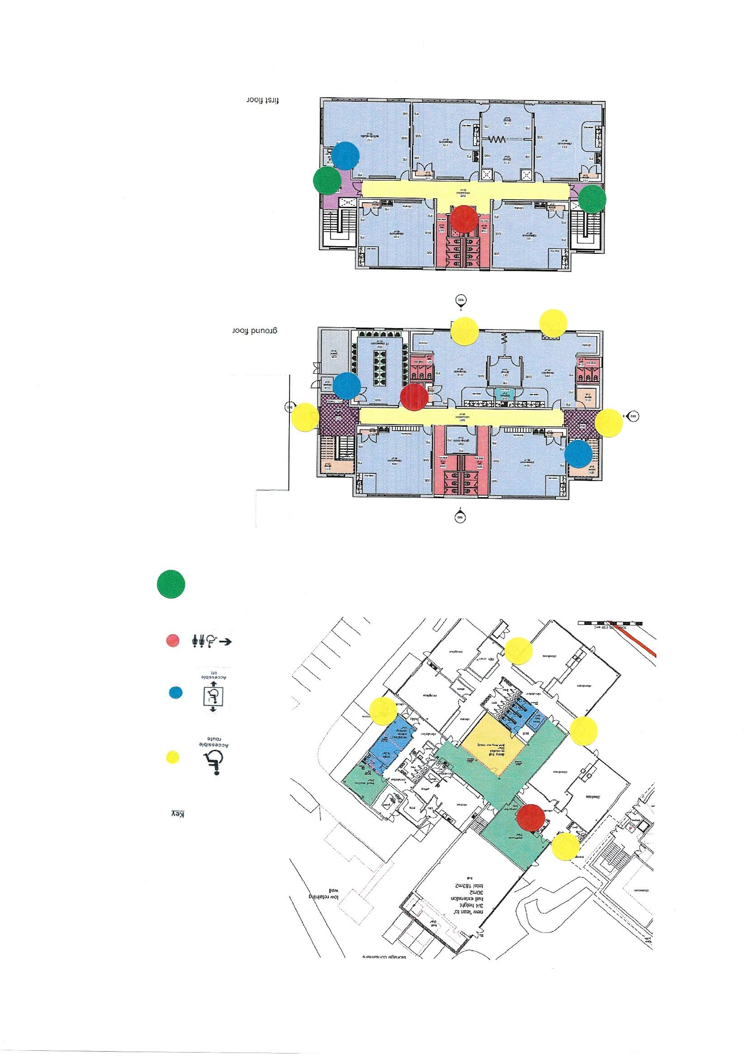
Refuge area

Accessibility Plan
An Access Audit was carried out by the Headteacher and Site Manager in Autumn 2016.
This Accessibility Policy and Plan are drawn up in compliance with current legislation and requirements as specified in Schedule 10, relating to Disability, of the Equality Act 2010. School Governors are accountable for ensuring the implementation, review and reporting on progress of the Accessibility Plan over a prescribed period.

- We are committed to providing an accessible environment which values and includes all pupils, staff, parents and visitors regardless of their education, physical, sensory, social, spiritual, emotional and cultural needs. We are committed to challenging negative attitudes about disability and accessibility and to developing a culture of awareness, tolerance and inclusion.
- William Ransom Primary School plans, over time, to ensure the accessibility of provision for all pupils, staff and visitors to the school.
- An Accessibility Plan will be drawn up to cover a three year period. The plan will be updated annually.

Following the expansion of the school and major building works in 2016, from September 2016 the school is fully accessible for any people with access needs. There are lifts to all floors and all playgrounds are accessible and there are now two designated parking spaces for those visitors with disabilities.

 | Targets | Strategies | Outcome | Timeframe | Goals Achieved
Short Term | The school to continue to implement staff development regarding the work process of children with disabilities e.g. mental effort needed, time taken to complete activities. | Any relevant training to be attended by SENCo and /or new staff | Staff will accommodate expectations of disabled children in the light of their needs  All staff & classrooms will have access to necessary materials to support the work process of children with disabilities. | On-going / when necessary
Short Term | The school will provide alternative ways for pupils to access the curriculum in the event of a short term medical issue i.e. broken limb. | ICT equipment could be used for pupils who cannot write. Location of lessons altered should access be a difficulty. | Staff will accommodate the needs of all pupils and they will be able to access all aspects of the curriculum | On-going / when necessary
Short term | Review documentation on website to check accessibility for parents with English as an Additional Language | Discuss with Website manager the possibility of a translator tool on the school website | The website will be accessible to all parents with English as an additional language. | By December 2016
Short Term | The school will continue to provide easy access around the school site [internally and externally] to make the use of the school building accessible to all users. | Purchase / Creation of appropriate signing to be investigated by the school and put up as and when needed. | All users of school will be able to find their way around the school campus with ease. | On-going / when necessary
Medium Term | The school will provide alternative ways of giving access to experience or understanding for disabled pupils who cannot engage in particular activities e.g. some forms of PE | INSET/Advice sought from County and Sports partnership | If needed children will be given alternative PE activities.  INSET will be provided if the school has a wheelchair bound pupil. | On-going / when necessary
Medium Term | Develop further the buddying and mentoring system for children with a range of disabilities | Careful selection of pupils to act as mentors for those pupils with learning disabilities  Any pupils with food allergies or eating disorders to be paired with a carefully selected buddy | When appropriate disabled children will be able to use the Buddying system to help in all aspects of school life. | On-going
Medium Term | The school will make available written material in alternative formats when specifically requested | The school will make itself aware of the services available for converting written information into alternative formats. | As the need arises all parents will be able to access school information in different formats | On going
Long Term | The school will ensure that school visits will be made accessible to all pupils irrespective of attainment or impairment subject to funding available for extra staff. | Extra funding will be sought to allow additional adult support to accompany disabled pupils on school visits. This would be an essential element if such visits were to take place. | As the need arises all children will be able to take part in all school visits subject to adequate funding. | On-going

Reference should also be made to the Equality and Diversity Scheme.
This plan is constantly under review to accommodate any new starters with a disability.

Review Autumn 2016
Next Review Autumn 2019

