Curriculum Overview for Year 2 Cedar and Pine
Reading  Develop phonics until decoding secure  Read common suffixes  Read & re-read phonic-appropriate books  Read common ‘exception’ words  Discuss & express views about fiction, non-fiction & poetry  Become familiar with & retell stories  Ask & answer questions; make predictions  Begin to make inferences  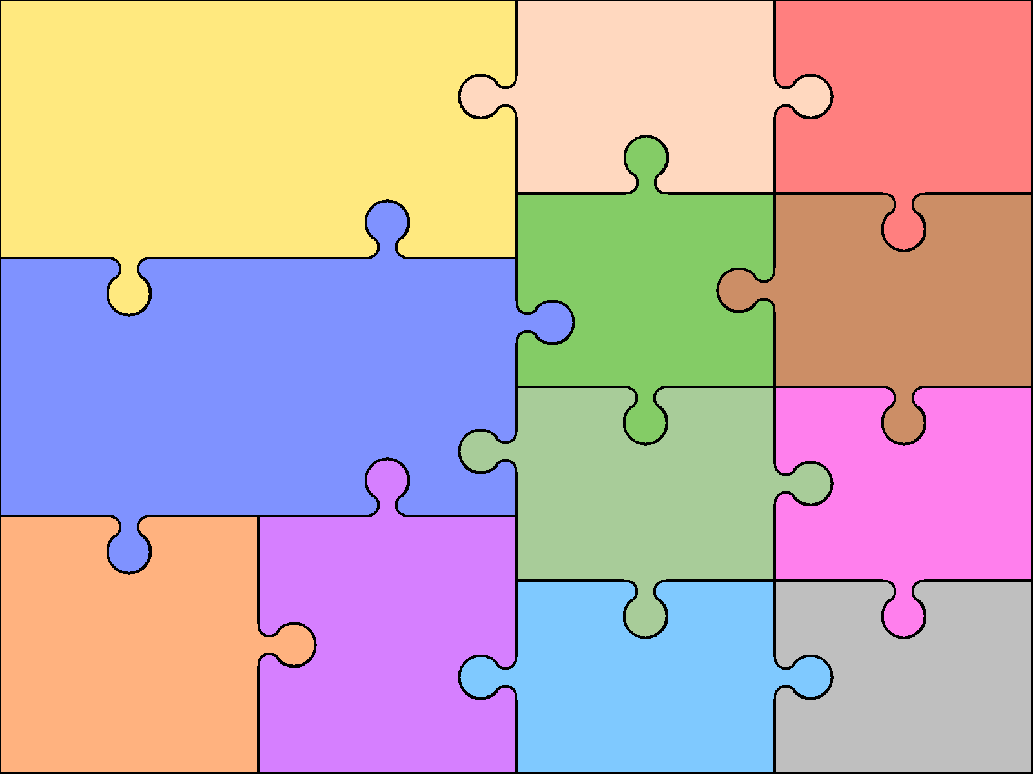 | English  Writing  Spell by segmenting into phonemes  Learn to spell common ‘exception’ words  Spell using common suffixes, etc.  Use appropriate size letters & spaces  Develop positive attitude & stamina for writing  Begin to plan ideas for writing  Record ideas sentence-by-sentence  Make simple additions & changes after proof-reading |  | Grammar  Use . ! ? , and ’  Use simple conjunctions  Begin to expand noun  phrases  Use some features of standard English  Speaking & Listening  Articulate & Justify answers  Initiate & respond to comments  Use spoken language to develop  understanding | Art & Design  Pattern – Galler  Rousseau  Portraits – Self portraits  Picasso  Klee  Hockney  Henry Moore Natural Sculptures | Computing  Computer skills – Word: Saving, opening etc.  Visual information – pictograms  Charts  Data bases  Coding- Espresso, J2Code  Discovering Turtles & Devices  Beebot  Turtle
 |  |  |  | Design & Technology  Puppets – glove puppets & sewing  Mechanisms – castles  Construction – 3 Little Pigs  Food Technology – Mexican Food  Pasta Salad  Breakfast Fruit Pots | Geography  Local Area – Map work  British Isles – Capitals and Seas  Chester City  Continents and Oceans  Mexico – Tocuaro – weather & comparison to UK  Seaside  Compass Directions
Number/Calculation  Know 2, 5, 10x tables  Begin to use place value (T/U)  Count in 2s, 3s, 5s & 10s  Identify, represent & estimate numbers  Compare / order numbers, inc. < > =  Write numbers to 100  Know number facts to 20 (+ related to 100)  Use x and ÷ symbols  Recognise commutative property of multiplication | Mathematics  Geometry & Measures  Know and use standard measures  Read scales to nearest whole unit  Use symbols for £ and p and add/subtract simple sums of less than £1 or in pounds  Tell time to the nearest 5 minutes  Identify & sort 2-d & 3-d shapes  Identify 2-d shapes on 3-d surfaces  Order and arrange mathematical objects  Use terminology of position & movement |  | Fractions  Find and write simple fractions  Understand equivalence of  e.g. 2/4 = 1/2  Data  Interpret simple tables & pictograms  Ask & answer comparison  questions  Ask & answer  questions about  totalling
 |  |  |  | Modern Languages  Not required at this age but children learn to say  hello and take the register in different languages. | Music  Charanga Units:  Hands Feet Heart  Ho Ho Ho  I Wanna Play in a Band  Zoo time  Friendship Song  Reflect, Rewind & Replay
Science  Animals including humans  Living Things and their habitats  Plants – growing beans  Everyday materials  Materials and their properties. |  | History  Local History – British Schools  Famous local people / significant events  Lord Lister  Henry Bessemer  Famous People – Florence Nightingale  Mary Seacole  Edith Cavell  Dr Barnado  Kings & Queens  Queen Elizabeth I
 |  |  |  | Physical Education  Gymnastics:  Basic skills – sequencing, jumping,  Pathways, apparatus  Dance  Indoor Athletics / circuit training  Athletics  Ball Skills – attacking and defending | Religious Education  Sources of Wisdom Religious Leaders  Ultimate questions – easy questions /  difficult answers  Easter  Christmas  Sikhism  Islam

