Week 1 Summer Term Making and continuing a pattern
Step 1
Make a pattern for your child to follow using toys such as Lego, cutlery, buttons or anything you have. Start with a simple AB pattern
A B A B A _ _ _ _ _ What comes next? Can your child copy and continue your patterns?

When you have done several of these and your child has shown that they can copy and extend your pattern get them to make their own pattern.
Step 2
An ABC pattern 3 variables. A B C A B C A _ _ _ _
sh ch th sh ch th sh _ _ _ _ _
Other examples:
Step 3
Topmarks website - Shape patterns (3 levels of difficulty)

Pattern worksheets available:
www.worksheetfun.com

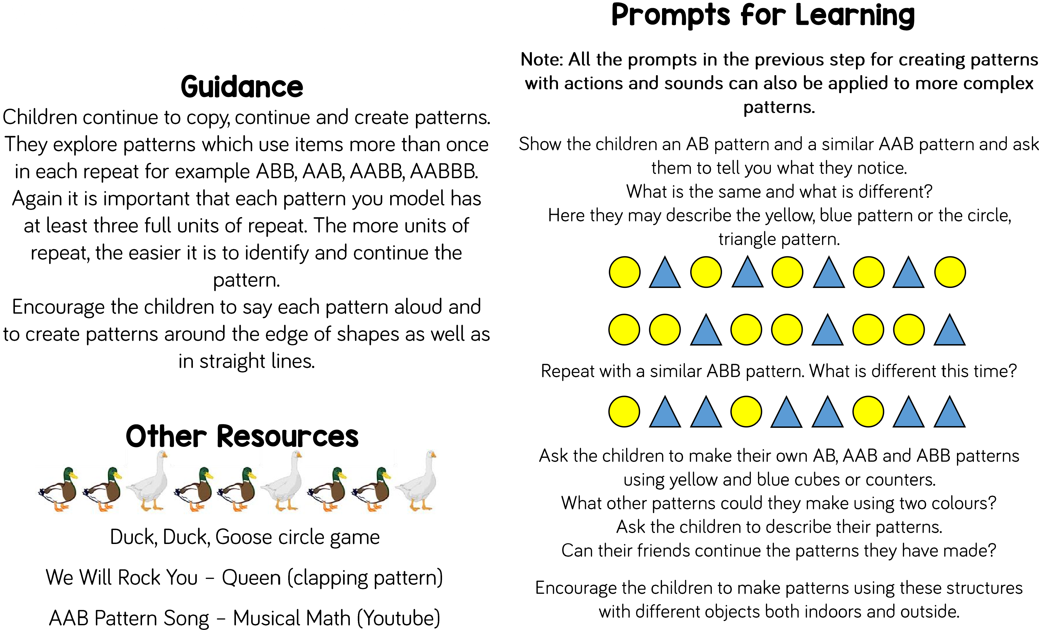

Step 4 Questions to ask
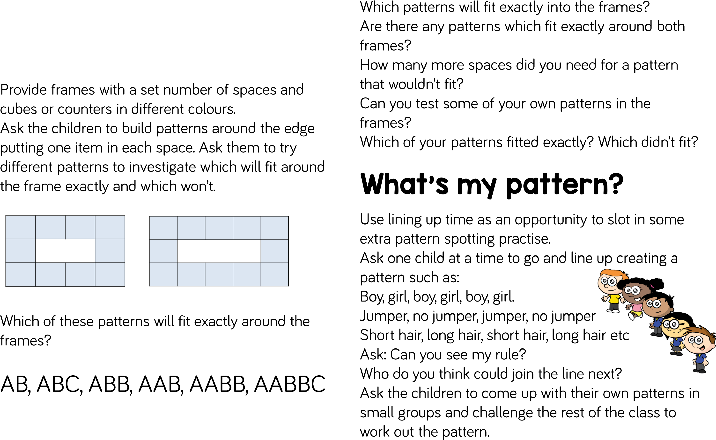
Step 5 Apply your patterns to something else:
Do some potato printing and make patterns.
Use playdough and cutters and make patterns.
Bead or pasta threading.
Do some exercise patterns eg hop, jump, jump ? ?

