Week 2 Adding more
Note for parents
The children need to use real objects to see that a quantity of a group will be changed by adding more. The first, then, now structure can be used to create mathematical stories in meaningful contexts.
At first the children may need to recount all of the items to see how many there are altogether eg 1,2,3,4…..5,6,7 When they are ready, encourage them to count on. Play games with different starting points to support this step.

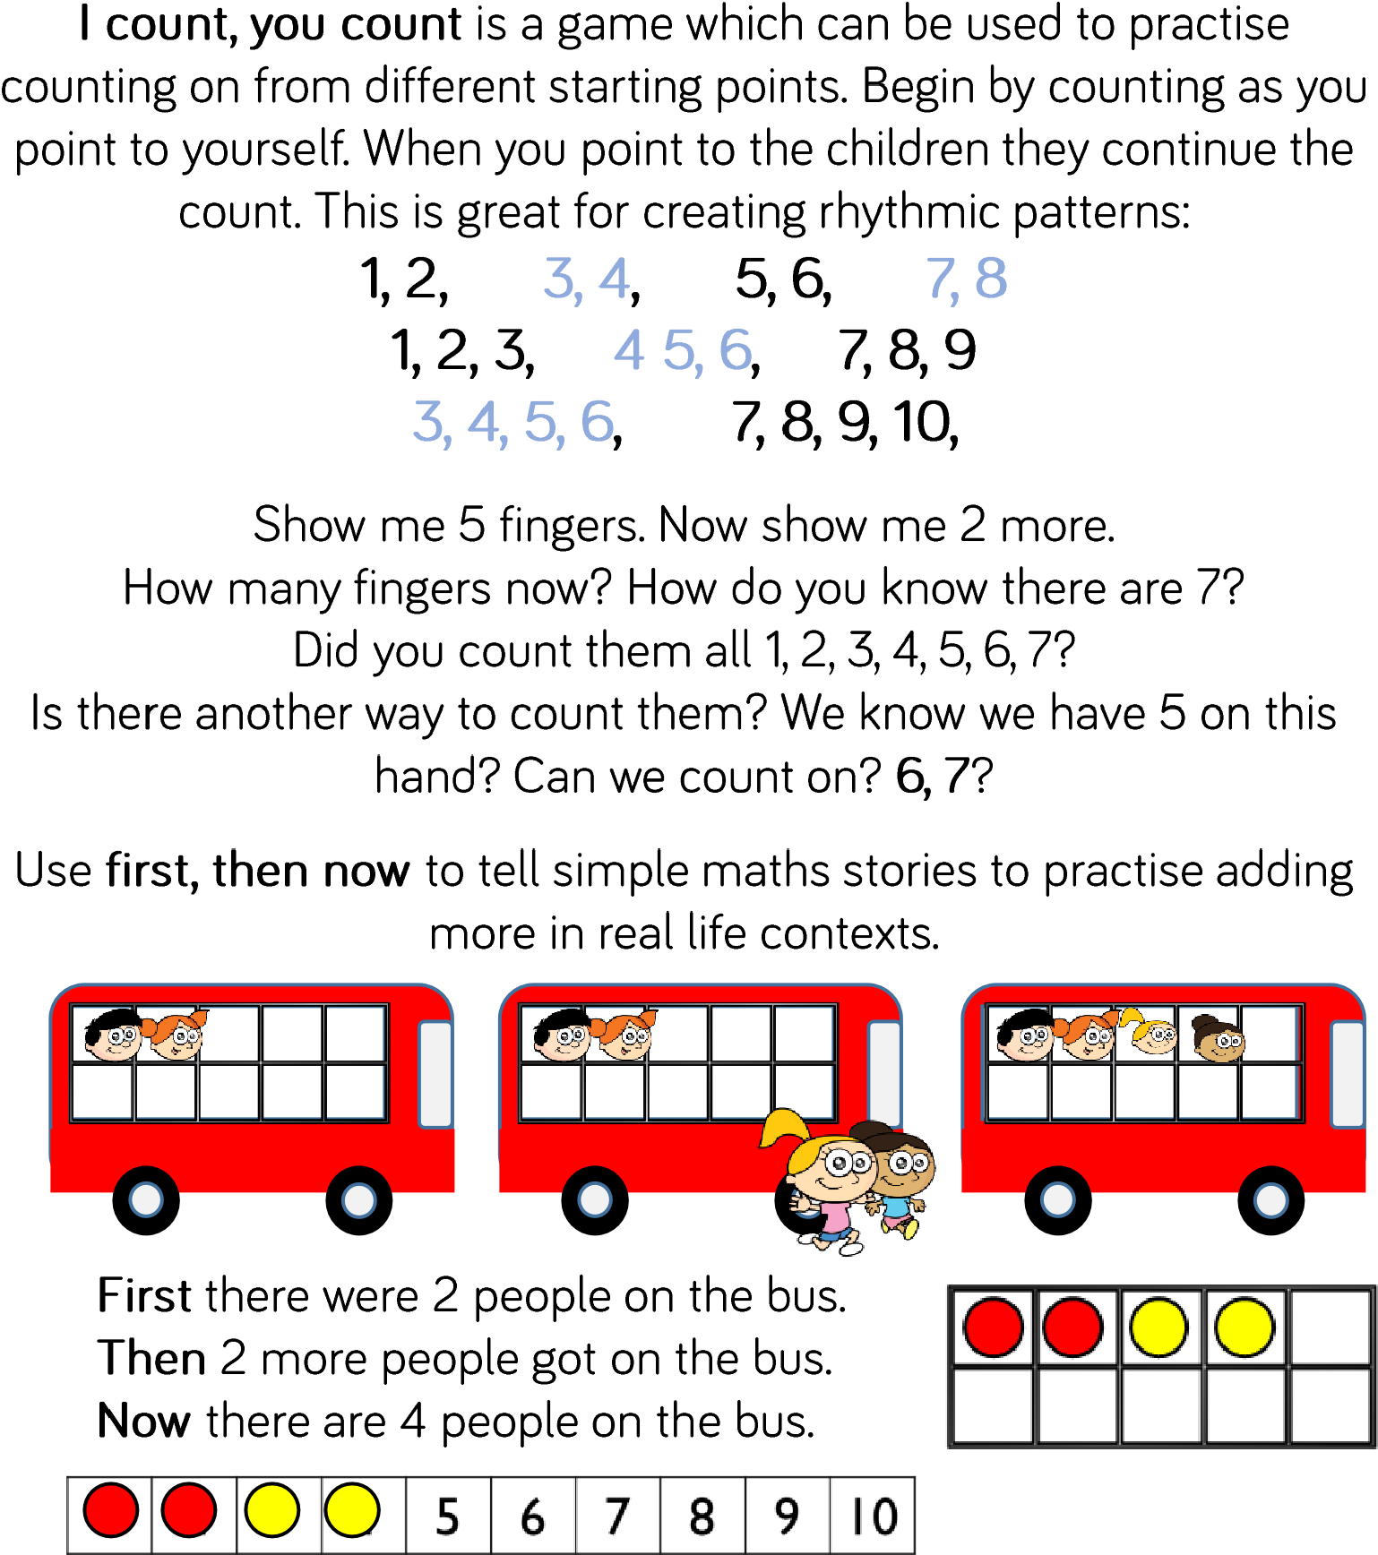
Starter activities

More activities
1.Read Mr Gumpy’s Outing by John Burningham .
2.Make up your own version adding toys to a pretend boat.
3.Can your child say how many there are without having to count them all.
4. Ask how they know that is the right answer, can they explain their working out.
5. Can they record a problem set by you. Eg There are 3 people in the boat 3 more get in, how many are there now? (They might draw the problem in pictures, they might know that this could be represented as 3+3=6.) They need to be explaining what they are doing and why, this is all part of ‘maths fluency’. The recording should be their own as it reflects their level of maths understanding.
6. Other books to read are The Shopping Basket by John Burningham and Mice Count by Ellen Stoll Walsh They are both about adding more and being able to count on to add.
7. Your child could write their own story or make up their own story using toys to act it out.
All books can be found on You Tube
Construction game
1.Take it in turns to throw a dice and build a tower.
2.Can your child add on the new number by counting on rather than counting them all. (If the numbers are too high for your child to count on, put a sticker over 3, 4,5,6 and make them lower numbers)
3. Can your child compare the height of the towers of other players by using the vocabulary of more and fewer.
4. Can your child say how many more their tower is than yours. How do they know?
Number track game
- Roll a dice and move along the number track. Can they say what number they will land on without counting? Set a target, the first person to 20 wins.
- You could chalk a number track outside and do the same sort of activity.

Written activity
1-Have the pile of numbers from your word box.
Turn one over and write the number- then roll the dice and draw the dice. Find the answer by counting on from the number using the spots and write the answer. Eg.
5 + 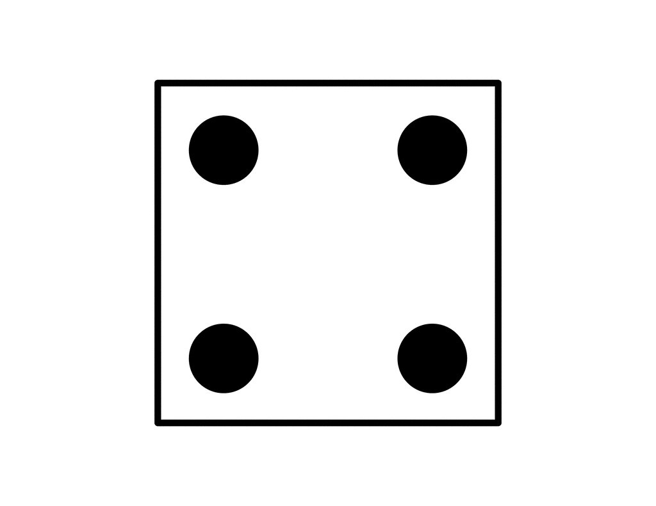 =
(Higher numbers could be used as a starting point.)

- Use the number cards as a starting number. Can they write what is 1 more each time in their book.
Eg
11 and 1 more is ____

- Can they do 2 more by counting on? 5 more/ 10 more? (use a number line to help)

- Make your own track game on a piece of paper and play it.

