Mountain Climates Fact Sheet
- How high a mountain is affects what its climate is like. Moving 300 metres up is the same as moving 350 miles towards one of the poles!
- Air pressure also changes as one gains altitude. At the top of Mount Everest (8848 m) the pressure is around 310-360 millibars, compared to around 1013 mb at sea level.
- As a result of falling air pressure, rising air expands and cools (although, dry air cools faster than moist air because, as the moist air rises, the water vapour condenses – like in clouds – and this gives off some heat). The higher you are the cooler it gets. That is why we often have snow on mountaintops, even along the equator.
- Mountains therefore act as a barrier to moisture-laden winds. Air rising to pass over the mountains cools and the water vapour condenses, turning into either clouds, rain, or if it is cold enough, snow. This is why on one side of a mountain you can experience a wet climate, while on the other side of the same mountain you find an arid one.
- A large mountain range can affect the weather of the land beyond it. The Himalayas influence the climate of the rest of India by sheltering it from the cold air mass of central Asia.
- In high mountains the first snow may fall several weeks earlier than it does in the surrounding area. In the same way, the last snow may melt well after the rest of the area is snow free.
- There is more rain in the mountains since the air rises and cools, causing the moisture in the clouds to condense and fall as rain.
- Although it may be freezing cold on the top of high mountains, it is still possible to get sunburn! This is because the air is thinner, and the sun’s rays are very strong. The sunlight may also be reflected off the snow. This is why people going skiing sometimes come back sunburnt!
- Mountain weather conditions can also change dramatically. A morning that starts sunny and fine can quickly change to an afternoon of thunderstorms and blizzards.
- The treeline or timberline is the edge of the habitat on a mountain beyond which trees are incapable of growing due to environmental conditions. Any higher up the mountain beyond the tree line and the weather is either too windy, too cold or snow persists for too much of the year to sustain trees.
- Alpine tree lines are dependent on different variables and so may be set at different elevations depending on where you are in the world. For instance, in the Swiss Alps the tree line is set at approximately 2400 metres, whereas in the Himalayas it sits at approximately 4400 metres. The height of the tree line is also affected by how wet or dry the mountain is, the steepness of its slope, and its proximity either to the coast or to either geographical pole.
- There are other types of tree line as well as alpine tree lines, such as the Arctic and Antarctic tree lines (the furthest north or south that trees can grow), desert tree lines (defined by how dry a place can be before it can’t support tree-growth), and exposure tree lines (beyond which trees can’t grow because the winds are too strong). These other types of tree line also affect how high up alpine tree lines are set in different mountain systems around the world. For example, in mountains that suffer very strong winds, the tree line may be lower than it otherwise might.
- The weather conditions above the tree line are known as the alpine climate. The snowline is that line above which there is always snow on the ground.
- The snow line is affected by the interplay of altitude and latitude. On or near the equator it is typically situated at approximately 4500 metres. As one moves towards the Tropic of Cancer or the Tropic of Capricorn, the snow line increases (in the Himalayas, the permanent snow line can be as high as 5700 metres). Beyond the Tropics the snowline becomes progressively lower as the latitude increases, falling all the way to sea level at either pole.

Mountain Diagram
ridge summit snowline treeline foothills
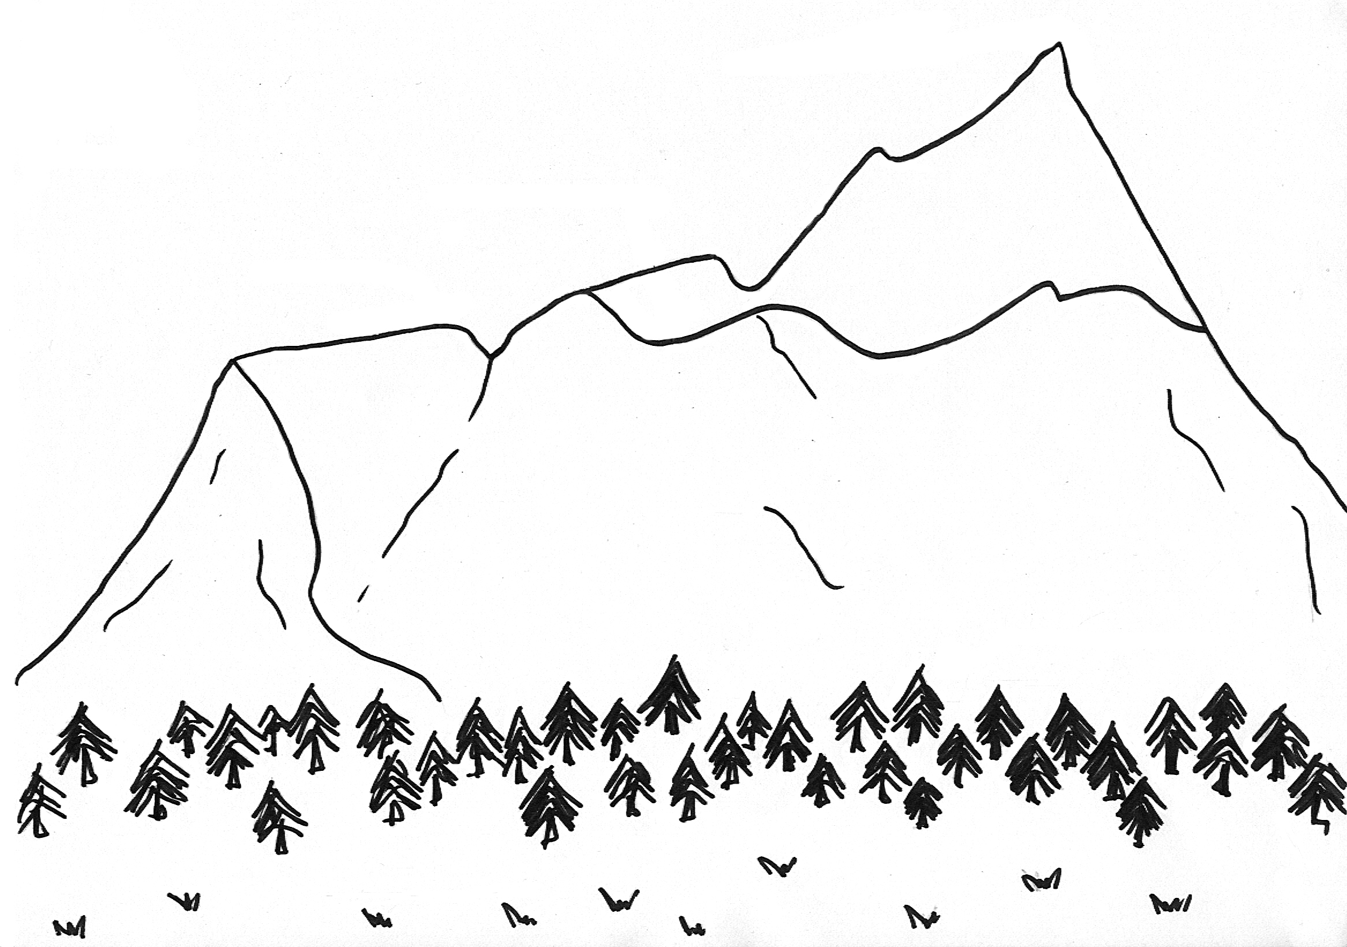

Mountain Climates Missing Words Game
snowline foothills colder oxygen quickly dramatically freezing
treeline blizzards severe sub-tropical air altitude pressure
The greater the __________ (distance above sea level), the _________ the temperature.
Altitude sickness is a common condition that can happen when you climb to a high altitude too ___________. The decrease in atmospheric __________ makes breathing difficult because you are not able to breathe in as much ___________.
The ___________ is the line around the mountains above which snow is on the ground all year round. The ____________ is the line around the mountains above which no trees will grow. This is because there is either too little ________, or the weather is so ____________ that trees cannot survive.
Mountain weather conditions can change __________. A morning that starts sunny and fine can quickly change to an afternoon of thunderstorms and ___________.
In hot places there can be a very real difference between the climate in the _________ of a large mountain range and the climate at the top of its highest peaks. The climate in the lower foothills can be ____________, whereas the climate at the top of the higher peaks can be very cold, sometimes below ____________ all year round.
Mountain Climates Missing Words Answers
The greater the altitude (distance above sea level), the colder the temperature.
Altitude sickness is a common condition that can happen when you climb to a high altitude too quickly. The decrease in atmospheric pressure makes breathing difficult because you are not able to breathe in as much oxygen.
The snowline is the line around the mountains above which snow is on the ground all year round. The treeline is the line around the mountains above which no trees will grow. This is because there is either too little air or the weather is so severe that trees cannot survive.
Mountain weather conditions can change dramatically. A morning that starts sunny and fine can quickly change to an afternoon of thunderstorms and blizzards.
In hot places there can be a very real difference between the climate in the foothills of a large mountain range and the climate at the top of its highest peaks. The climate in the lower foothills can be sub-tropical, whereas the climate at the top of the higher peaks can be very cold, sometimes below freezing all year round.

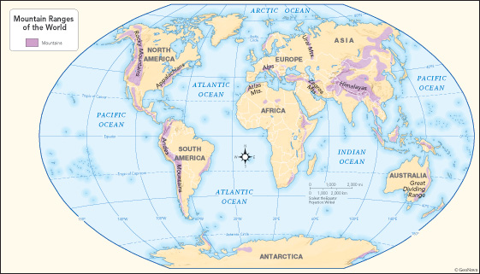
Mountain Ranges of the World Map

