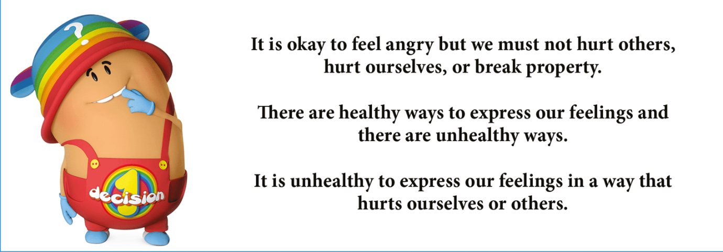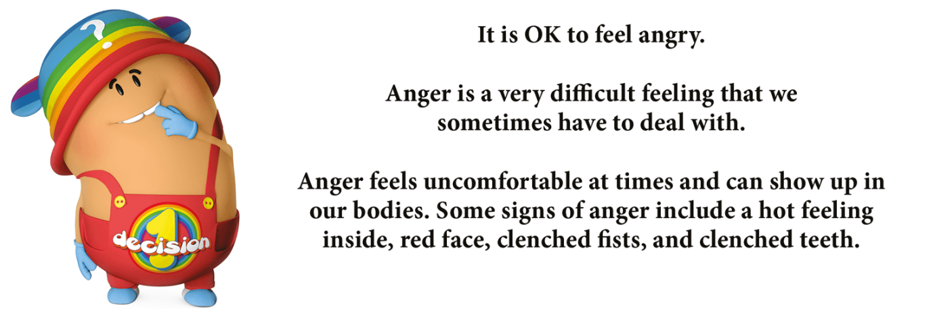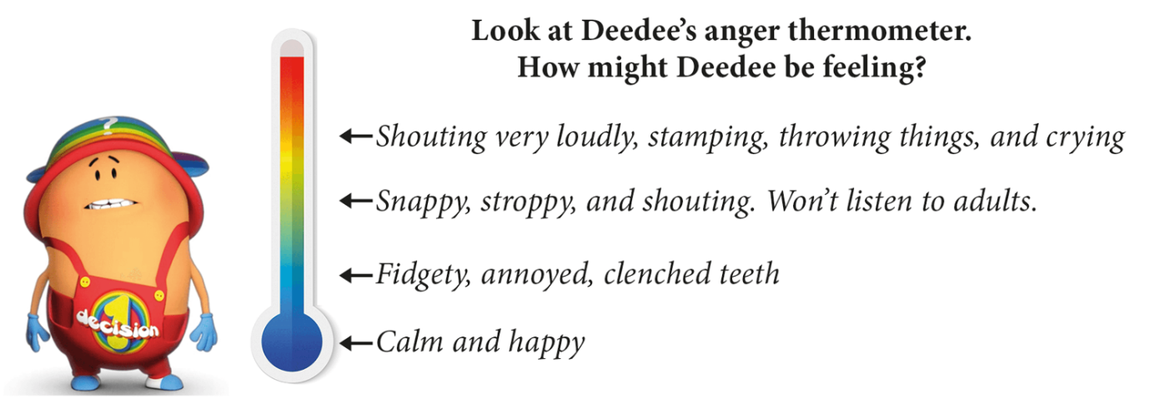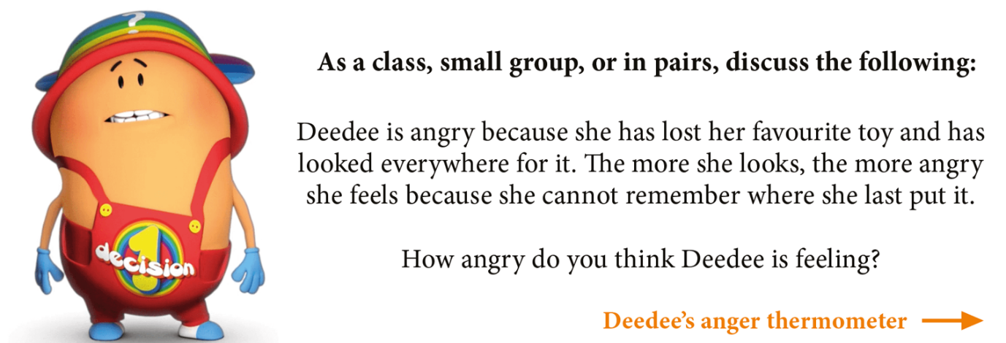

**Draw a picture about how you deal with anger. Do you listen to music, talk to a friend, find a quite place to clam down, go for a walk?**