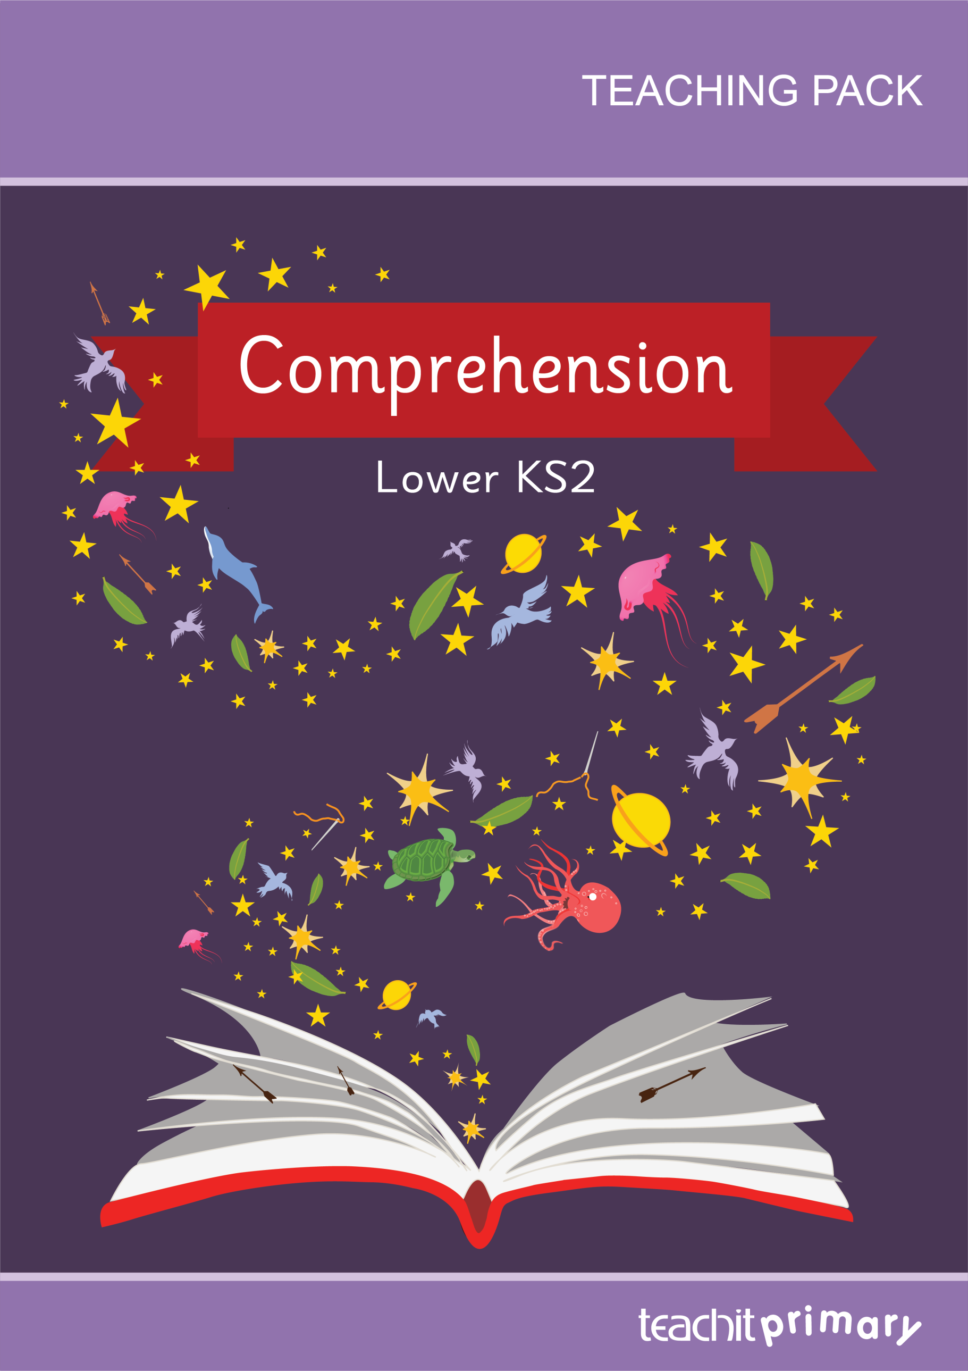Front cover

Contents

|  |
| --- |
| Contents |

Introduction 003

Unit 1 – The Little Prince 007

Teaching notes 007

Resource printouts 013

Unit 2 – The Velveteen Rabbit 017

Teaching notes 017

Resource printouts 024

Unit 3 – The Little Mermaid 026

Teaching notes 026

Resource printouts 034

Unit 4 – Robin Hood 037

Teaching notes 037

Resource printouts 045

Unit 5 – Four square 049

Teaching notes 049

Resource printouts 056

Unit 6 – A letter 057

Teaching notes 057

Resource printouts 063

Introduction

|  |
| --- |
| Introduction |

This pack aims to provide creative teaching ideas to support children in the development of reading comprehension skills. Each of the six units is made up of a starter, main activities, plenary and activities to take the learning further, including homework ideas.

Teaching notes and supporting resources take you through the teaching sequence and help with your teaching preparation. Each of the units includes pupil activities which are designed for children to carry out independently, either as a whole class or in groups.

An assessment sheet is provided as a means of monitoring and assessing the children’s skills and knowledge for each unit.

Please note that, at the time of publishing, all external links referenced within the pack are fully functioning. However, Teachit Primary cannot take responsibility for the maintenance of external websites.

We hope you enjoy using this pack. If you have any questions, please get in touch: email [support@teachitprimary.co.uk](mailto:support@teachitprimary.co.uk) or call us on 01225 788851. Alternatively, you might like to give some feedback for other Teachit Primary members – you can do this by adding a comment on the [Comprehension – Lower KS2](https://www.teachitprimary.co.uk/reading-ks1) page on Teachit Primary (please log in to access this!).

Curriculum coverage and mapping

This pack matches the requirements of the statutory guidance in the National Curriculum for English years 3 and 4 as follows:

Reading – comprehension

* develop positive attitudes to reading and understanding of what they read by:
  + listening to and discussing a wide range of fiction, poetry, plays, non-fiction and reference books or textbooks
  + reading books that are structured in different ways and reading for a range of purposes
  + using dictionaries to check the meaning of words that they have read
  + increasing their familiarity with a wide range of books, including fairy stories, myths and legends and retelling some of these orally
  + identifying themes and conventions in a wide range of books
  + discussing words and phrases that capture the reader’s interest and imagination.
* understand what they read, in books they can read independently, by:
  + checking that the text makes sense to them, discussing their understanding and exploring the meaning of words in context
  + asking questions to improve their understanding of a text
  + drawing inferences such as inferring characters’ feelings, thoughts and motives from their actions, and justifying inferences with evidence
  + predicting what might happen from details stated and implied
  + identifying main ideas drawn from more than one paragraph and summarising these
  + identifying how language, structure and presentation contribute to meaning.
* retrieve, record and present information from non-fiction
* participate in discussions about both books that are read to them and those they can read for themselves, taking turns and listening to what others say.

Statutory requirements covered

This grid indicates when skills are explicitly taught. Many are also covered in the comprehensions.

|  |  |  |  |  |  |  |  |
| --- | --- | --- | --- | --- | --- | --- | --- |
| **Curriculum coverage** | Unit | 1 | 2 | 3 | 4 | 5 | 6 |
| *Reading – Comprehension:* | |  |  |  |  |  |  |
| listening to and discussing a wide range of fiction, poetry, plays, non-fiction and reference books or textbooks | |  |  |  |  |  |  |
| reading books that are structured in different ways and reading for a range of purposes | |  |  |  |  |  |  |
| using dictionaries to check the meaning of words that they have read | |  |  |  |  |  |  |
| increasing their familiarity with a wide range of books, including fairy stories, myths and legends and retelling some of these orally | |  |  |  |  |  |  |
| identifying themes and conventions in a wide range of books | |  |  |  |  |  |  |
| discussing words and phrases that capture the reader’s interest and imagination | |  |  |  |  |  |  |
| checking that the text makes sense to them, discussing their understanding and exploring the meaning of words in context | |  |  |  |  |  |  |
| asking questions to improve their understanding of a text | |  |  |  |  |  |  |
| drawing inferences such as inferring characters’ feelings, thoughts and motives from their actions, and justifying inferences with evidence | |  |  |  |  |  |  |
| predicting what might happen from details stated and implied | |  |  |  |  |  |  |
| identifying main ideas drawn from more than one paragraph and summarising these | |  |  |  |  |  |  |
| identifying how language, structure and presentation contribute to meaning | |  |  |  |  |  |  |
| retrieving, recording and presenting information from non-fiction | |  |  |  |  |  |  |
| participating in discussions about both books that are read to them and those they can read for themselves, taking turns and listening to what others say. | |  |  |  |  |  |  |

|  |  |  |  |  |  |  |  |  |  |  |  |  |  |  |  |  |  |  |  |  |  |  |  |  |  |  |  |  |  |  |
| --- | --- | --- | --- | --- | --- | --- | --- | --- | --- | --- | --- | --- | --- | --- | --- | --- | --- | --- | --- | --- | --- | --- | --- | --- | --- | --- | --- | --- | --- | --- |
| **Reading comprehension skills checklist** | name |  |  |  |  |  |  |  |  |  |  |  |  |  |  |  |  |  |  |  |  |  |  |  |  |  |  |  |  |  |
| listening to and discussing a wide range of fiction, poetry, plays, non-fiction and reference books or textbooks |  |  |  |  |  |  |  |  |  |  |  |  |  |  |  |  |  |  |  |  |  |  |  |  |  |  |  |  |  |  |
| reading books that are structured in different ways and reading for a range of purposes |  |  |  |  |  |  |  |  |  |  |  |  |  |  |  |  |  |  |  |  |  |  |  |  |  |  |  |  |  |  |
| using dictionaries to check the meaning of words that they have read |  |  |  |  |  |  |  |  |  |  |  |  |  |  |  |  |  |  |  |  |  |  |  |  |  |  |  |  |  |  |
| increasing their familiarity with a wide range of books, including fairy stories, myths and legends and retelling some of these orally |  |  |  |  |  |  |  |  |  |  |  |  |  |  |  |  |  |  |  |  |  |  |  |  |  |  |  |  |  |  |
| identifying themes and conventions in a wide range of books |  |  |  |  |  |  |  |  |  |  |  |  |  |  |  |  |  |  |  |  |  |  |  |  |  |  |  |  |  |  |
| discussing words and phrases that capture the reader’s interest and imagination |  |  |  |  |  |  |  |  |  |  |  |  |  |  |  |  |  |  |  |  |  |  |  |  |  |  |  |  |  |  |
| checking that the text makes sense to them, discussing their understanding and exploring the meaning of words in context |  |  |  |  |  |  |  |  |  |  |  |  |  |  |  |  |  |  |  |  |  |  |  |  |  |  |  |  |  |  |
| asking questions to improve their understanding of a text |  |  |  |  |  |  |  |  |  |  |  |  |  |  |  |  |  |  |  |  |  |  |  |  |  |  |  |  |  |  |
| drawing inferences such as inferring characters’ feelings, thoughts and motives from their actions, and justifying inferences with evidence |  |  |  |  |  |  |  |  |  |  |  |  |  |  |  |  |  |  |  |  |  |  |  |  |  |  |  |  |  |  |
| predicting what might happen from details stated and implied |  |  |  |  |  |  |  |  |  |  |  |  |  |  |  |  |  |  |  |  |  |  |  |  |  |  |  |  |  |  |
| identifying main ideas drawn from more than one paragraph and summarising these |  |  |  |  |  |  |  |  |  |  |  |  |  |  |  |  |  |  |  |  |  |  |  |  |  |  |  |  |  |  |
| identifying how language, structure and presentation contribute to meaning |  |  |  |  |  |  |  |  |  |  |  |  |  |  |  |  |  |  |  |  |  |  |  |  |  |  |  |  |  |  |
| retrieving, recording and presenting information from non-fiction |  |  |  |  |  |  |  |  |  |  |  |  |  |  |  |  |  |  |  |  |  |  |  |  |  |  |  |  |  |  |
| participating in discussions about both books that are read to them and those they can read for themselves, taking turns and listening to what others say. |  |  |  |  |  |  |  |  |  |  |  |  |  |  |  |  |  |  |  |  |  |  |  |  |  |  |  |  |  |  |

1 Listening skills

|  |
| --- |
| Unit 1 – The Little Prince |

Teaching notes

Starter:

* Show children a selection of illustrations of characters from children’s books which were originally written in a different language. For example: *The Adventures of Pippi Longstocking* by Astrid Lindgren (Swedish), *Mrs Pepperpot* by Alf Prøysen (Norwegian), *Heidi* by Johanna Spyri (German), *Finn Family Moomintroll* by Tove Jansson (Swedish), *The Rainbow Fish* by Marcus Pfister (German), *Asterix the Gaul* by René Goscinny and Albert Uderzo (French), *The Adventures of Tintin* by Hergé (French). In groups, give the children three minutes to identify as many of the characters as they can, and/or the books they come from. Take feedback, and ask: *What do all of these books have in common?* Elicit that they are all translations, so were originally written in a language other than English. Explain that the story extract we are looking at today comes from *The Little Prince* by Antoine de Saint-Exupery, which in its original French is titled *Le Petit Prince*.

Main activities:

**Main teaching activity:** Using **Resource 1 – Unlocking words (a)**, prepare a set of eight different, real padlocks and keys. (If you do not have enough padlocks you can use the versions with pictures of keys and locks provided as an alternative.) Each padlock should have one of the words from **Resource 1 – Unlocking words (a)**stuck to it, and the corresponding key should have the definition tied to it as a label. Hide the padlocks around the classroom and keep the keys somewhere central, e.g. the teacher’s desk. Depending on the number of children, provide pairs or small groups of children with a copy of **Resource 2 – Unlocking words (b)** and a dictionary. Explain to the children that they are going to be hunting for words and definitions. When they find one of the hidden padlocks, they must write down the word on their sheet and then use the dictionary to find a definition for that word, which they must also write on their sheet. Once they have done this, they can come and look at the keys and choose the one whose definition they think will open the padlock. If the key works, they may put a tick by the word on their sheet and continue – not forgetting to relock the padlock for the next group! The first group to find and match all eight definitions correctly is the winner!

* **Pupil activity one:** Ask children to work in pairs to read the**extract** aloud to one another, taking turns to read alternate paragraphs. (You will also need children to have access to a copy of the book to see the picture of the Little Prince on page nine of the book.) Remind them that they may choose to use a highlighter or a pencil to pick out key information from the extract. Now provide each child with a copy of the **comprehension questions** and ask them to work through the questions individually (you may wish to pair lower ability children together, or provide them with an adult support).

**Chapter 1**

* **Pupil activity two:** Give groups of children a large sheet of sugar paper and some felt-tip pens, and ask them to discuss and write down any questions they have about the story extract from *The Little Prince*. For example: *Who is the small person? How did he get to the desert? Where was the narrator flying his plane to before the crash? Why does the small person want a drawing of a sheep? Does the narrator draw the sheep in the end? Who is ‘The Little Prince’ from the story title?* Take feedback and record some of the children’s questions on the interactive whiteboard. What do they think will happen next? Challenge the children to write the next two to three paragraphs of the story.

Plenary:

* Use a random name-generator to choose children to read their continuation of the story from **pupil activity two**. For each story read, choose a child from the audience to provide ‘two stars and a wish’ feedback on the writing (you could alternatively ask three children for this feedback – two to provide stars, one to provide a wish). If **pupil activity two** has not been completed, the children could instead provide ‘two stars and a wish’ feedback for the story extract itself!

Taking it further:

* **Fact from fiction:** Have pairs of children look through the **extract**to choose a topic mentioned in the story that they would like to research further. For example, they might select *planes*, *the Sahara Desert*, *sheep*, etc. They should then conduct their research either using the internet or non-fiction books (or a combination of the two), and prepare a short, informative presentation to share their findings with the rest of the class.
* **Home learning activity:** Ask children to choose any book at home and open it at random. They must then read the two open pages and copy down at least *three* tricky or unfamiliar words to look up definitions for in the dictionary – and be ready to share with other children in class!

The Little Prince – extract

|  |  |
| --- | --- |
| So I lived my life alone, without anyone that I could really talk to, until I had an accident with my plane in the Desert of Sahara, six years ago. Something was broken in my engine. And as I had with me neither a mechanic nor any passengers, I set myself to attempt the difficult repairs all alone. It was a question of life or death for me: I had scarcely enough drinking water to last a week. |  |
| The first night, then, I went to sleep on the sand, a thousand miles from any human habitation. I was more isolated than a shipwrecked sailor on a raft in the middle of the ocean. Thus you can imagine my amazement, at sunrise, when I was awakened by an odd little voice.  It said: “If you please – draw me a sheep!”  “What!”  “Draw me a sheep!”  I jumped to my feet, completely thunderstruck. I blinked my eyes hard. I looked carefully all around me. And I saw a most extraordinary small person, who stood there examining me with great seriousness. Here you may see the best portrait that, later, I was able to make of him. But my drawing is certainly very much less charming than its model.  That, however, is not my fault. The grown-ups discouraged me in my painter’s career when I was six years old, and I never learned to draw anything, except boas from the outside and boas from the inside.  Now I stared at this sudden apparition with my eyes fairly starting out of my head in astonishment. Remember, I had crashed in the desert a thousand miles from any inhabited region. And yet my little man seemed neither to be straying uncertainly among the sands, nor to be fainting from fatigue or hunger or thirst or fear. Nothing about him gave any suggestion of a child lost in the middle of the desert, a thousand miles from any human habitation. When at last I was able to speak, I said to him:  “But – what are you doing here?”  And in answer he repeated, very slowly, as if he were speaking of a matter of great consequence:  “If you please – draw me a sheep…” | |

Comprehension questions

Name: Date:

1. Where in the world did the narrator’s accident take place?

1. What job does the narrator of the story have?

|  |  |  |  |  |  |  |  |
| --- | --- | --- | --- | --- | --- | --- | --- |
|  | **Sailor** |  | **Artist** |  | **Pilot** |  | **Shepherd** |

1. Repairing the plane was a question of life and death for the narrator because:

|  |  |  |  |  |
| --- | --- | --- | --- | --- |
|  |  | **He only had enough water to last a week** |  | **The plane engine was broken** |
|  |  | **He hadn’t got anybody to talk to** |  | **He hadn’t got a mechanic** |

1. *‘I was more isolated than a shipwrecked sailor on a raft in the middle of the ocean.’*

Circle the word closest in meaning to the word **isolated**.

|  |  |  |  |
| --- | --- | --- | --- |
| **island** | **cold** | **exhausted** | **alone** |

1. At what time of day was the narrator woken up by a voice?

1. *‘I jumped to my feet, completely thunderstruck.’*

What does the word **thunderstruck** tell you?

1. Look at the paragraph which begins: *‘Now I stared* …’

Find and copy a word which means **wonder**.

1. *“But – what are you doing here?”*

Why was the narrator surprised to find a child talking to him?

Comprehension answers

1. Where in the world did the narrator’s accident take place?

**The Desert of Sahara.**

1. What job does the narrator of the story have?

|  |  |  |  |  |  |  |  |
| --- | --- | --- | --- | --- | --- | --- | --- |
|  | **Sailor** |  | **Artist** | **X** | **Pilot** |  | **Shepherd** |

1. Repairing the plane was a question of life and death for the narrator because:

|  |  |  |  |  |
| --- | --- | --- | --- | --- |
|  | **X** | **He only had enough water to last a week** |  | **The plane engine was broken** |
|  |  | **He hadn’t got anybody to talk to** |  | **He hadn’t got a mechanic** |

1. *‘I was more isolated than a shipwrecked sailor on a raft in the middle of the ocean.’*

Circle the word closest in meaning to the word **isolated**.

|  |  |  |  |
| --- | --- | --- | --- |
| **island** | **cold** | **exhausted** | **alone** |

1. At what time of day was the narrator woken up by a voice?

**At sunrise**

1. *‘I jumped to my feet, completely thunderstruck.’*

What does the word **thunderstruck** tell you?

**He was very shocked.**

1. Look at the paragraph which begins: *‘Now I stared* …’

Find and copy a word which means **wonder**.

**Astonishment**

1. *“But – what are you doing here?”*

Why was the narrator surprised to find a child talking to him?

**Because he is in the middle of the desert, a thousand miles away from other humans.**

Resource 1 – Unlocking words (a)



scarcely



apparition



only just



a surprising or ghostly appearance of someone or something



habitation



consequence



a house or home



importance



straying



fatigue



wandering or roaming



tiredness



mechanic



region



a worker who repairs

machines and engines



an area of a country or

of the world



As an alternative to using real keys and padlocks, cut out the following slips and fold them in half, gluing if required. Display them with words and definitions facing upwards for children to match up. They can then check their matches by turning over the slips to see if the keys and locks match.

|  |  |
| --- | --- |
| **Fold here** | |
| apparition |  |
| fatigue |  |
| straying |  |
| consequence |  |
| habitation |  |
| region |  |
| mechanic |  |
| scarcely |  |

|  |  |
| --- | --- |
| **Fold here** | |
|  | a surprising or ghostly appearance of someone or something |
|  | tiredness |
|  | wandering or roaming |
|  | importance |
|  | a house or home |
|  | an area of a country or of the world |
|  | a worker who repairs machines and engines |
|  | only just |

Resource 2 – Unlocking words (b)

Name: Date:

|  |  |  |
| --- | --- | --- |
| Word | Definition | Unlocked? |
| **1.** |  |  |
| **2.** |  |  |
| **3.** |  |  |
| **4.** |  |  |
| **5.** |  |  |
| **6.** |  |  |
| **7.** |  |  |
| **8.** |  |  |

istening skills

|  |
| --- |
| Unit 2 – The Velveteen Rabbit |

Teaching notes:

Starter:

* Give groups of children an A3 sheet of paper and some felt tip pens. Explain that the story we are looking at today is all about a child’s toy who can think and feel. Ask: *what other stories can the children think of that feature a ‘living’ toy?* Give the groups two minutes to come up with as many ideas as possible. Take feedback (e.g. Pinocchio, Winnie-the-Pooh, Old Bear, Toy Story). Ask: *why do you think that children’s writers often choose to use toys as characters in their stories?*

Main activities:

* **Main teaching activity:** Ask children to work in pairs to read the**extract** aloud to one another, taking turns to read alternate paragraphs. Remind them that they may choose to use a highlighter or a pencil to pick out key information from the extract. Now provide each child with a copy of the **comprehension questions** and ask them to work through the questions individually (you may wish to pair lower ability children together, or provide them with an adult support).
* **Pupil activity one:** *The Velveteen Rabbit* was written in 1922 – nearly a hundred years ago! Ask the children to go through the **extract** in pairs, highlighting/underlining all the clues in the text that this is not a modern story. They can record these in the first column of **Resource 1 – Old-fashioned to modern day.** Take feedback, and record the children’s findings on the interactive whiteboard (e.g. Nana uses a candle to look outside in the dark; the toys are made from china or tin). Now ask: *how would the story change if it was set in the modern world?* Challenge the pairs to ‘translate’ the story from ‘old-fashioned’ to ‘modern day’. What toys will the Boy have in the nursery? (Will it even be a nursery?) What materials would they be made from? What clothes would Nana be wearing (rather than an apron)? Ask the children to record their ideas in the second column on **Resource 1 – Old-fashioned to modern day.**
* **Pupil activity two:** Give each pair of children a copy of **Resource 2 – What’s in the bag?**Explain that the three bags on the page belong to each of the main characters in the story: Nana, the Boy, and the Velveteen Rabbit. The children’s job is to read the **extract** and think about what items each of the characters might be carrying in their bag. Some items may be directly mentioned in the story (e.g. Nana uses a candle to see outside at night), but some items the children will have to think of for themselves (e.g. Nana would need to carry matches for her candle). They can be as imaginative as they like (e.g. the Boy might have a tub of glitter in his bag to decorate the fairy huts), but they must be able to explain *why* they have chosen to put each item into the character’s bag. Set different targets for different ability levels, e.g. for lower ability, the children should aim to put three items in each bag; higher ability should aim for six.

Plenary:

If **pupil activity two** has been completed, ask pairs of children to contribute their favourite idea for what should go in a character’s bag. Make sure the children give a justification for each item they have chosen.

Taking it further:

* **A day in the life:** Ask the children: *from which character’s point of view is this story told?* Elicit that it is told from the point of view of the Velveteen Rabbit. What would need to change if the story was told from the point of view of the Boy? Draw out that the story would have to include the Boy’s thoughts and feelings. Ask the children to imagine that they are the Boy, and choose an event from the extract to rewrite as a diary entry. For example, it might be the first night that he cuddled Rabbit to sleep instead of the china dog. Or they could choose to write a diary entry about one of the days the Boy and the Rabbit spent together in the spring garden. Remind the children that they should include the*thoughts*and *feelings* that the Boy has, especially his thoughts and feelings about the Velveteen Rabbit.
* **Home learning activity:** Ask the children to choose one of their favourite toys at home, and imagine that it can think and feel. What would their toy think about the games the child plays with it? What would the toy like best? What would it like the least? How would the toy feel about the child? Ask the children to write a paragraph about their toy in the style of *The Velveteen Rabbit*. They could also bring in a photograph of their toy, to add to a class display of their writing.

The Velveteen Rabbit – extract

|  |
| --- |
| There was a person called Nana who ruled the nursery. Sometimes she took no notice of the playthings lying about, and sometimes, for no reason whatever, she went swooping about like a great wind and hustled them away in cupboards. She called this “tidying up,” and the playthings all hated it, especially the tin ones. The Rabbit didn’t mind it so much, for wherever he was thrown he came down soft.  One evening, when the Boy was going to bed, he couldn’t find the china dog that always slept with him. Nana was in a hurry, and it was too much trouble to hunt for china dogs at bedtime, so she simply looked about her, and seeing that the toy cupboard door stood open, she made a swoop.  “Here,” she said, “take your old Bunny! He’ll do to sleep with you!” And she dragged the Rabbit out by one ear, and put him into the Boy’s arms.  That night, and for many nights after, the Velveteen Rabbit slept in the Boy’s bed. At first he found it rather uncomfortable, for the Boy hugged him very tight, and sometimes he rolled over on him, and sometimes he pushed him so far under the pillow that the Rabbit could scarcely breathe. And he missed, too, those long moonlight hours in the nursery, when all the house was silent, and his talks with the Skin Horse. But very soon he grew to like it, for the Boy used to talk to him, and made nice tunnels for him under the bedclothes that he said were like the burrows the real rabbits lived in. And they had splendid games together, in whispers, when Nana had gone away to her supper and left the night-light burning on the mantelpiece. And when the Boy dropped off to sleep, the Rabbit would snuggle down close under his little warm chin and dream, with the Boy’s hands clasped close round him all night long.  And so time went on, and the little Rabbit was very happy–so happy that he never noticed how his beautiful velveteen fur was getting shabbier and shabbier, and his tail becoming unsewn, and all the pink rubbed off his nose where the Boy had kissed him.  Spring came, and they had long days in the garden, for wherever the Boy went the Rabbit went too. He had rides in the wheelbarrow, and picnics on the grass, and lovely fairy huts built for him under the raspberry canes behind the flower border. And once, when the Boy was called away suddenly to go out to tea, the Rabbit was left out on the lawn until long after dusk, and Nana had to come and look for him with the candle because the Boy couldn’t go to sleep unless he was there. He was wet through with the dew and quite earthy from diving into the burrows the Boy had made for him in the flower bed, and Nana grumbled as she rubbed him off with a corner of her apron.  “You must have your old Bunny!” she said. “Fancy all that fuss for a toy!”  The Boy sat up in bed and stretched out his hands.  “Give me my Bunny!” he said. “You mustn’t say that. He isn’t a toy. He’s REAL!” |

Comprehension questions

Name: Date:

1. Look at the first paragraph. Why didn’t the Rabbit mind being tidied up?

1. *‘... sometimes, for no reason whatever, she went swooping about like a great wind ...’*

What does the description **like a great wind** tell you about the way Nana was moving?

1. Which toy did the Boy sleep with before Nana gave him the Rabbit?

1. Look at the paragraph which begins: *‘“Here,” she said …’*

Find and copy a word that means **hauled**.

1. Why does the Velveteen Rabbit find it uncomfortable to sleep in the Boy’s bed? Give **two** reasons.

4. *‘… his beautiful velveteen fur was getting shabbier and shabbier …’*

Which word most closely matches the meaning of **shabbier?**

|  |  |  |  |  |  |  |  |
| --- | --- | --- | --- | --- | --- | --- | --- |
|  | **shinier** |  | **longer** |  | **darker** |  | **scruffier** |

1. Look at the paragraph which begins: ‘*Spring came …’*

What did the Boy and the Rabbit do together in the garden? Name **two** activities.

3. Put the following events in order. The first one has been done for you:

|  |  |  |
| --- | --- | --- |
|  |  | Rabbit gets left out on the lawn. |
|  |  | The Boy and the Rabbit have long days in the garden. |
|  | 1 | The Boy can’t find the china dog. |
|  |  | Nana finds Rabbit wet through with dew. |
|  |  | Nana drags Rabbit out of the toy cupboard. |



Comprehension answers

1. Look at the first paragraph. Why didn’t the Rabbit mind being tidied up?

**Because wherever he was thrown, he came down soft.**

1. *‘... sometimes, for no reason whatever, she went swooping about like a great wind ...’*

What does the description **like a great wind** tell you about the way Nana was moving?

**She was moving fast and powerfully.**

1. Which toy did the Boy sleep with before Nana gave him the Rabbit?

**The china dog.**

1. Look at the paragraph which begins: *‘“Here,” she said …’*

Find and copy a word that means **hauled**.

**Dragged.**

1. Why does the Velveteen Rabbit find it uncomfortable to sleep in the Boy’s bed? Give **two** reasons.

**Any two of the following:**

|  |  |
| --- | --- |
| 1. **the Boy hugged him very tight** | 1. **the Boy rolled over on him** |
| 1. **sometimes the Boy pushed him so far under the pillow that he could scarcely breathe.** | |

1. *‘… his beautiful velveteen fur was getting shabbier and shabbier …’*

Which word most closely matches the meaning of **shabbier?**

|  |  |  |  |  |  |  |  |
| --- | --- | --- | --- | --- | --- | --- | --- |
|  | **shinier** |  | **longer** |  | **darker** | **X** | **scruffier** |

1. Look at the paragraph which begins: *‘Spring came …’*

What did the Boy and the Rabbit do together in the garden? Name **two** activities.

|  |  |
| --- | --- |
| 1. **rides in the wheelbarrow** | 1. **picnics on the grass** |
| 1. **building fairy huts under the raspberry canes.** | |

1. Put the following events in order. The first one has been done for you:

|  |  |  |
| --- | --- | --- |
|  | **4** | Rabbit gets left out on the lawn. |
|  | **3** | The Boy and the Rabbit have long days in the garden. |
|  | **1** | The Boy can’t find the china dog. |
|  | **5** | Nana finds Rabbit wet through with dew. |
|  | **2** | Nana drags Rabbit out of the toy cupboard. |

Resource 1 – Old-fashioned to modern day

Name: Date:

1. Look through the **extract** for clues that this text was written a long time ago, in 1922. Record these in the first column.
2. How would you change these details to set the story in the modern day? Record your ideas in the second column.

|  |  |
| --- | --- |
| **Clues that the text was written in 1922** | **How I would change this to set the story in the modern day.** |
|  |  |
|  |  |
|  |  |
|  |  |
|  |  |
|  |  |
|  |  |

Resource 2 – What’s in the bag?

Name: Date:

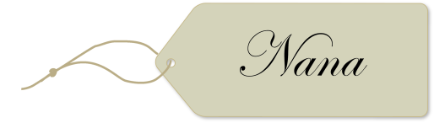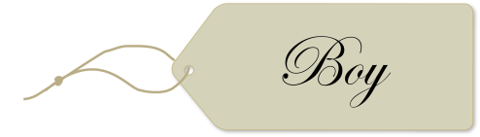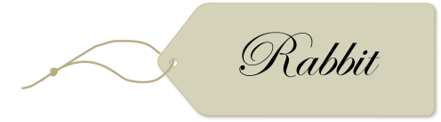

Listening skills

|  |
| --- |
| Unit 3 – The Little Mermaid |

Teaching notes

Starter:

* **Pick a stick:** Invite all the children to stand in a circle, then display the words, ‘Once upon a time’ on the interactive whiteboard. Do the children recognise this phrase? What genre does it come from? Elicit that this is a conventional opening for a fairy tale. Using a pot of lollipop sticks, or name cards with children’s names on, pick one out to choose a child. The chosen child must state another ‘ingredient’ for a fairy tale (e.g. a curse from a fairy/witch; talking animals; orphaned children). Once they have said something, they may sit down. Continue like this until all the children are sitting down, or until they have exhausted their ideas!

Main activities:

* **Main teaching activity:** Ask children to work in pairs to read the**extract** aloud to one another, taking turns to read alternate paragraphs. Remind them that they may choose to use a highlighter or a pencil to pick out key information from the extract. Now provide each child with a copy of the **comprehension questions** and ask them to work through the questions individually (you may wish to pair lower ability children together, or provide them with an adult support).
* **Pupil activity one:** Ask the children: *what is a simile?* Draw out that it is a way of describing something by comparing it to something else with a shared quality. Ask the children to give a few examples, and record them on the interactive whiteboard for reference. Now ask the children to work through the **extract** in pairs, writing any similes they find on **Resource 1 – Underwater similes****.** What is each simile describing? The children should discuss this in their pairs, and write their answer in the second column of **Resource 1 – Underwater similes****.** Take feedback from the class. Why do they think that the author chose to use ‘as light as a bubble’ to describe the way the little mermaid swam, rather than ‘as light as a feather’? Draw out that we associate bubbles with water, and so this image works better than that of a feather because it helps us to build a picture of the little mermaid’s underwater world.
* **Pupil activity two:** In the story, each sea-princess is allowed to visit the surface of the water on her fifteenth birthday. They return to the sea-kingdom with stories of what they have seen: ‘*feathered fish that swam through the air, and of strange wooden whales that floated on the surface of the water, and of a huge round shell that burned in the sky as brightly as lava that bursts from underwater volcanoes.’* Ask children to find this passage in the third paragraph of the extract and ask them to work in groups to decide what they think the mermaids have seen above the water (if pupils have completed the main activity comprehension task, they should already have begun to think about this). Take feedback. Establish that the mermaids are talking about birds, ships and the sun – but because they don’t know what these above-water objects are, they are describing them in terms of objects that are familiar to them, such as fish, whales and shells! What did the children think about this part of the story? Which of the words and phrases captured their imagination?

Now provide each child with a copy of **Resource 2 – Through the eyes of a mermaid**. Explain that their task is to describe some more above-water objects as if they were being seen by a mermaid for the first time. What would the mermaid think that the objects are? Remind the children that they also need to think about what underwater object the mermaid would compare this new object to. Higher ability children could think of some objects of their own to describe.

Plenary:

* **Retell the story:** Sit the children in a circle and explain that they are going to retell the story of *The Little Mermaid* as well as they can remember it. Tell them not to worry about getting the wording exactly right, or if they accidentally mix up the story with a version of *The Little Mermaid* that they’ve read or heard before. Explain that fairy and folk tales are in the *oral tradition*, which means that they are often passed down through generations by parents telling them to their children, without writing them down – so details often get tweaked or missed out! Ask them to listen carefully to the person speaking before them, and see if they can follow on with a sentence or two that they think comes next in the story. As an extra challenge, they could try to work together to make sure that the story finishes with the last person in the circle left to speak! Taking it further:
* **Story baskets:** What five props would the children put into a story basket to help them retell the story of *The Little Mermaid*? Take feedback and discuss the value of each prop suggested. Challenge groups of children to put together story baskets to help them retell a fairy tale of their choice. Can the class guess which fairy tale the other groups have chosen by looking at the props they have gathered in their story basket? Encourage the groups to use the props to tell their chosen story to the class. Can a child who has listened to one of the groups tell their story then go on to use the props to retell that story themselves another day?
* **Home learning activity:** Ask the children to find a lesser-known fairy or folk tale to bring in to share with the class. This could be a tale from old mythology, or perhaps from a different culture or tradition, e.g. Japanese or South American. They might find their fairy tale in the library, in an anthology at home, or perhaps on the internet. Allow a little time each day for the children to take turns to retell their tale to the class.

The Little Mermaid – extract abridged by Gabbie Chant

|  |
| --- |
| Far, far away from here, there once was an ocean that was deeper than man can measure. Above the surface, the water looked as dark as ink and as cold as glass, and it seemed a lonely and dangerous place. But deep beneath the waves – ah, that was a different story. Right down in the depths of the water, a thousand times deeper than any living human had ever dived, there lay a castle.  The castle was hidden behind forests of tangled seaweed, and guarded by fish of such curious and startling colours that you and I would gasp to see them. Its walls and turrets were fashioned from shells and crab claws and coral, and within its halls there stood a throne carved from an enormous pearl – and on that throne there sat a sea-king. He was a good and wise ruler, but a great sadness lay heavy on his heart: his queen had died, many years before. All that he had left to remember her was their six lovely daughters – six sea-princesses, who, just like their father, had no legs. Each of their bodies ended in a fish’s tail.  Now, it was a custom of the kingdom that when each of the sea-princesses had their fifteenth birthday, they were permitted to swim to the surface of the ocean, to look upon the world above the water for a single day. The five eldest sea-princesses had each already had this privilege. They had returned to the castle with stories of feathered fish that swam through the air, and of strange wooden whales that floated on the surface of the water, and of a huge round shell that burned in the sky as brightly as lava that bursts from underwater volcanoes.  The littlest sea-princess listened to her elder sisters’ stories, and she longed for the day that she too would turn fifteen and be able to rise to the ocean’s surface. She spent her days using stones and seaweed to make pictures on the seabed of all her sisters had told her, and at night she dreamed of feeling the warmth of that bright round shell on her skin.  At long last, the little mermaid’s fifteenth birthday arrived. Up, up she swam through the water, as light as a bubble. The higher she rose, the brighter the blue of the ocean became, and the water grew less and less cold – until at last, the tips of her fingers broke the surface of the water and she emerged, glittering with salt water, into the mild sea air.  And – oh! – what was this gigantic dark shape before her? A huge floating creature made of wood, just as her sisters had described, with vast white fins! And what a great noise it was making! The creak of its bones as it moved towards her! And its voice – like a hundred different voices, all shouting at once!  Would it eat her?  The little sea-princess shrank back into the sea until just her eyes and the top of her head peeped out above the surface of the water. She looked as sleek as a seal, bobbing there in the waves, with her hair wet against her skull. She held her breath and watched with a fast-beating heart as the creature drew ever closer. |

Comprehension questions

Name: Date:

1. Name **two** of the items the sea-king’s castle was made from.

4. Why was the sea-king sad?

1. Look at the paragraph which begins: ‘*Now, it was a custom in the kingdom …’*

Find and copy a word that means **allowed**.

1. *Now, it was a custom in the kingdom* …

Circle the word closest in meaning to **custom**.

|  |  |  |  |
| --- | --- | --- | --- |
| tradition | punishment | shopper | curse |

1. *‘They had returned to the castle with stories of feathered fish that swam through the air …’*

What were the ‘feathered fish’ that the sea-princesses saw?

1. Look at the paragraph which begins: ‘*The littlest sea-princess listened …’*

Find and copy the word that tells you she wanted something very much.

1. *‘A huge floating creature made of wood, just as her sisters had described, with vast white fins!’*

What is the ‘creature’ that the little mermaid is afraid of?

1. Put the following events in order. The first one has been done for you:

|  |  |  |
| --- | --- | --- |
|  |  | The little mermaid turns fifteen. |
|  | 1 | The sea-queen dies. |
|  |  | A strange creature frightens the youngest sea-princess. |
|  |  | The five older sea-princesses tell stories about the world above the surface. |
|  |  | The youngest sea-princess swims to the surface. |

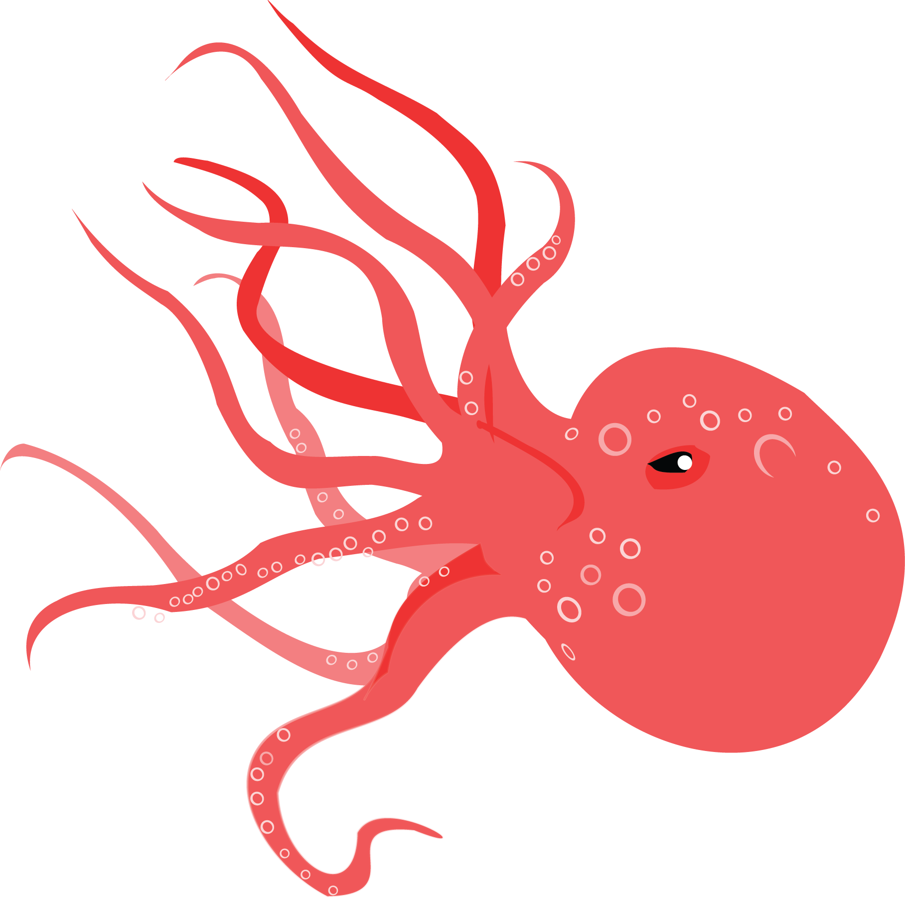

Comprehension answers

1. Name **two** of the items the sea-king’s castle was made from.

**Any two of:**

|  |  |
| --- | --- |
| 1. **shells** | 1. **crab claws** |
| 1. **coral.** |  |

1. Why was the sea-king sad?

**Because his wife, the queen, had died many years before.**

1. Look at the paragraph which begins: ‘*Now, it was a custom in the kingdom …’*

Find and copy a word that means **allowed**.

**Permitted.**

1. *‘Now, it was a custom in the kingdom* …’

Circle the word closest in meaning to **custom**.

|  |  |  |  |
| --- | --- | --- | --- |
| **tradition** | punishment | shopper | curse |

1. *‘They had returned to the castle with stories of feathered fish that swam through the air …’*

What were the ‘feathered fish’ that the sea-princesses saw?

**Birds.**

1. Look at the paragraph which begins: ‘*The littlest sea-princess listened …’*

Find and copy the word that tells you she wanted something very much.

**Longed.**

1. *‘A huge floating creature made of wood, just as her sisters had described, with vast white fins!’*

What is the ‘creature’ that the little mermaid is afraid of?

**A ship.**

1. Put the following events in order. The first one has been done for you:

|  |  |  |
| --- | --- | --- |
|  | **3** | The little mermaid turns fifteen. |
|  | **1** | The sea-queen dies. |
|  | **5** | A strange creature frightens the youngest sea-princess. |
|  | **2** | The five older sea-princesses tell stories about the world above the surface. |
|  | **4** | The youngest sea-princess swims to the surface. |

Resource 1 – Underwater similes

Name: Date:

Look through *The Little Mermaid* **extract** for similes, and write each simile you find in the first column. Now write what the simile is describing in the second column.

|  |  |
| --- | --- |
| Simile | What the simile is describing |
|  |  |

Underwater similes - answers

|  |  |
| --- | --- |
| Simile | What the simile is describing |
| as dark as ink  as cold as glass  as brightly as lava  as light as a bubble  like a hundred different voices  as sleek as a seal | the look of the water from above  the look of the water from above  the way the huge, round shell burned in the sky  the little mermaid  the sound of the huge, floating wooden creature  the way the little mermaid looked |

Resource 2 – Through the eyes of a mermaid

Name: Date:

|  |  |  |
| --- | --- | --- |
| Object | Ideas of what the mermaid might think it is / compare it to | Description |
| Shoes |  |  |
| A horse |  |  |
| A tea cup |  |  |
| An oak tree |  |  |
| A pair of glasses |  |  |

Listening skills

|  |
| --- |
| Unit 4 – Robin Hood |

Teaching notes

Starter:

* **Dictionary race:** Provide pairs of children with dictionaries, and tell them that they are being challenged to a dictionary race! You will provide a word, and they will need to work together to find the definition as fast as possible. The fastest pair to locate and read out each definition from the dictionary will be declared the winners. Play the game using the following words: *thicket*, *archer, outlaw, peasant, tax, sheriff.* Once the game has been completed, ask the children: can they guess from the words which legend is the subject of our lesson today?

Main activities:

* **Main teaching activity:** Ask children to work in pairs to read the**extract** aloud to one another, taking turns to read alternate paragraphs. Remind them that they may choose to use a highlighter or a pencil to pick out key information from the extract. Now provide each child with a copy of the **comprehension questions** and ask them to work through the questions individually (you may wish to pair lower ability children together, or provide them with an adult support).
* **Pupil activity one:**  Divide children into groups of three, and explain that their task is to retell the Robin Hood story *in their own words*. They don’t need to worry about getting it exactly the same as the extract – in the time of Robin Hood, most people wouldn’t have been able to read and write and so they would have told stories orally, passing them from person to person. Inevitably, this would mean that the story got changed or embellished with each retelling! Ask the children to use **Resource 1 – Retelling Robin Hood** to help them gather their ideas for the retelling. What events can they remember from the extract? What attention-grabbing vocabulary are they going to put into their retelling, to excite their audience? How are they going to divide the story up among themselves – will one child narrate while the other two retell the dialogue, or will they split the story into beginning, middle and end? Allow plenty of time for the children to rehearse their retelling before they share their version of the Robin Hood story with the class.
* **Pupil activity two:** Provide each child with a copy of **Resource 2 – Robin Hood’s arrows**. Explain that their task is to fill Robin Hood’s quiver with arrows – by searching for words and phrases in the **extract** that describe how Robin Hood feels and behaves, and writing them on the dotted lines of the arrow shafts. How many arrows can they complete? (You may wish to pair lower ability children to support each other in completing this task.)

Plenary:

* **Predictions:** What do the children think happened next in the fight between Robin Hood and the stranger? Ask them to work in talking partners to predict what might happen next in the story. Take feedback, ensuring that the children give reasons for their predictions. You may wish to reveal what actually happens at the end of the story: that the stranger knocks Robin Hood into the water and wins the fight! Once Robin has climbed out onto the bank, he shakes hands with the stranger and makes friends with him. The stranger turns out to be Little John, who becomes one of Robin’s greatest allies.

Taking it further:

* **Soundtrack:** Ask the children: what is a soundtrack? Establish that it is music that accompanies a film, which helps to convey the atmosphere of the story. Ask groups of children to imagine they have been asked by a film company to compose a soundtrack for the events in the **extract**. What instruments will they use? How will they create the atmosphere of the forest in springtime? How will they create a feeling of tension when Robin meets the stranger on the bridge? If they like, they may also choose to write lyrics to accompany their composition.
* **Home learning activity:** There are many stories about the legend of Robin Hood. Challenge the children to research another tale of Robin Hood and retell it in any way they choose. They may like to make a recording of themselves telling the story orally, or they could make an animation of the tale, or they could even bring in props to help them retell the story ‘live’ in front of the class.

Robin Hood – extract



|  |
| --- |
| It happened on a bright sunshiny day in early spring. All through the winter Robin and his men had had a very dull time. Nearly all their fun and adventures happened with people travelling through the forest. As there were no trains, people had to travel on horseback. In winter the roads were bad, and the weather so cold and wet, that most people stayed at home. So it was rather a quiet time for Robin and his men. They lived in great caves during the winter, and spent their time making stores of bows and arrows, and mending their boots and clothes.  This bright sunshiny morning Robin felt dull and restless, so he took his bow and arrows, and started off through the forest in search of adventure.  He wandered on for some time without meeting any one. Presently he came to a river. It was wide and deep, swollen by the winter rains. It was crossed by a very slender, shaky bridge, so narrow, that if two people tried to pass each other on it, one would certainly fall into the water.  Robin began to cross the bridge, before he noticed that a great, tall man, the very tallest man he had ever seen, was crossing too from the other side.  “Go back and wait until I have come over,” he called out as soon as he noticed the stranger.  The stranger laughed, and called out in reply, “I have as good a right to the bridge as you. You can go back till I get across.”  This made Robin very angry. He was so accustomed to being obeyed that he was very much astonished too. Between anger and astonishment he hardly knew what he did.  He drew an arrow from his quiver, and fitting it to his bow, called out again, “If you don’t go back I’ll shoot.” |

|  |  |
| --- | --- |
| “If you do, I’ll beat you till you are black and blue,” replied the stranger.  “You talk like an ass,” said Robin Hood.  “If I talk like an ass you talk like a coward,” replied the stranger. “Do you call it fair to stand with your bow and arrow ready to shoot at me when I have only a stick to defend myself with? I tell you, you are a coward. You are afraid of the beating I would give you.”  Robin was not a coward, and he was not afraid. So he threw his bow and arrows on the bank behind him.  “You are a big, boastful bully,” he said. “Just wait there until I get a stick. I hope I may give you as good a beating as you deserve.”  The stranger laughed. “I won’t run away; don’t be afraid,” he said.  Robin Hood stepped to a thicket of trees and cut himself a good, thick oak stick. While he was doing this, he looked at the stranger, and saw that he was not only taller but much stronger than himself.  However, that did not frighten Robin in the least. He was rather glad of it indeed. The stranger had said he was a coward. He meant to prove to him that he was not. |  |
| Back he came with a fine big stick in his hand and a smile on his face. The idea of a real good fight had made his bad temper fly away, for, like King Richard, Robin Hood was rather fond of a fight.  “We will fight on the bridge,” said he, “and whoever first falls into the river has lost the battle.”  “All right,” said the stranger. “Whatever you like. I’m not afraid.” |
|  | |

Comprehension questions

Name: Date:

1. Name **two** reasons why people did not travel through the forest in winter.

4. How did Robin and his men spend their time in winter? Name **one** activity.

1. Look at the paragraph which begins: *‘He wandered on …’*

Find and copy a word which means **unsteady.**

1. Why was Robin astonished when the stranger told him to go back?

1. *‘You are a big, boastful bully …’*

Circle the word closest in meaning to **boastful**.

|  |  |  |  |
| --- | --- | --- | --- |
| unkind | ugly | bragging | frightening |

1. Why does the stranger think that Robin is being unfair?

1. *‘Robin Hood was rather fond of a fight.’*

Explain in your own words what this means.

1. Put the following events in order. The first one has been done for you:

|  |  |  |
| --- | --- | --- |
|  |  | Robin went off through the forest in search of adventure. |
|  |  | The stranger agrees to fight on the bridge. |
|  |  | Robin threatens to shoot the stranger with his bow and arrow. |
|  | 1 | Robin and his men lived in caves during the winter. |
|  |  | A tall man begins to cross the bridge. |

Comprehension answers

1. Name **two** reasons why people did not travel through the forest in winter.

**The roads were bad and the weather was cold and wet.**

1. How did Robin and his men spend their time in winter? Name **one** activity.

|  |
| --- |
| 1. **making stores of bows and arrows** |
| 1. **mending their boots and clothes.** |

1. Look at the paragraph which begins: *‘He wandered on …’*

Find and copy a word which means **unsteady.**

**Shaky**

1. Why was Robin astonished when the stranger told him to go back?

**Because he was accustomed to being obeyed.**

1. *‘You are a big, boastful bully …’*

Circle the word closest in meaning to **boastful**.

unkind ugly  **bragging** frightening

1. Why does the stranger think that Robin is being unfair?

**Because Robin is armed with a bow and arrow, while the stranger only has a stick.**

1. *‘Robin Hood was rather fond of a fight.’*

Explain in your own words what this means.

**That Robin enjoys fighting.**

1. Put the following events in order. The first one has been done for you:

|  |  |  |
| --- | --- | --- |
|  | 2 | Robin went off through the forest in search of adventure. |
|  | 5 | The stranger agrees to fight on the bridge. |
|  | 4 | Robin threatens to shoot the stranger with his bow and arrow. |
|  | 1 | Robin and his men lived in caves during the winter. |
|  | 3 | A tall man begins to cross the bridge. |

Resource 1 – Retelling Robin Hood

Name: Date:

Write a brief summary of the events from the story in the boxes below:



Fill the tree with exciting vocabulary to use in your retelling.



Make notes on the faces to show which member of your group is responsible for which part of the retelling.



Resource 2 – Robin Hood’s arrows

Name: Date:

Read through the extract to find words or phrases that describe how Robin Hood **feels** or **behaves**.

Write them onto the dotted lines of the arrow shafts below.

How many arrows can you complete?

|  |  |
| --- | --- |
|  |  |
|  |  |
|  |  |
|  |  |
|  |  |
|  |  |
|  |  |
|  |  |
|  |  |
|  |  |

Listening skills

|  |
| --- |
| Unit 5 – Four Square |

Teaching notes

Starter:

* **Instructions for a Stone Age time traveller:** What do we call a text that tells us how to do something? Instructions! Put the children into pairs and label them ‘A’ and ‘B’. Explain that all the ‘A’s now need to imagine that they are time travellers from the Stone Age who know nothing about modern life. Challenge the ‘B’s to give their partner verbal instructions to carry out an everyday task – such as putting on a pair of socks, or using a pencil to write a word. The ‘A’s must listen carefully to their partner and *only* do *exactly* as they are instructed. Will their partner’s instructions be good enough, or will our Stone Age time travellers end up in a muddle? Take feedback from the class on their successes and difficulties.

Main activities:

* **Main teaching activity:** Take the children out into the playground and divide them into groups of five or more. Explain that they are going to be reading and following an instruction text on how to play a game. Provide each group with a few copies of the **instructions** – enough for the children to all be able to see a copy easily. Leave chalk (for marking out the Four Square courts) and balls ready for the children to access. If you are playing inside in a hall, the children could use low-tack masking tape to mark out the grids instead of chalk. Allow plenty of time for the children to read the instructions and try out playing the game. Gather the children back together. What did they find useful about the instructions? Did anything confuse them? Do they have any ideas for how the instructions could be improved?
* **Pupil activity one:** Provide each child with a copy of the**instructions** and the **comprehension questions**. Remind them that they may choose to use a highlighter or a pencil to pick out key information from the extract. Ask them to work through the questions individually (you may wish to pair lower ability children together, or provide them with an adult support).
* **Pupil activity two:** Provide a wide range of everyday instruction texts for the children to examine – for example, a leaflet on how to assemble a toy, a board game rule book, a TV manual, a recipe book, etc. Provide each child with a copy of **Resource 1 – Instruction text detectives** and explain that they must now don their detective hats and search for examples of instruction text features in these real-life texts! To differentiate this activity, you could challenge higher ability children to find more examples per feature, and also to explain in their own words why each feature is useful for an instruction text.

Plenary:

* **Order of importance:** Recap the features of an instruction text from **Resource 1 – Instruction text detectives**. Ask the children to work in pairs to list the features in order of their importance, from most to least important. Take feedback, encouraging the pairs to share their reasoning.

Taking it further:

* **Instructions for a fantasy sport:** J.K. Rowling famously invented a new sport for her wizarding pupils to play in Harry Potter – Quidditch. It had its own special equipment (a golden snitch, bludgers, broomsticks, etc.), terminology (a chaser, a beater), and rules (the game ends when the snitch is caught). Ask the children to invent their own fantasy sport, and then write an instruction text on how to play it. This would be an excellent task for mixed-ability pairs or groups.
* **Home learning activity:** Challenge the children to ask an adult at home to help them to find an example of a suitable instruction text to follow for themselves. It might be a recipe, or instructions to maintain or set up a piece of household equipment. Ask the children to document their experience and be prepared to give a short presentation about it to the class.

Instructions for Four Square

How to play Four Square

**About Four Square:**

The game is called ‘Four Square’ because the court is made up of four squares! Each square is ranked 1 – 4, with 1 being the highest ranking. The object of the game is to occupy the highest ranked square for as long as possible.

**You will need:**

* five or more players
* a large ball such as a volleyball or basketball
* a hard surface to play on
* chalk.

|  |  |  |  |
| --- | --- | --- | --- |
| 1. First, you will need to use the chalk to mark out a court of four equal squares. The lines around the squares are the boundaries. Number the squares 1 – 4. The finished court should look like the diagram to the right. 2. The first four players should begin the game by standing in one of the four squares. Any remaining players should stand in line beside the game, waiting their turn. |  | **1** | **2** |
|  | **3** | **4** |

1. The player in square 1 serves the ball. To serve the ball, they must drop it and allow it to bounce before hitting it to square 4.
2. The player in square 4 must allow the ball to bounce once in their square before hitting the ball to the square of their choice.
3. Continue play in this way, with each player allowing the ball to bounce once in their square before hitting it to another square.
4. When a player is eliminated, they must leave the game and join the back of the line of waiting players. The remaining players should move up a square to fill any gaps, leaving a space in square 4. The waiting player at the front of the line steps into square 4.
5. Each time a player is eliminated, the player standing in square 1 may make up their own additional rule!

Rules:

* You may only use your hands to hit the ball.
* You may not catch, carry or hold the ball.
* You can move anywhere on the court.
* You are only allowed to hit the ball when it lands in your square.

Elimination:

**You will be eliminated from the game if:**

* you hit the ball outside the playing area
* you fail to hit the ball into another player’s square
* you allow the ball to bounce more than once in your own square
* you hit the ball when it’s not your turn
* you hit the ball with a part of your body other than your hands
* you hit the ball and it touches one of the inside boundary lines. (If it touches an outside boundary line, it is still in play.)

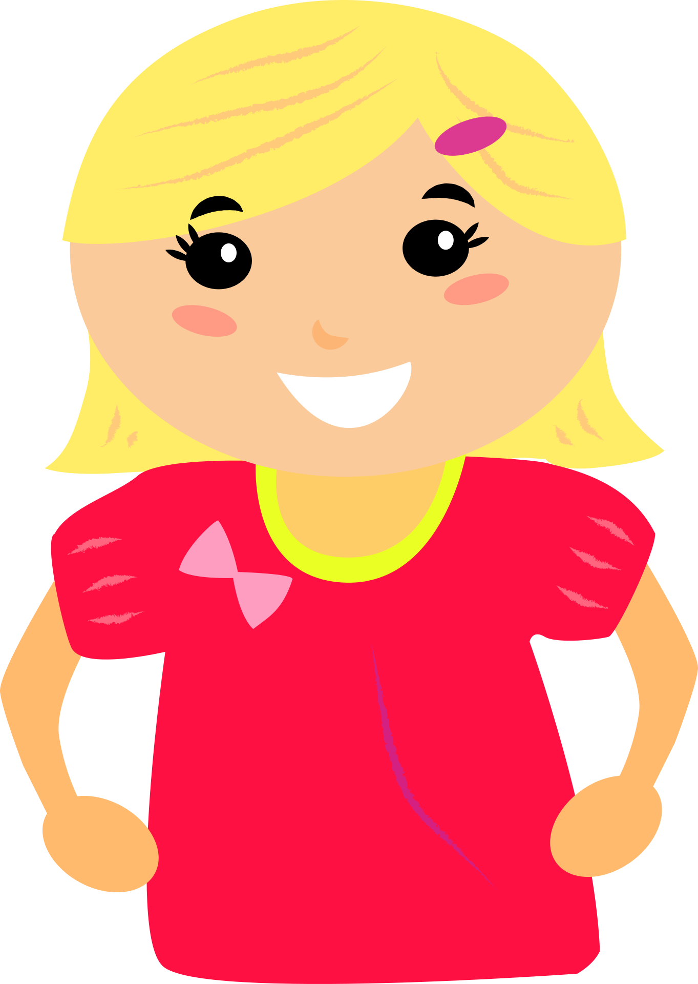 

Comprehension questions

Name: Date:

1. How many players are needed for a game of Four Square?

1. Which number square is the highest ranking?

1. What equipment do you need to play the game? Name **two** items.

4. What is the first thing you need to do to set up the game?
5. *‘When the player is eliminated …’*

Circle the word or phrase closest in meaning to **eliminated**.

|  |  |  |  |  |  |  |  |
| --- | --- | --- | --- | --- | --- | --- | --- |
|  | included |  | knocked out |  | lined up |  | excited |

1. When is it possible to make up a new rule for the game?
2. Name **one** reason a player might be eliminated from the game.
3. Tick **true** or **false** in the following table to show what happens during a game of Four Square:

|  |  |  |
| --- | --- | --- |
|  | **True** | **False** |
| The player in square 1 serves the ball. |  |  |
| You can hit the ball with any part of your body. |  |  |
| A player can move anywhere on the court. |  |  |
| You must not allow the ball to bounce in your square. |  |  |

Comprehension answers

1. How many players are needed for a game of Four Square?

**Five or more.**

1. Which number square is the highest ranking?

**1.**

1. What equipment do you need to play the game? Name **two** items.

**Any two of:**

|  |  |
| --- | --- |
| **chalk** | **a hard surface** |
| **a large ball** | **five or more players** |

1. What is the first thing you need to do to set up the game?

**Draw out the court.**

1. *‘When the player is eliminated …’*

Circle the word or phrase closest in meaning to **eliminated**.

|  |  |  |  |  |  |  |  |
| --- | --- | --- | --- | --- | --- | --- | --- |
|  | included | **X** | **knocked out** |  | lined up |  | excited |

1. When is it possible to make up a new rule for the game?

**When a player is eliminated.**

1. Name **one** reason a player might be eliminated from the game.

**Any one of:**

|  |  |
| --- | --- |
| **You hit the ball outside the playing area.** | **You hit the ball when it’s not your turn.** |
| **You fail to hit the ball into another player’s square.** | **You hit the ball with a part of your body other than your hands.** |
| **You allow the ball to bounce more than once in your own square** | **You hit the ball and it touches one of the inside boundary lines. (If it touches an outside boundary line, it is still in play.)** |

1. Tick **true** or **false** in the following table to show what happens during a game of Four Square:

|  |  |  |
| --- | --- | --- |
|  | **True** | **False** |
| The player in square 1 serves the ball. | **X** |  |
| You can hit the ball with any part of your body. |  | **X** |
| A player can move anywhere on the court. | **X** |  |
| You must not allow the ball to bounce in your square. |  | **X** |

Resource 1 – Instruction text detectives

Name: Date:

Can you search through some everyday instruction texts to find examples of the features below?

|  |  |
| --- | --- |
| ­­**Imperative (‘bossy’) verbs**  *(e.g. ‘mix the ingredients’, ‘continue to play’, ‘put it inside’)* |  |
| **Time connectives**  *(e.g. ‘first’)* |  |
| **Adverbs**  *(e.g. ‘gently’)* |  |
| **Sub-headings** |  |
| **Diagrams**  *(This might also be helpful photographs or illustrations.)* |  |
| **Materials list**  *(e.g. parts required for assembly; ingredients for a recipe)* |  |
| **Extras**  *(e.g. helpful tips; warnings)* |  |

Listening skills

|  |
| --- |
| Unit 6 – A letter |

Teaching notes

Starter:

* **Reasons for writing a letter:** Prepare copies of the **letter**in sealed envelopes with Mrs Halloway’s address on the outside. Give one prepared envelope to each pair of children, and tell them that they may examine the outside of the envelope but they may not yet open it. Ask: *what reasons might someone have to write a letter to this lady?* Encourage the children to look at the address for clues. Give the children a few minutes to discuss, then take feedback. They may offer ideas such as: an inventor who has come up with an idea for a new sweet, an ingredients supplier sending a bill, etc.

Main activities:

* **Main teaching activity:** Allow the pairs to open their envelopes and read the **letter** inside. Ask: *what type of letter is this?* Draw out that it is a letter of complaint. What words and phrases has the writer of the letter used to capture the reader’s attention? Ask the pairs to read the letter through again, highlighting all such words and phrases. Take feedback and discuss. Ensure that the discussion covers the writer’s emotional appeals to the reader (‘Imagine her surprise’; ‘the distress caused’), the use of questions (‘Surely this is a step too far?’), use of powerful adjectives (‘revolting taste’; ‘misleading adverts’). Use these to build a class word bank of attention-grabbing words and phrases. Can the children think of any of their own?
* **Pupil activity one:** Provide each child with a copy of the**letter** and the **comprehension questions**. Remind them that they may choose to use a highlighter or a pencil to pick out key information from the extract. Ask them to work through the questions individually (you may wish to pair lower ability children together, or provide them with an adult support).
* **Pupil activity two:** Tell the children that now they have thoroughly examined the letter of complaint, their job is to write a response from Mrs Halloway herself. Provide each child with a copy of **Resource 1 – A letter in reply**, and ask them to use this writing frame to help them come up with a letter which replies to the points Ms Watson makes in her original letter.

Plenary:

* **Letters in everyday life:** Start a class discussion on real-life letters the children have sent and received. Have any of them ever written to a celebrity? Did they receive a response? Have they sent or received postcards? Where in the world were the postcards from? Do they write thank you letters for presents? Have they ever received a thank you letter themselves? What does it feel like to read your name on the envelope of a letter and realise it’s for you?

Taking it further:

* **Class post box:** Set up a class post box for the children to ‘post’ letters to one another. It would be good to also provide a stack of inexpensive envelopes and some paper cut to A5 size nearby, for the children to compose their letters. Display **Resource 2 – Letter-writing ideas**near the post box, to give the class some letter-writing inspiration. Make sure the children understand that they must not put anything unkind in their letters. Appoint a child to be the class post-person, and have them hand out the letters every day at the start of quiet reading time.
* **Home learning activity:** Ask the children to write a letter to anyone of their choice – it could be a family member, a famous sportsperson, a character in a book, the Prime Minister – absolutely anyone! Ask them to ensure they lay out their letter correctly, and that they use words and phrases to capture their reader’s interest. They could bring in their letter to show the class – or they could actually post it to the person they’ve written it to. If the children get any responses to their letters, these would make a lovely and inspiring display of the real-life benefit of letter-writing.

A letter



3 Greenwood Road

Edinville

Shropshire

SH49 3WV

Mrs L. Halloway

Manager

Epic Sweets Ltd.

Unit 352

Sugarton Industrial Estate

Sugarton

SU52 8EP

Wednesday 4th October 2017

Dear Mrs Halloway,

I am writing about a product of yours that my eight-year-old daughter, Lola, purchased recently. Lola had seen your Almighty Chewing Gum advertised on television and she was very impressed by your claims that it was the ‘tastiest yet’ and ‘the healthiest chewing gum around’. She decided to spend some of her pocket money to buy a stick of the gum for herself, as well as one for her best friend, Oskar.

Imagine her surprise when, on trying the gum, she found that it did not taste of mint as she had expected. Instead, she found that it tasted of overcooked broccoli! Now, my daughter is not a fussy child. She understands that it is important to consume vegetables as part of a healthy balanced diet. But chewing gum that tastes of broccoli? Surely this is a step too far?

Similarly, when Lola’s friend Oskar tried his stick of Almighty Chewing Gum, he discovered that it had an extremely strong asparagus flavour. Unfortunately, Oskar is a much fussier eater than my daughter. I am afraid to report that the revolting taste of his chewing gum actually caused him to vomit on the spot.

Frankly, I am appalled. Why did your advertisement not make it clear that your chewing gum would not taste of the typical mint flavour? You have tricked an innocent child into wasting her money on foul-tasting sweets. I think this is nothing less than daylight robbery!

I have two requests for you now. Firstly, I would like you to stop broadcasting your misleading adverts. Secondly, I would like to know what compensation you are going to offer Lola and Oskar for the distress caused.

I look forward to hearing from you very soon.

Yours sincerely,

Ms P. Watson

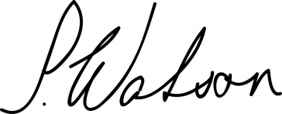

Comprehension questions

Name: Date:

1. In which county does Ms P. Watson live?

1. What is the name of Lola’s best friend?

1. What claims did the advert make about Almighty Chewing Gum? Name **one**.

1. *‘She understands that it is important to consume vegetables …’*

Circle the word closest in meaning to **consume**.

|  |  |  |  |
| --- | --- | --- | --- |
| chop | choose | cook | eat |

1. What happened to Oskar when he tried the chewing gum?

1. What does Ms Watson think was wrong about Mrs Halloway’s advert?

1. Look at the paragraph which begins: *‘Frankly, I am …’*

Find and copy a word which means **normal.**

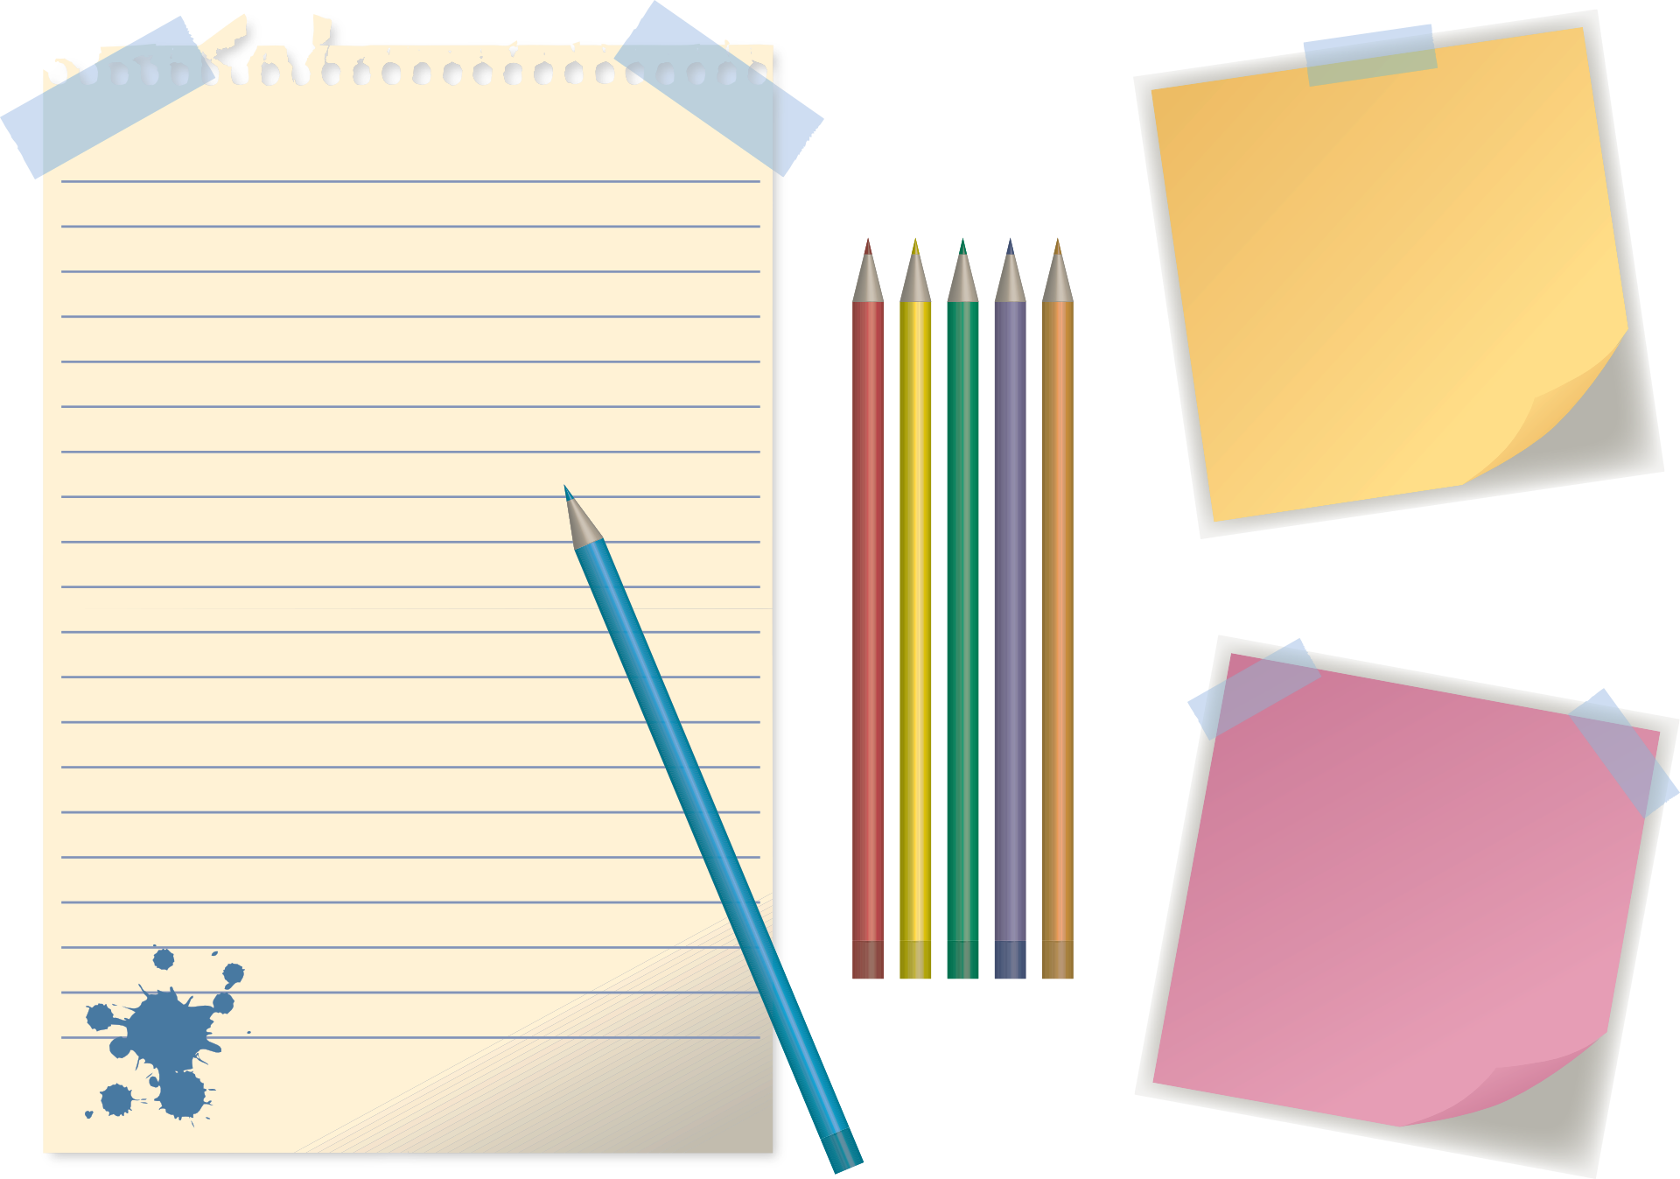

1. Using information from the text, tick one box in each row to show whether each statement is a **fact** or an **opinion**:

|  |  |  |
| --- | --- | --- |
|  | **Fact** | **Opinion** |
| Lola bought two sticks of chewing gum. |  |  |
| It is a step too far to have chewing gum which tastes of broccoli. |  |  |
| The chewing gum had a revolting taste. |  |  |

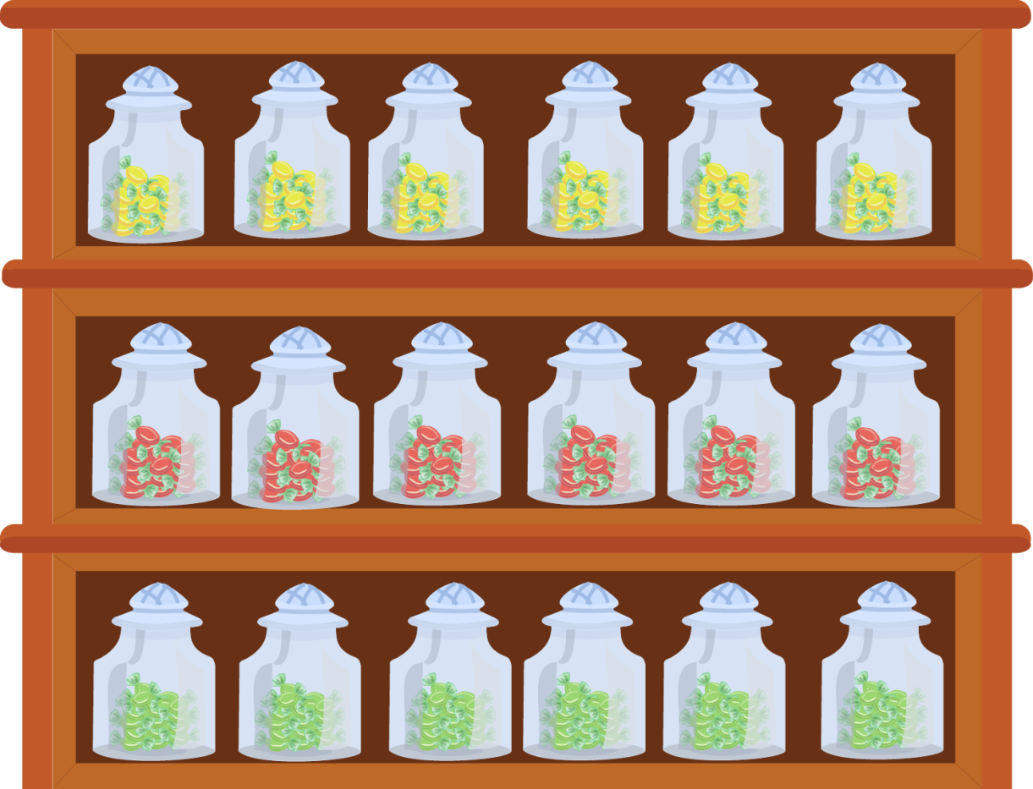

Comprehension answers

1. In which county does Ms P. Watson live?

**Shropshire**

1. What is the name of Lola’s best friend?

**Oskar**

1. What claims did the advert make about Almighty Chewing Gum? Name **one**.

**Either:**

|  |  |
| --- | --- |
| 1. **it’s the ‘tastiest yet’** | 1. **it’s ‘the healthiest chewing gum around’** |

1. *‘She understands that it is important to consume vegetables …’*

Circle the word closest in meaning to **consume**.

chop choose cook  **eat**

1. What happened to Oskar when he tried the chewing gum?

**He vomited.**

1. What does Ms Watson think was wrong about Mrs Halloway’s advert?

**Ms Watson thinks that the advert should have made it clear that the chewing gum would not taste of mint.**

1. Look at the paragraph which begins: *‘Frankly, I am …’*

Find and copy a word which means **normal.**

**Typical.**

1. Using information from the text, tick one box in each row to show whether each statement is a **fact** or an **opinion**:

|  |  |  |
| --- | --- | --- |
|  | **Fact** | **Opinion** |
| Lola bought two sticks of chewing gum. | **X** |  |
| It is a step too far to have chewing gum which tastes of broccoli. |  | **X** |
| The chewing gum had a revolting taste. |  | **X** |

Resource 1 – A letter in reply

Name: Date:

Imagine you are Mrs Halloway, the manager of Epic Sweets Ltd. Can you write a response to Ms Watson’s letter of complaint?

(Think: when was the original letter dated?)

**Dear**

Your recipient’s name and address

**Date**

Your address

**Paragraph 1:**

**Paragraph 2:**

**Paragraph 3:**

*Explain why you are writing*.

*Defend your company’s product and its advertisement.*

*Are you going to do as Ms Watson asks? Why / why not?*

Yours sincerely,

Mrs L. Halloway

Manager

Epic Sweets Ltd.

Resource 2 – Letter-writing ideas

* Write a letter to tell someone all the things you like best about them, and the reasons why you are glad they are in your class.
* Write a letter which tells a funny story about something which really happened to you.
* Write a letter which asks for help with a problem you have.
* Write a letter to thank somebody for something nice they have done for you.
* Write a letter to someone in your class that you don’t know very well, asking questions to help you get to know them better.
* Write a letter explaining what happened on an exciting trip you took recently.
* Write a letter telling someone what your dream job would be. Ask them about their dream job too!
* Write a letter including some interesting facts that you’ve found out, and send it to someone who you think would be interested.
* Write a letter to congratulate someone on something they have achieved.
* Write an encouraging letter to someone who you think might be having a hard time.
* Send a good joke to someone who you think will enjoy a laugh!

