Wednesday Fractions Halving amounts extension
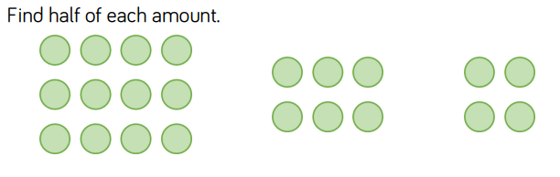

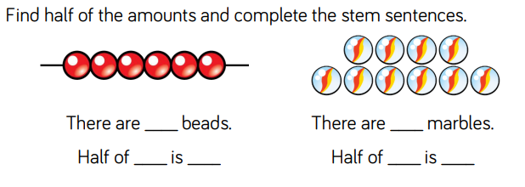

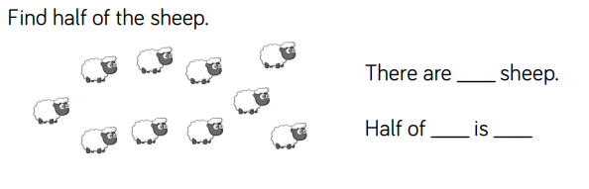
Work out these halves using bar models.
Half of 14 is

½ of 12 is

½ of 24 is

