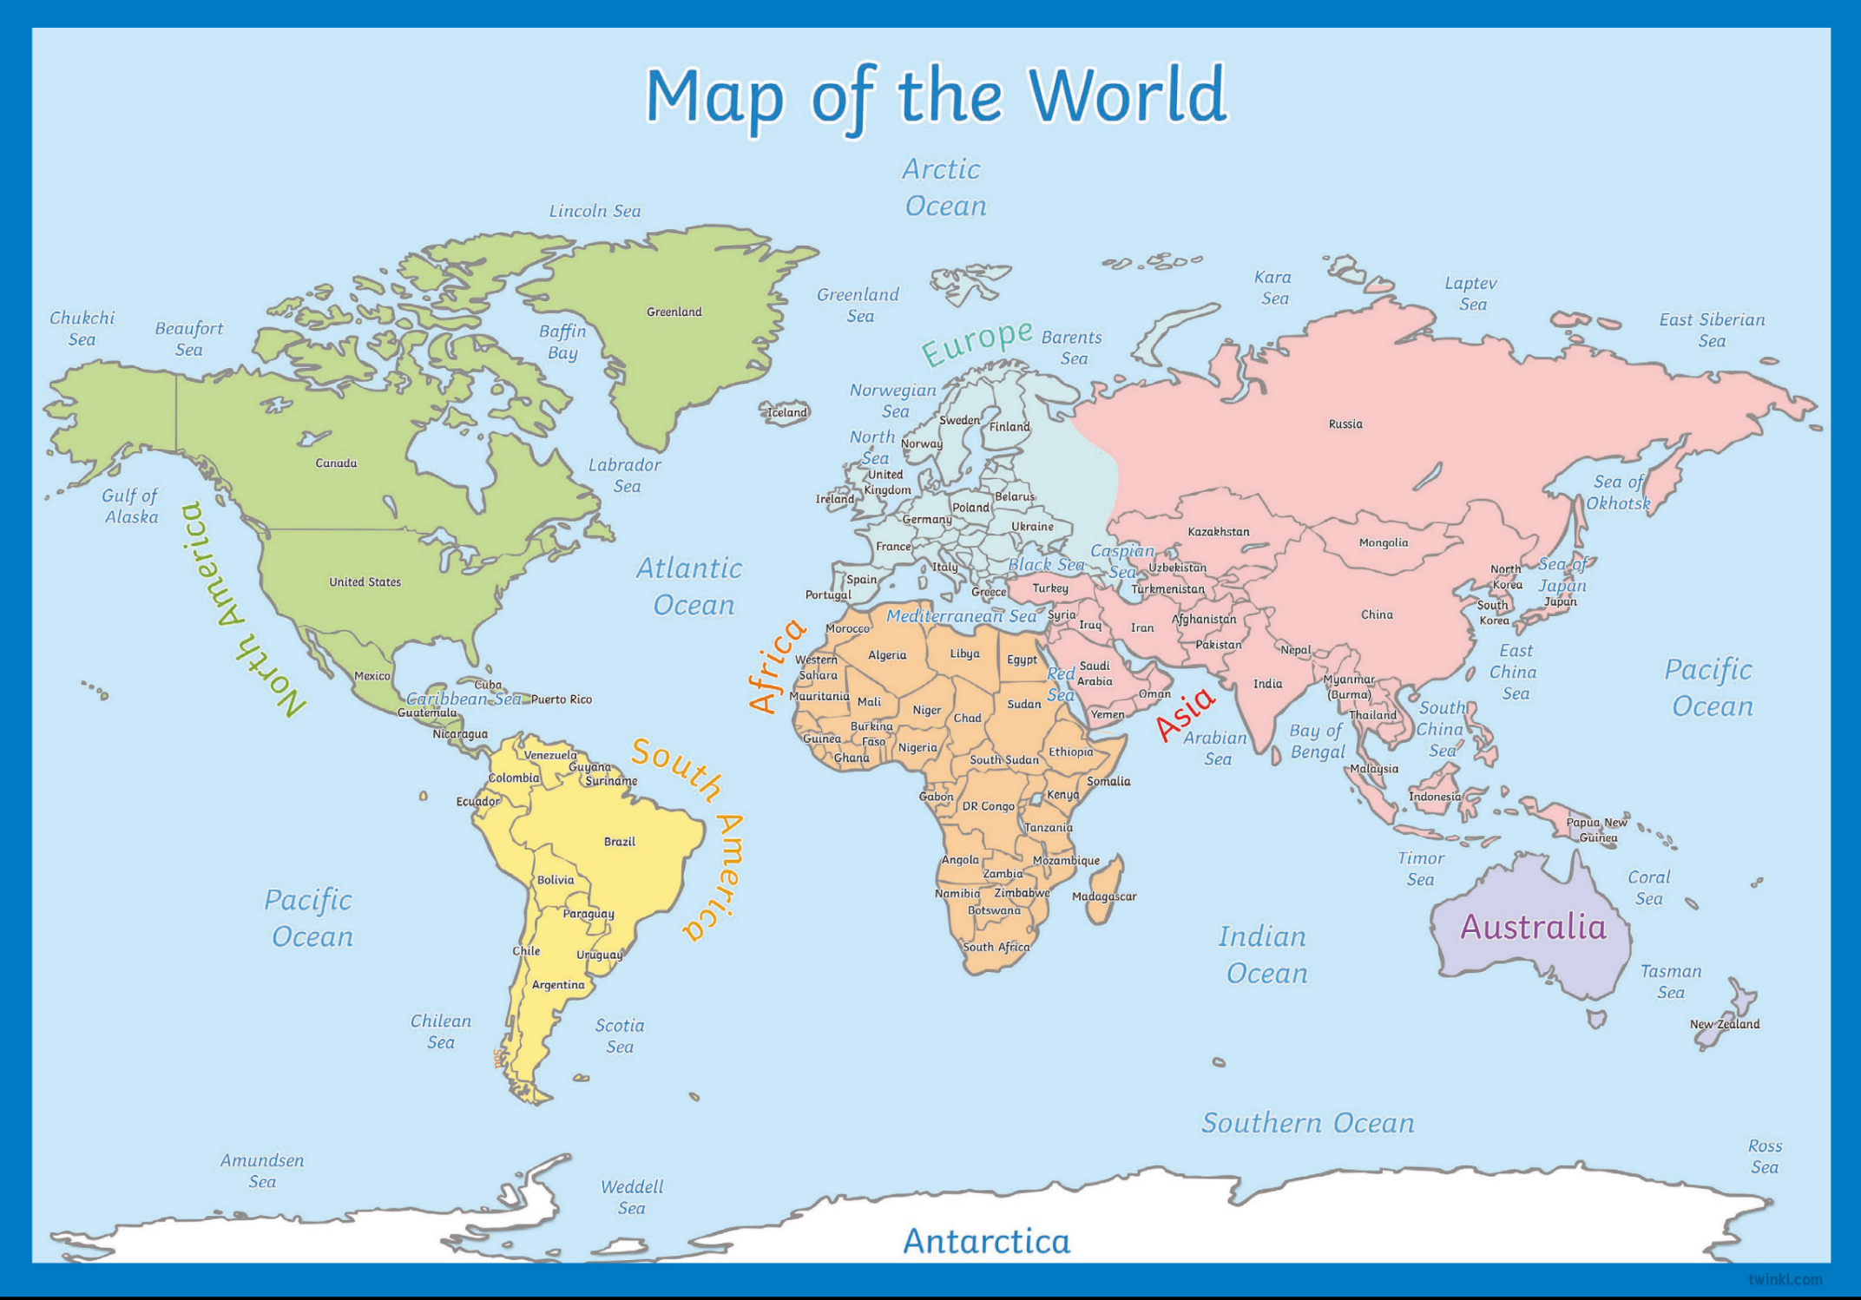
Here’s the map of the world! If you look really closely you’ll see me flying over the UK. Now use a coloured pencil to draw the route I took all in one night!

