Local History Project – Hitchin
A project is where we do lots of different tasks to find out as much information as we possibly can about something! Your task is to complete a research project all about Hitchin. Hitchin has so many different things to look at and visit. It has lots of different landmarks to see too.

Once you have found all your facts and researched Hitchin as much as you can choose a landmark in Hitchin you like the most! It could be St Mary’s Church, Windmill Hill, The British Schools etc. Use some recycling and create a junk model of your Hitchin Landmark. You could colour or paint it too when you are finished!
Here are some ideas to help with your project!
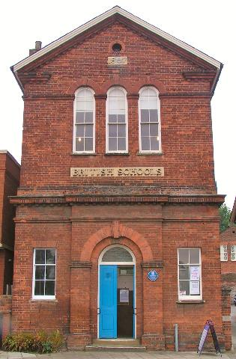
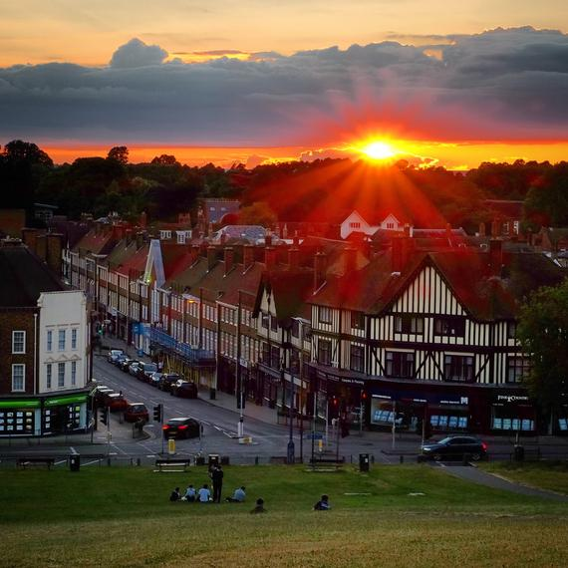
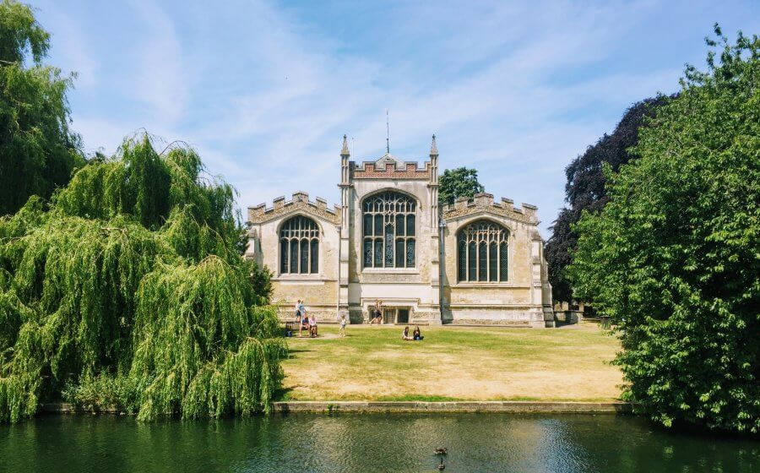

Use these tasks to help you with your research project!
Make a collage full of photographs or drawings with facts | Interview someone you know who has lived in Hitchin for a long time | Create a board game of Hitchin like Monopoly. Choose places you could land on!
Create quiz questions you could use with your family to see how much they know about Hitchin! | Make a short film all about what you have found out | Create a poster all about Hitchin. It might encourage people to come and visit!
Make a paper chain and write a different fact on each link! | Create a newspaper report describing all about the exciting things you have found in Hitchin | Go and visit some different places or find pictures on google. Use your sketching skills to draw them.

