Task 3

1. Add some missing words
- Read Extract 1. Write what the missing words could be.
- You can check your answers at the end of this pack. Are there any times when you prefer your idea to the original words?

2. Find out about the background to the story
- Read Background to Henry’s Freedom Box.
- Read and answer the Comprehension Questions.

3. Now for some writing
- Imagine you are Henry. Write a letter to a friend from when you were a child, explaining your story.
- You can use the Map of Events from Day 1 to help you.

Well done. Share your writing with a grown-up. You can check your answers to the Comprehension Questions at the end of this pack.

Try these Fun-Time Extras
- If you could meet three of these people who would you choose? What would you ask them?
- Henry ‘Box’ Brown
- Olaudah Equiano
- Ignatius Sancho
- William Wilberforce
- Harriet Martineau
- Ottobah Cugoana
- Thomas Clarkson
- Try to find out some more information about them.

Extract 1

Henry Brown wasn’t sure how old he was. He was a slave. And slaves weren’t allowed to know their birthdays.

Henry and his brothers and sisters worked in the big house where the master lived. Henry’s master had been good to Henry and his family. But Henry’s mother knew things could change.
“Do you see those leaves blowing in the wind? They are torn from the trees like slave children are torn from their families.”

One morning the master called for Henry and his mother. They climbed the wide staircase. The master lay in bed with only his head above the quilt. He was very ill. He beckoned them to come closer.
Some slaves were freed by their owners. Henry’s heart beat fast. Maybe the master would set him free.

But the masters said, “You are a good worker, Henry. I am giving you to my son. You must obey him and never tell a lie.”
Henry nodded, but he didn’t say thank you. That would have been a lie.

Later that day, Henry watched a bird soar high among the trees. “Free bird? Happy bird!” Henry thought.
Henry said goodbye to his family. He looked across the field. The leaves swirled in the wind.

Background to Henry’s Freedom Box
Slavery was a major issue in Britain as well as the USA. British merchants and businessmen traded in slaves and transported people from their homes in west or central Africa to the British-owned sugar plantations in the Caribbean. These were mainly on the islands of Jamaica, Barbados, St Kitts and Trinidad. Many people were involved in campaigning for the abolition of the slave trade in Britain. These include:
Olaudah Equiano | Ignatius Sancho | William Wilberforce
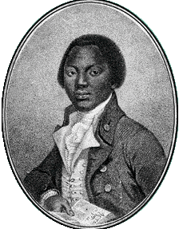 | 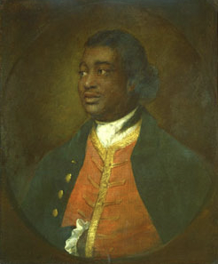 | 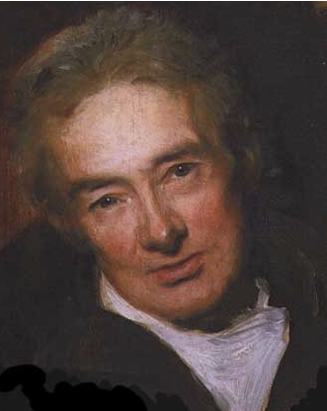
Born in Nigeria, Olaudah was captured as a slave and sold to a Royal Navy captain. He came to London, earning the price of his freedom from a Quaker merchant, and campaigned to abolish the slave trade. | Ignatius, probably born a slave, was certainly a child slave in Greenwich, London. He became a butler, then owned a grocery shop before becoming a composer and famous letter writer. | A Christian who believed that the slave trade was evil, William worked tirelessly to abolish slavery. Parliament finally agreed to make the slave trade illegal in 1807 and to end slavery in 1833.
Harriet Martineau | Ottobah Cugoana | Thomas Clarkson
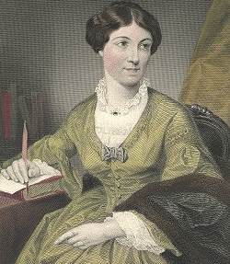 | 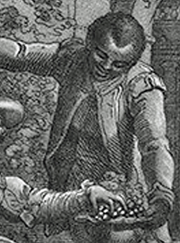 | 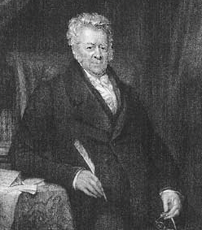
This extraordinary woman was born in Norwich in 1802 and lived in London during her early life. She then travelled to the USA where she worked and campaigned to end slavery after the law in Britain had abolished it in 1833. | Cugoano was born in Ghana in the 1750s. Captured and taken as a slave to Grenada plantations, he was then taken to England where he became free. He wrote a very famous book on the evils of the slave trade. | Clarkson was educated at Cambridge University. He wrote a prize-winning essay in Latin on the evils of the slave trade, and, once translated into English, this became widely read and highly influential. He campaigned to end the slave trade.

Comprehension questions
- Where were slaves transported to and why?
- Which two countries did Ottobah Cugoano live as a free man? And where was he a slave?
- Who became a composer and letter writer after being a child slave?
- Name two people who wrote about the evils of the slave trade.
- Name three people who campaigned for the abolition of slavery but who had not been slaves themselves.
- What do you think the difference between a servant and a slave is?
- What do you think it means when it says: ‘earning the price of his freedom’?
- Why was William Wilberforce in a good position to influence parliament on issues around slavery?
- How many years were there between the agreement to make the slave trade illegal and the point at which to end slavery? Why do you think this is?
- Why did Harriet Martineau travel to the USA after the law in Britain had abolished slavery in 1833?
- Why do you think people wanted the slave trade to end?

Background to Henry’s Freedom Box : comprehension question ANSWERS
- Where were slaves transported to and why? The Caribbean. These were mainly on the islands of Jamaica, Barbados, St Kitts and Trinidad. To work on British-owned sugar plantations.
- Which two countries did Ottobah Cugoano live as a free man? And where was he a slave? Ghana and England (free); Grenada (slave).
- Who became a composer and letter writer after being a child slave? Ignatius Sancho.
- Name two people who wrote about the evils of the slave trade. Ottobah Cugoano and Thomas Clarkson.
- Name three people who campaigned for the abolition of slavery but who had not been slaves themselves. William Wilberforce, Harriet Martineau and Thomas Clarkson.
- What do you think the difference between a servant and a slave is? Highlight that one is a position of employment and the person is free, while the other is enforced work by a person who is not free.
- What do you think it means when it says: ‘earning the price of his freedom’ Suggest something along the lines that he saved enough money from small extra jobs to pay his owner for his freedom
- Why was William Wilberforce in a good position to influence parliament on issues around slavery? He was an MP
- How many years were there between the agreement to make the slave trade illegal and the point at which to end slavery? Why do you think this is? Parliament finally agreed to make the slave trade illegal in 1807 and to end slavery in 1833. Note that ending trade is not the same as ending slavery itself. Suggest a logical reason for the length of this campaign – Discuss this together.
- Why did Harriet Martineau travel to the USA after the law in Britain had abolished slavery in 1833? While the law in Britain had changed, this didn’t change the law in the USA.
- Why do you think people wanted the slave trade to end? Set out some clear and logical ideas.
Henry’s Letter

Write your letter here.

Extract 1

Henry Brown wasn’t sure how old he was. He was a slave. And slaves weren’t allowed to know their birthdays.

Henry and his brothers and sisters worked in the big house where the master lived. Henry’s master had been good to Henry and his family. But Henry’s mother knew things could change.
“Do you see those leaves blowing in the wind? They are torn from the trees like slave children are torn from their families.”

One morning the master called for Henry and his mother. They climbed the wide staircase. The master lay in bed with only his head above the quilt. He was very ill. He beckoned them to come closer.
Some slaves were freed by their owners. Henry’s heart beat fast. Maybe the master would set him free.

But the masters said, “You are a good worker, Henry. I am giving you to my son. You must obey him and never tell a lie.”
Henry nodded, but he didn’t say thank you. That would have been a lie.

Later that day, Henry watched a bird soar high among the trees. “Free bird? Happy bird!” Henry thought.
Henry said goodbye to his family. He looked across the field. The leaves swirled in the wind.

