Task 5

1. Write descriptive sentences
- Look carefully at the Jewellery. They’re all types of amulet.
- Write a descriptive sentence for each. Try your sentences out on someone else, can they work out which amulet you are describing?

2. Read a poem
- Read the poem Amulet.
- What do you like about the poem? What patterns can you spot? Which is your favourite line?
- Look at Amulet Images. Which of these images is described best in the poem do you think?

3. Practise using possessive apostrophes.
- Use the Revision Card to remind yourself about possessive apostrophes.
- Complete Plural Possession Sentences.

4. Write your own poem
- Follow the instructions on Amulet Poem Idea.
- Use your ideas to write your poem on the Writing Frame.

Well done. Share your poem with a grown-up. You can check your answers to Plural Possession Sentences at the end of this pack.

Try the Fun-Time Extra
Practise reading your poem. Share your reading with someone else.
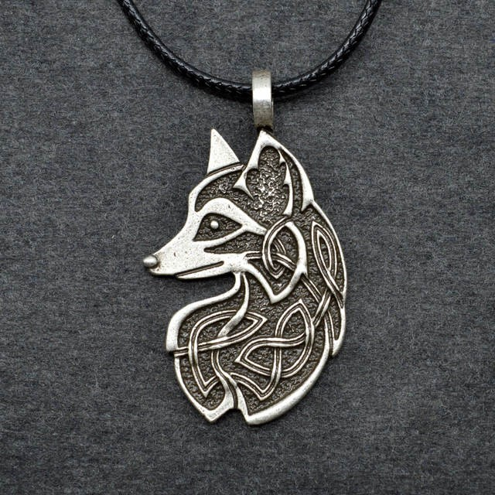
Jewellery

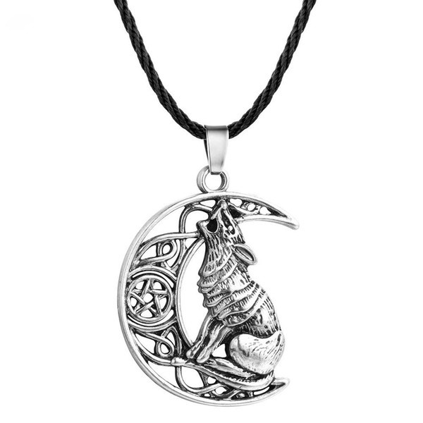 | 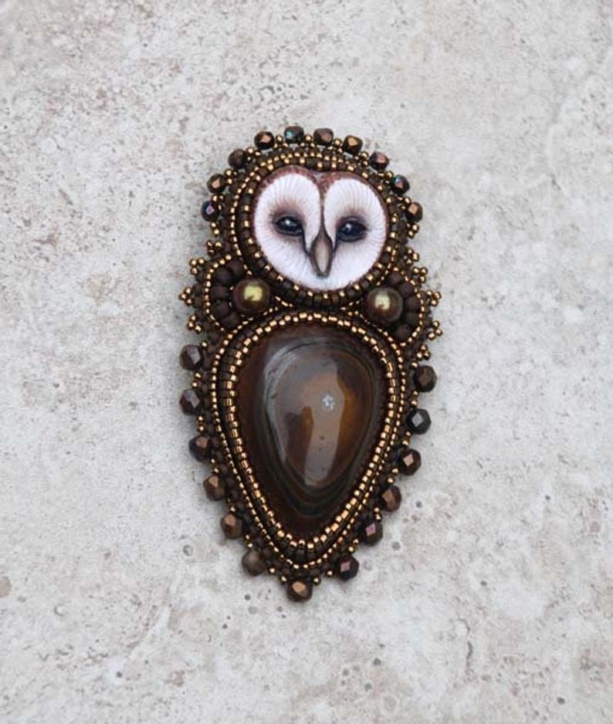

Amulet

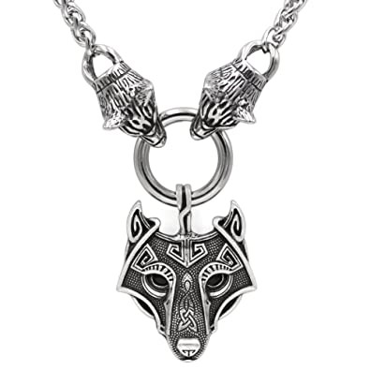

Inside the wolf’s fang, the mountain of heather.
Inside the mountain of heather, the wolf’s fur.
Inside the wolf’s fur, the ragged forest.
Inside the ragged forest, the wolf’s foot.
Inside the wolf’s foot, the stony horizon.
Inside the stony horizon, the wolf’s tongue.
Inside the wolf’s tongue, the doe’s tears.
Inside the doe’s tears, the frozen swamp.
Inside the frozen swamp, the wolf’s blood.
Inside the wolf’s blood, the snow wind.
Inside the snow wind, the wolf’s eye.
Inside the wolf’s eye, the North star.
Inside the North star, the wolf’s fang.

by Ted Hughes, p316

Amulet Images

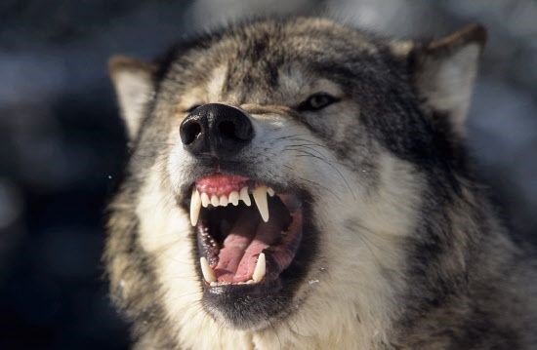

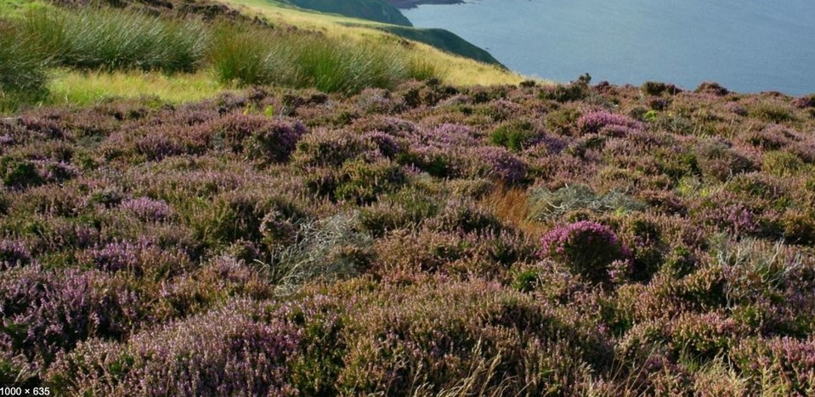 | 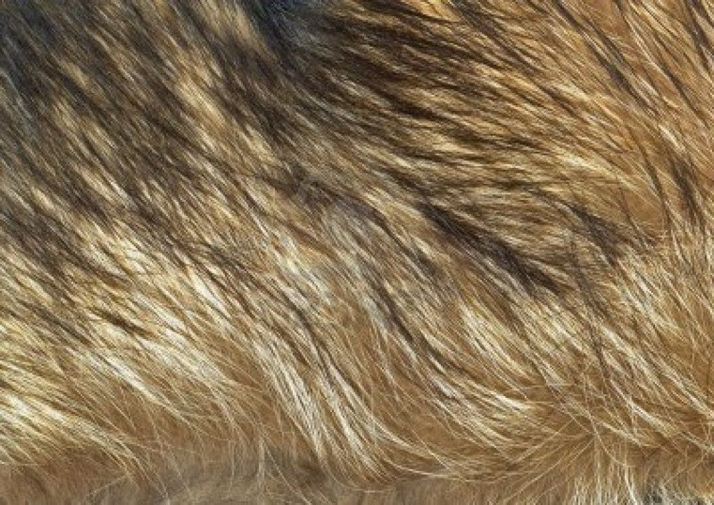

Revision Card - Possessive Apostrophes

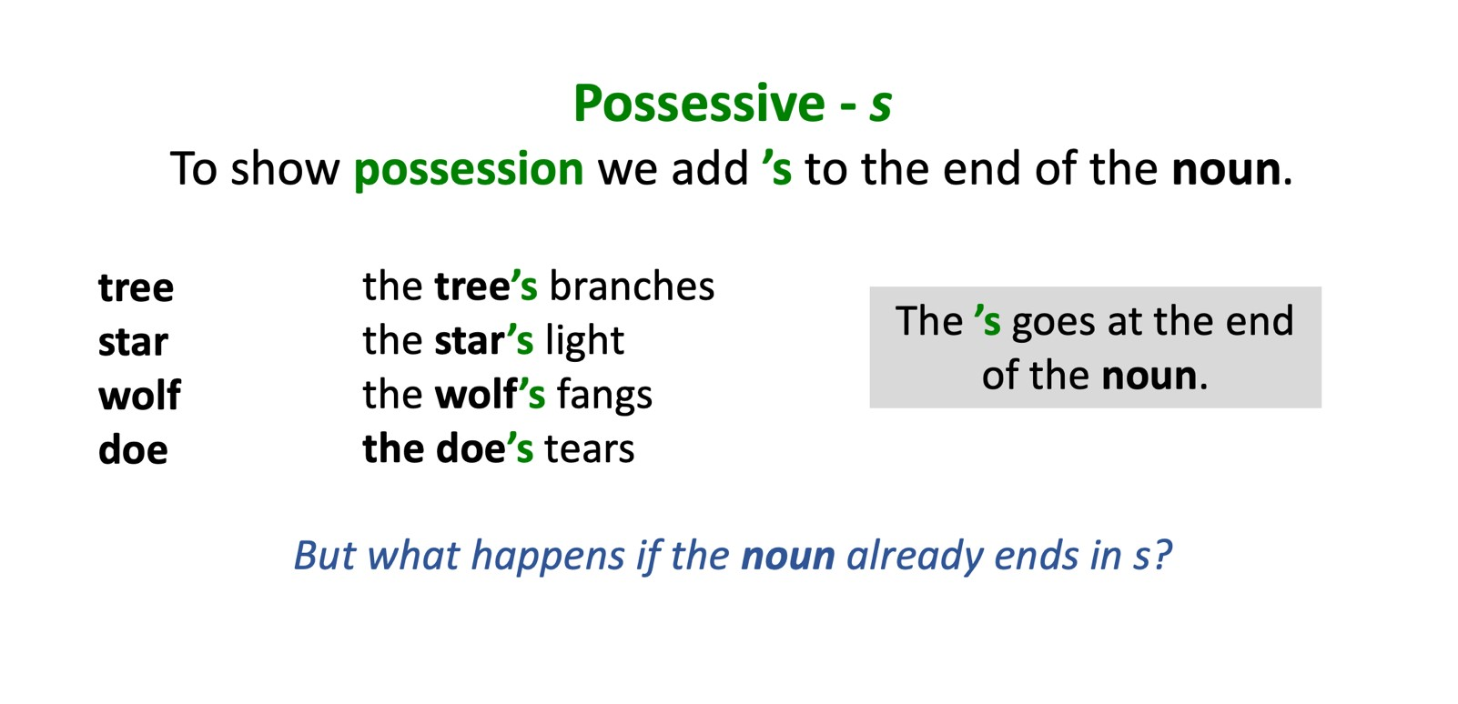

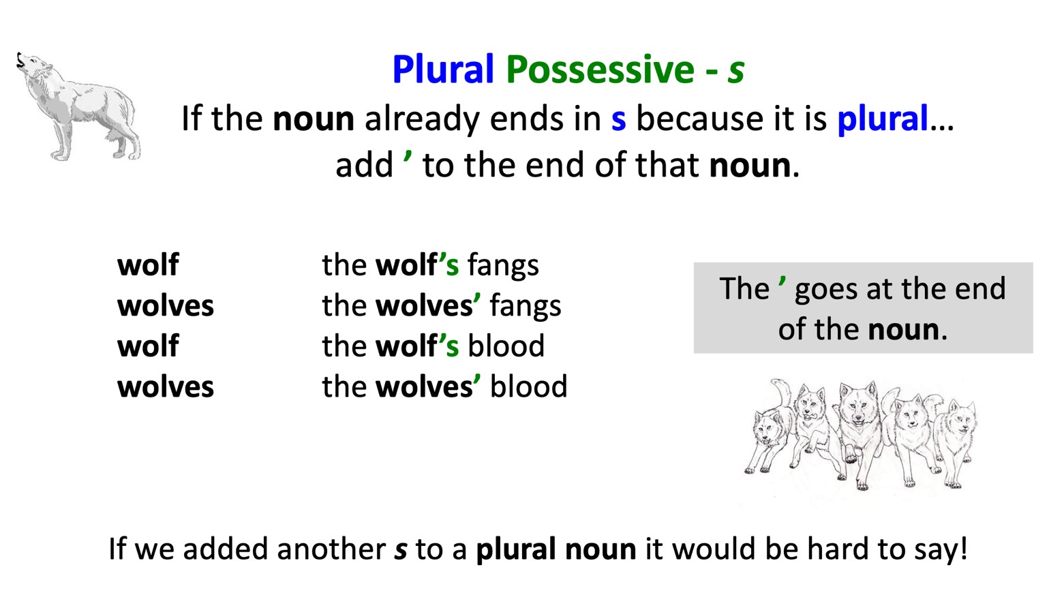

Plural Possession Sentences

Make the singular noun into a plural and put a possessive apostrophe in the right place.

The _________ cries echoed through the land.
(Noun: wolf)

The _________ home was hidden underground.
(Noun: fox)

The _________ fangs are sharp and terrifying.
(Noun: wolf)

The _________ nest was high in the tree.
(Noun: eagle)

The _________ eyes reflected the moonlight
(Noun: fox)

The _________ call was heard at night.
(Noun: owl)

The _________ branches sheltered the owl.
(Noun: tree)

The _________ light shone brightly in the sky
(Noun: star)

The _________ voices were heard by the animals.
(Noun: child)

Plural Possession Sentences - Answers

Make the singular noun into a plural and put a possessive apostrophe in the right place.

The wolves’ cries echoed through the land.
(Noun: wolf)

The foxes’ home was hidden underground.
(Noun: fox)

The wolves’ fangs are sharp and terrifying.
(Noun: wolf)

The eagles’ nest was high in the tree.
(Noun: eagle)

The foxes’ eyes reflected the moonlight
(Noun: fox)

The owls’ call was heard at night.
(Noun: owl)

The trees’ branches sheltered the owl.
(Noun: tree)

The stars’ light shone brightly in the sky
(Noun: star)

The children’s voices were heard by the animals.
(Noun: child)

Unit 4 Day 2

Amulet Poem Ideas

- Choose an animal.
- Write nouns or noun phrases on the cards. Body parts on the red cards and habitat features on the blue cards.
- Cut the cards up and decide the order for your poem.

Amulet Poem Ideas – Examples (Fox)

- Choose an animal.
- Write nouns or noun phrases on the cards. Body parts on the red cards and habitat features on the blue cards.
- Cut the cards up and decide the order for your poem.

deep brown eyes |  | grassy meadows
bushy brush tail |  | scent of the rabbit
soft paws |  | deep burrows
sharp teeth |  | secret tracks
inquisitive snout |  | hidden forest
restless claws |  | fresh-laid snow

Writing Frame

Inside the | , | the | .
Inside the | , | the | .
Inside the | , | the | .
Inside the | , | the | .
Inside the | , | the | .
Inside the | , | the | .
Inside the | , | the | .

