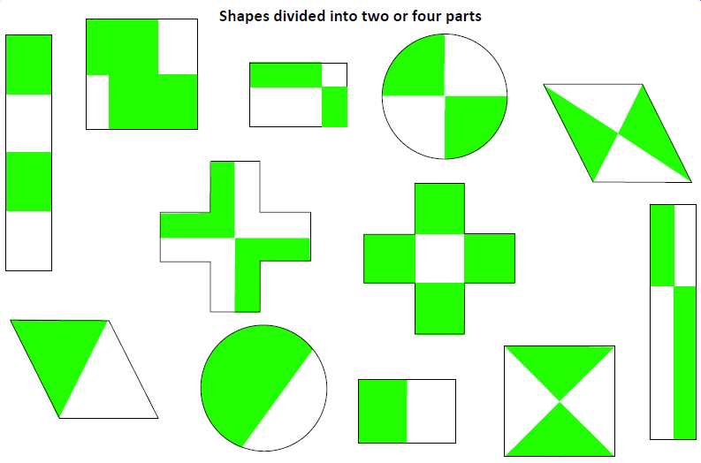
Mark the shapes that show a half in one colour and shapes that show a quarter in a different colour.

