Summer W7 Friday Extension and consolidation sheet

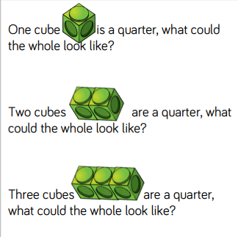 | 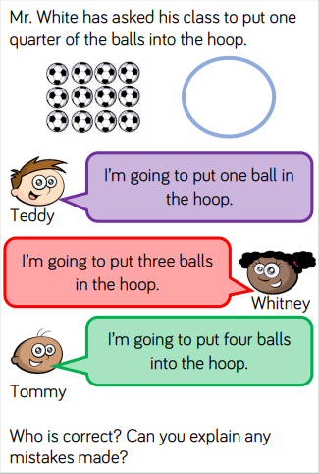

Draw bar models to answer these questions

Half of 12 =  Quarter of 28 =  Half of 18 =  ½ of 22 = | Quarter of 16 =  ¼ of 24 =  ¼ of 32 =  1/3 of 12 =

