Summer W8 Monday Extension questions

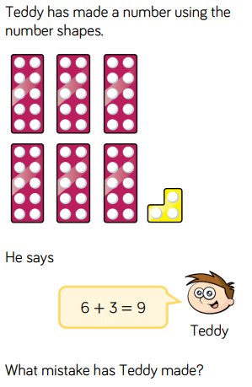 | 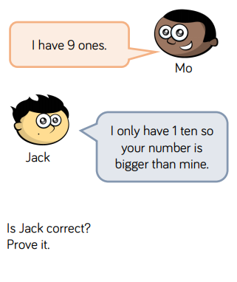
Guess the number  It has less than 3 tens.  It has more than 1 ten.  It has fewer than 4 ones.  My number is odd.  What could my number be? | Guess the number  It has more than 4 tens.  It is smaller than 55.  It has more than 2 ones.  My number is even.  What is my number?

