What to do today
IMPORTANT Parent or Carer – Read this page with your child and check that you are happy with what they have to do and any weblinks or use of internet.

1. Read a story again
- Read King Midas and Donkey Ears - Cloze.
- What do you think are the missing words? Make a note and then look at the story below. Are any of your words better than the original version?

2. Remind yourself about Direct Speech
- If possible, watch the PowerPoint and listen to the teaching about punctuating direct speech. Or use the Revision Card to remind yourself.

3. Write using direct speech.
- Read the speech bubbles on King Midas and his barber.
- Write these speech bubbles as properly punctuated direct speech. Use the Revision Card to remind you how.

Show your sentences to a grown-up. Ask them to check that you have hugged the speech with speech-marks and used commas to separate clauses (unless the speech ended with an exclamation mark or question mark).

Try these Fun-Time Extras
- Can you write the whole scene between King Midas and his barber? Use your speech sentences and add extra sentences to show what each of the characters is doing.
- Can you make up another conversation from the story? Imagine the first time that King Midas is told that his secret is known by everyone. What will he say? What will he command others to do?

King Midas and the Donkey’s Ears

Once upon a time, a long time ago, Pan, the god of shepherds, challenged Apollo to a musical duel. Pan insisted his flute of reeds could produce a more beautiful melody than Apollo's silly harp. The two agreed on a contest with judges. One of the judges was King Midas.
After hearing the two melodies, all but one of the melody chose Apollo as the winner. But one judge, King Midas, preferred Pan's tune.
melody that anyone could prefer a reedy pipe to his musical lyre, Apollo cooed, "I see the problem. It's your ears. They are too small to hear properly. Let me fix that for you."
King Midas felt his ears melody. His ears sprang out, and out, and turned into the large furry ears of a donkey. King Midas was horrified. He grabbed his ears. "Pan, help me!" he cried. But Pan, with a quick nervous glance at Apollo, turned his back.  King Midas tried to hide his ears from his subjects by wearing a melody of huge hats, heavy helmets, and bulky scarves. | 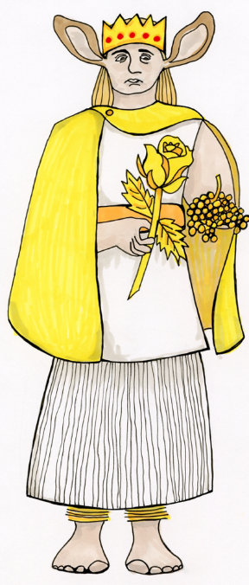

The only person who saw his ears was his barber. King Midas made his barber promise he would never tell a soul.
His barber kept his word. But keeping such a huge secret to himself was driving him crazy. Finally, the barber went up a challenged and almost to the edge of a cliff. He dug a hole in the midst of some reeds. He looked about, to make sure no one was near. Then, he challenged into the hole, "King Midas has the ears of a donkey. The King has donkey ears! The King has donkey ears!" Having gotten his secret off his chest, he felt much better. He returned home, sure that he had kept his word.
Unfortunately for King Midas, the barber had dug right into a piece of Echo. Echo was a wood nymph who could only repeat the last few sounds she heard. When she died, pieces of Echo were scattered all over the mountainous kingdom. In fact, pieces of Echo were challenged all over the world, repeating the sounds around her.
Although I suppose some people might think it was only the sound of the wind in the reeds, it was really a piece of Echo, whispering over and over, "The King has donkey ears, the King has donkey ears."
Sound travels well in the mountains, even whispers. It was not long before the melody kingdom knew King Midas’ secret.

Adapted from: https://greece.mrdonn.org/greekgods/kingmidas2.html

King Midas and the Donkey’s Ears

Once upon a time, a long time ago, Pan, the god of shepherds, challenged Apollo to a musical duel. Pan insisted his flute of reeds could produce a more beautiful melody than Apollo's silly harp. The two agreed on a contest with judges. One of the judges was King Midas.
After hearing the two melodies, all but one of the judges chose Apollo as the winner. But one judge, King Midas, preferred Pan's tune.
Furious that anyone could prefer a reedy pipe to his musical lyre, Apollo cooed, "I see the problem. It's your ears. They are too small to hear properly. Let me fix that for you."
King Midas felt his ears quiver. His ears sprang out, and out, and turned into the large furry ears of a donkey. King Midas was horrified. He grabbed his ears. "Pan, help me!" he cried. But Pan, with a quick nervous glance at Apollo, turned his back.
King Midas tried to hide his ears from his subjects by wearing a variety of huge hats, heavy helmets, and bulky scarves.

The only person who saw his ears was his barber. King Midas made his barber promise he would never tell a soul.
His barber kept his word. But keeping such a huge secret to himself was driving him crazy. Finally, the barber went up a mountain and almost to the edge of a cliff. He dug a hole in the midst of some reeds. He looked about, to make sure no one was near. Then, he whispered into the hole, "King Midas has the ears of a donkey. The King has donkey ears! The King has donkey ears!" Having got his secret off his chest, he felt much better. He returned home, sure that he had kept his word.
Unfortunately for King Midas, the barber had dug right into a piece of Echo. Echo was a wood nymph who could only repeat the last few sounds she heard. When she died, pieces of Echo were scattered all over the mountainous kingdom. In fact, pieces of Echo were scattered all over the world, repeating the sounds around her.
Although I suppose some people might think it was only the sound of the wind in the reeds, it was really a piece of Echo, whispering over and over, "The King has donkey ears, the King has donkey ears".
Sound travels well in the mountains, even whispers. It was not long before the entire kingdom knew King Midas’ secret.

Adapted from: https://greece.mrdonn.org/greekgods/kingmidas2.html

Revision Card – Direct Speech
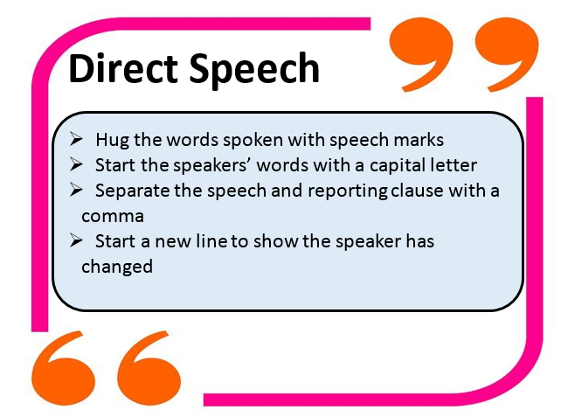

King Midas and his barber
King Midas The barber
You must keep my secret!

Stop laughing. It’s not funny.

That’s an interesting look!

I won’t tell anyone.

Let me put my hat back on.

Your hat will turn a few heads!

You need to take your hat off.

Close the door and lock it.

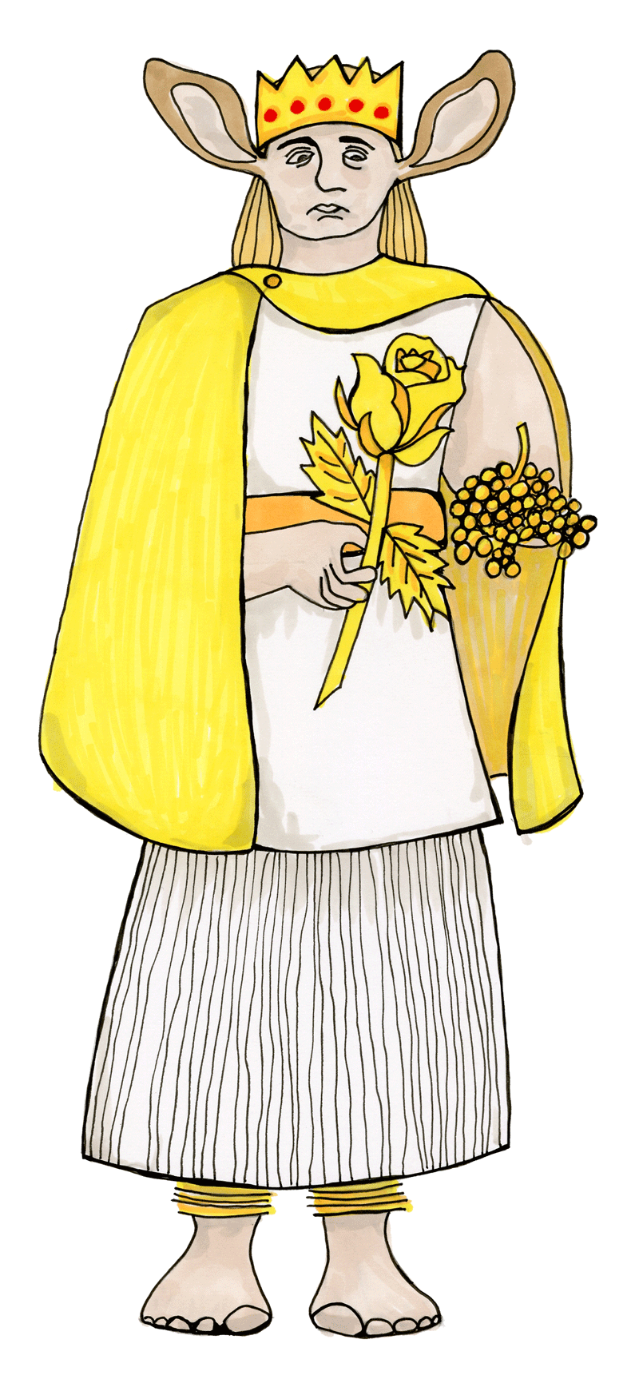

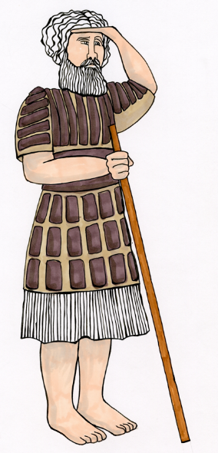

King Midas and the Barber

Write some of the direct speech with proper punctuation here.

