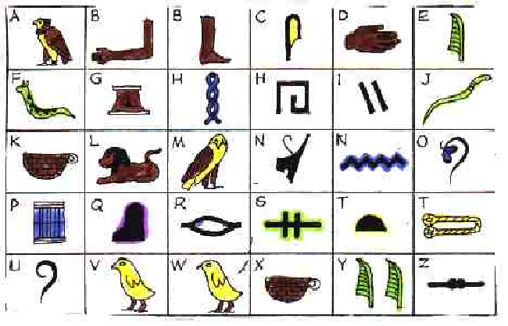

Can you work out the secret hieroglyphic code?
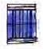 | 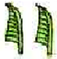 | 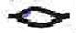 | 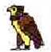 | 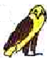 | 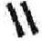 | 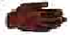 | 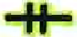
 | 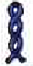 |  |  | 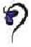
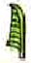 | 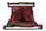 |  |  | 

