Weekly Planning Sheet for Mathematics Week 2 Year Reception William Ransom Primary School

 | Objectives | Activity
Mon/Wed  For children in school this will be teacher led. | To understand what odd and even numbers are.  To be able to explain what odd and even numbers are  To be able to find out which numbers are odd and which numbers are even. | Activity  - What is and even number?  - What is an odd number?  - Write the definition on the board  - Watch-Number blocks  https://www.bing.com/videos/search?q=numberblocks+odd+and+even&docid=608005586014570981&mid=C22BE791C5C110C1785DC22BE791C5C110C1785D&view=detail&FORM=VIRE | Independent work  - Using the 10 frame worksheet colour each number and see the pattern for 1-10  (See below but up to 10 not 8)  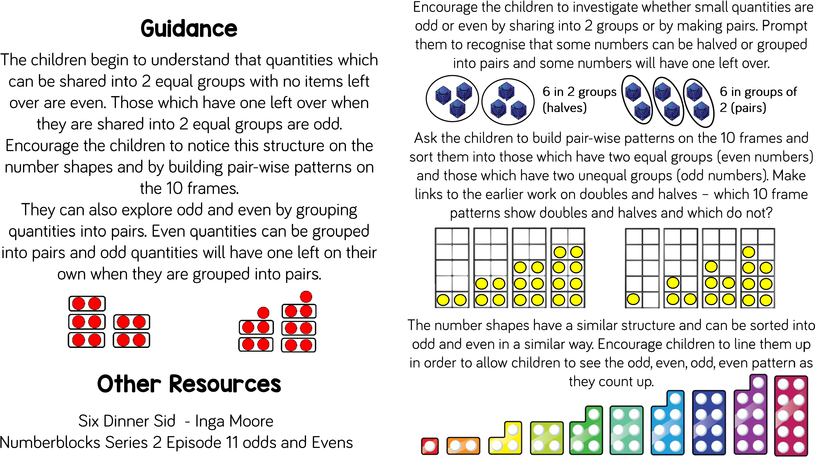6. Can you work out if higher numbers are odd or even using the colouring 10 frames to help. | 7.Watch  https://www.bbc.co.uk/bitesize/ topics/zknsgk7/articles/zt4jj6f
Tues/Thur  For children in school this will be teacher led. | To revise what odd and even numbers are.  To be able to explain what odd and even numbers are  To be able to find out which numbers are odd and which numbers are even.  To recognise numbers 11-20.  To count out the correct number of cubes to correspond to a numeral. | - Have a feely bag. Take out a Numicon shape and show the chn. Is it odd or even? How do you know?  - At home as you won’t have Numicon, you could show your child a number. Can they remember from yesterday, if it is an even or an odd number?  - Watch  https://www.bbc.co.uk/bitesize/clips/zm26sbk | Independent work  I can share between 2 people to find out if it is an odd or an even number  - Using numbers 11-20 (from the children’s word box) for each child, shuffled up.  Pick a card from the pile. Write the number in their book. Count out the items between 2 pots. How many are in each pot. Draw your pots. Are there any left over? Is it an odd or even number? How do you know?

Home Learning

Day 1
- Watch Numberjacks about odd and even numbers
https://www.bing.com/videos/search?q=Numberjacks+odd+and+even&docid=608033073827217976&mid=B3BF3E4964D943E8A036B3BF3E4964D943E8A036&view=detail&FORM=VIRE
- Write down the even numbers up to 10
- If the ‘Number Taker’ took away all the even numbers what else couldn’t work properly- draw them. What would the even number become?
- Eg spider 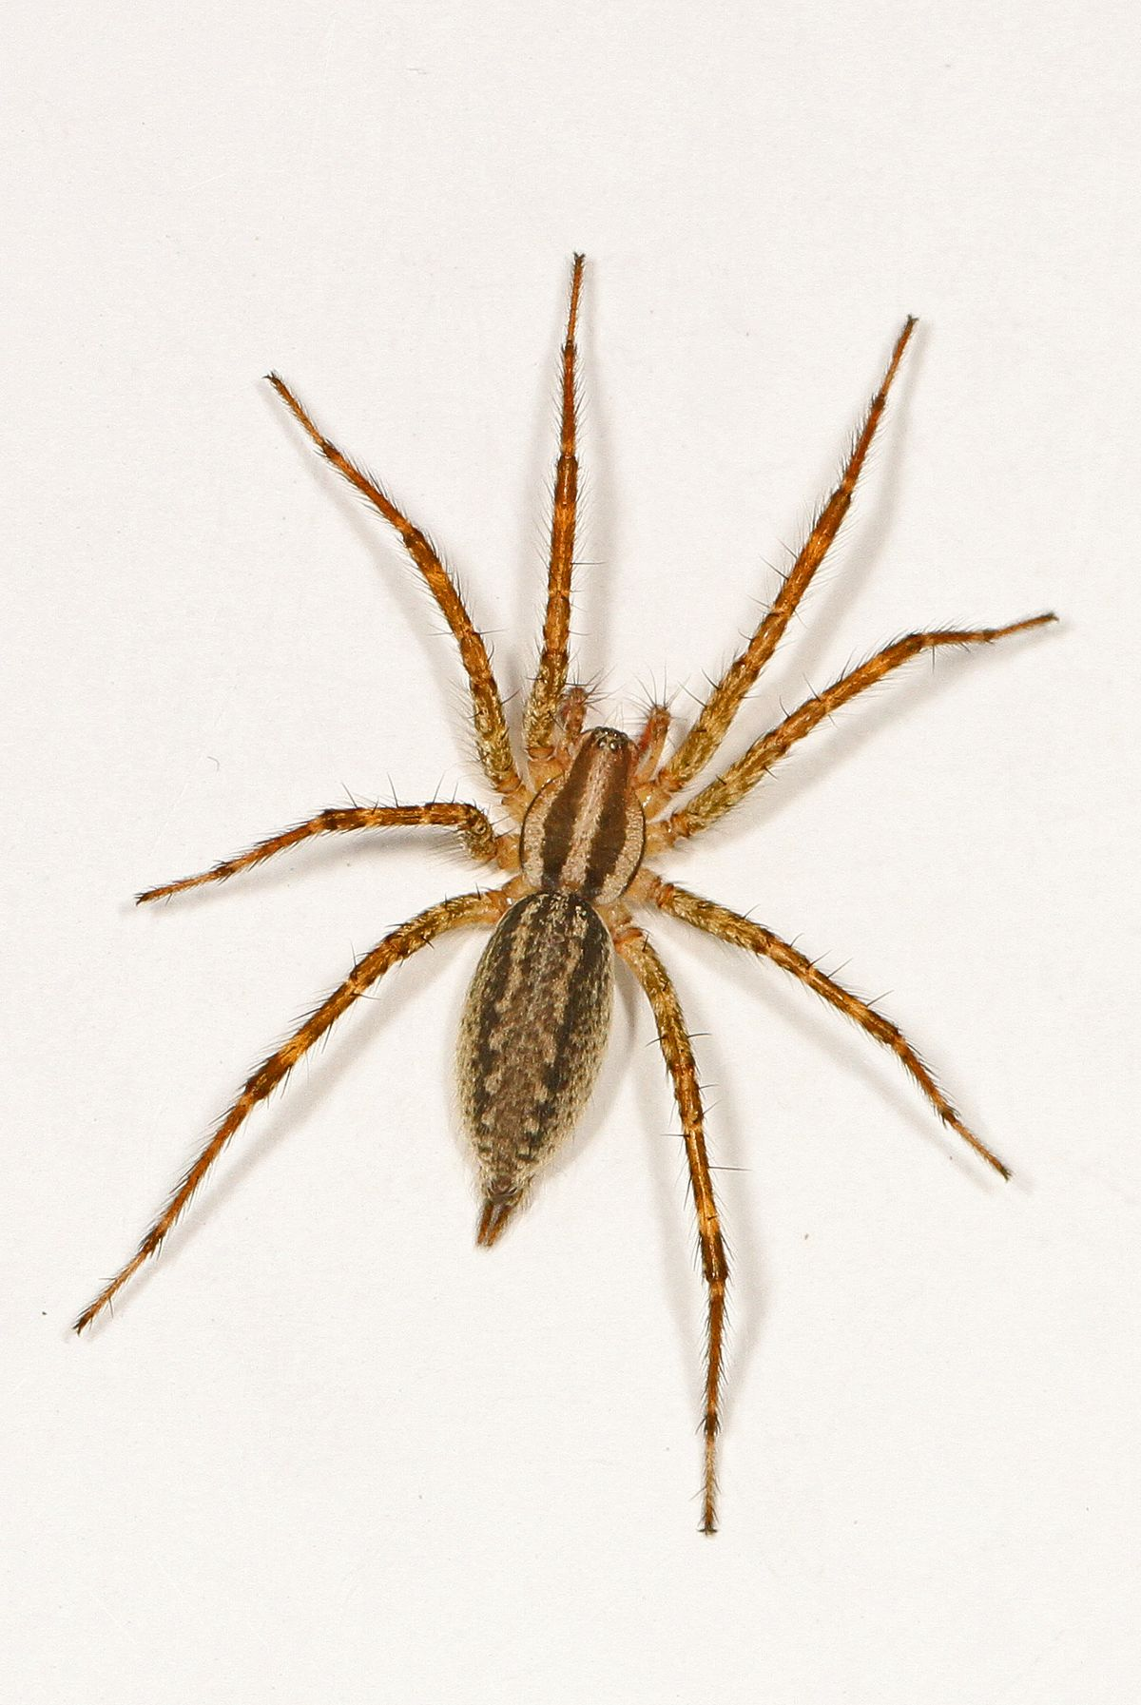 8 legs – 1 = 7 (8 even number take away 1 leaves 7 an odd number)

- Do some mental maths- numbers that make 5 say 2 they should say 3 etc Numbers that make 10 say 9 they should say 1 etc.

Day 2
- Do some mental maths- numbers that make 5 say 2 they should say 3 etc Numbers that make 10 say 9 they should say 1 etc.

- Play – Play Coconut odd and even https://www.topmarks.co.uk/Search.aspx?q=odd%20and%20even%20numbers
- Complete the worksheets to circle the odd and even numbers. (If you cannot print them out copy the numbers from the screen and circle in your book)

- When you go out for a walk look at the house numbers. Is every house on one side of the road odd and the other side even?
Point to a house number and ask your child if it is an even number. If it is, what number will come next?

