Weekly Planning Sheet for Mathematics Week 3 Year Reception William Ransom Primary School

Topic-length, height and distance
Guidance
Children should be using language to describe length and height eg the tree is tall, the twig is short. They should be able to describe and compare, using language such as big or bigger than somethingelse. Encorage them to use more specific lnguage relating to length (Longer, shorter, shortest, longest), height (taller , shorter, tallest shortest), and breadth (Wider, narrower, widest narrowest). They need to understand and be able to sue the language.

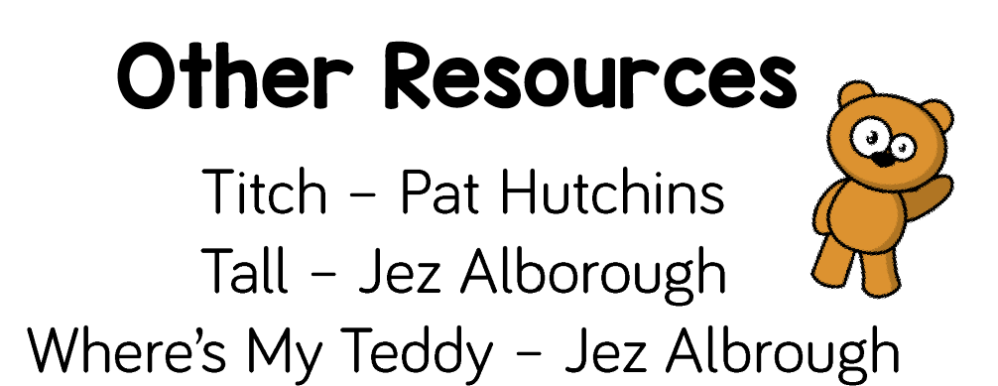
 | Objectives | Activity |  | Plenary
Mon/Wed  For children in school this will be teacher led. | To use the correct language to compare heights  To use and understand the terms  Short, tall, shortest, tallest, taller than shorter than  To use and understand the terms longest, shortest, shorter, longer, same length | - Children get themselves in height order  Take a photo  Show on the screen  Discuss heights  At home you could get a selection of toys and put in height order and discuss.  - Use the ‘Compare poster’ and discuss with the children. (Print and put under visualiser)  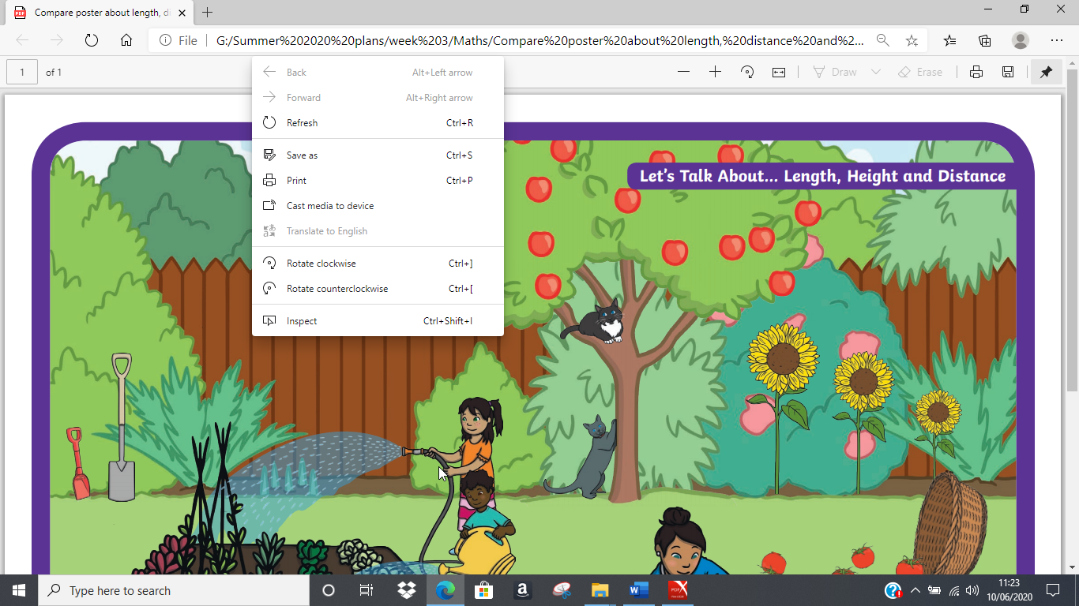  - Let them offer the vocabulary and then ask questions to assess their understanding of the vocabulary. | - Independent activities  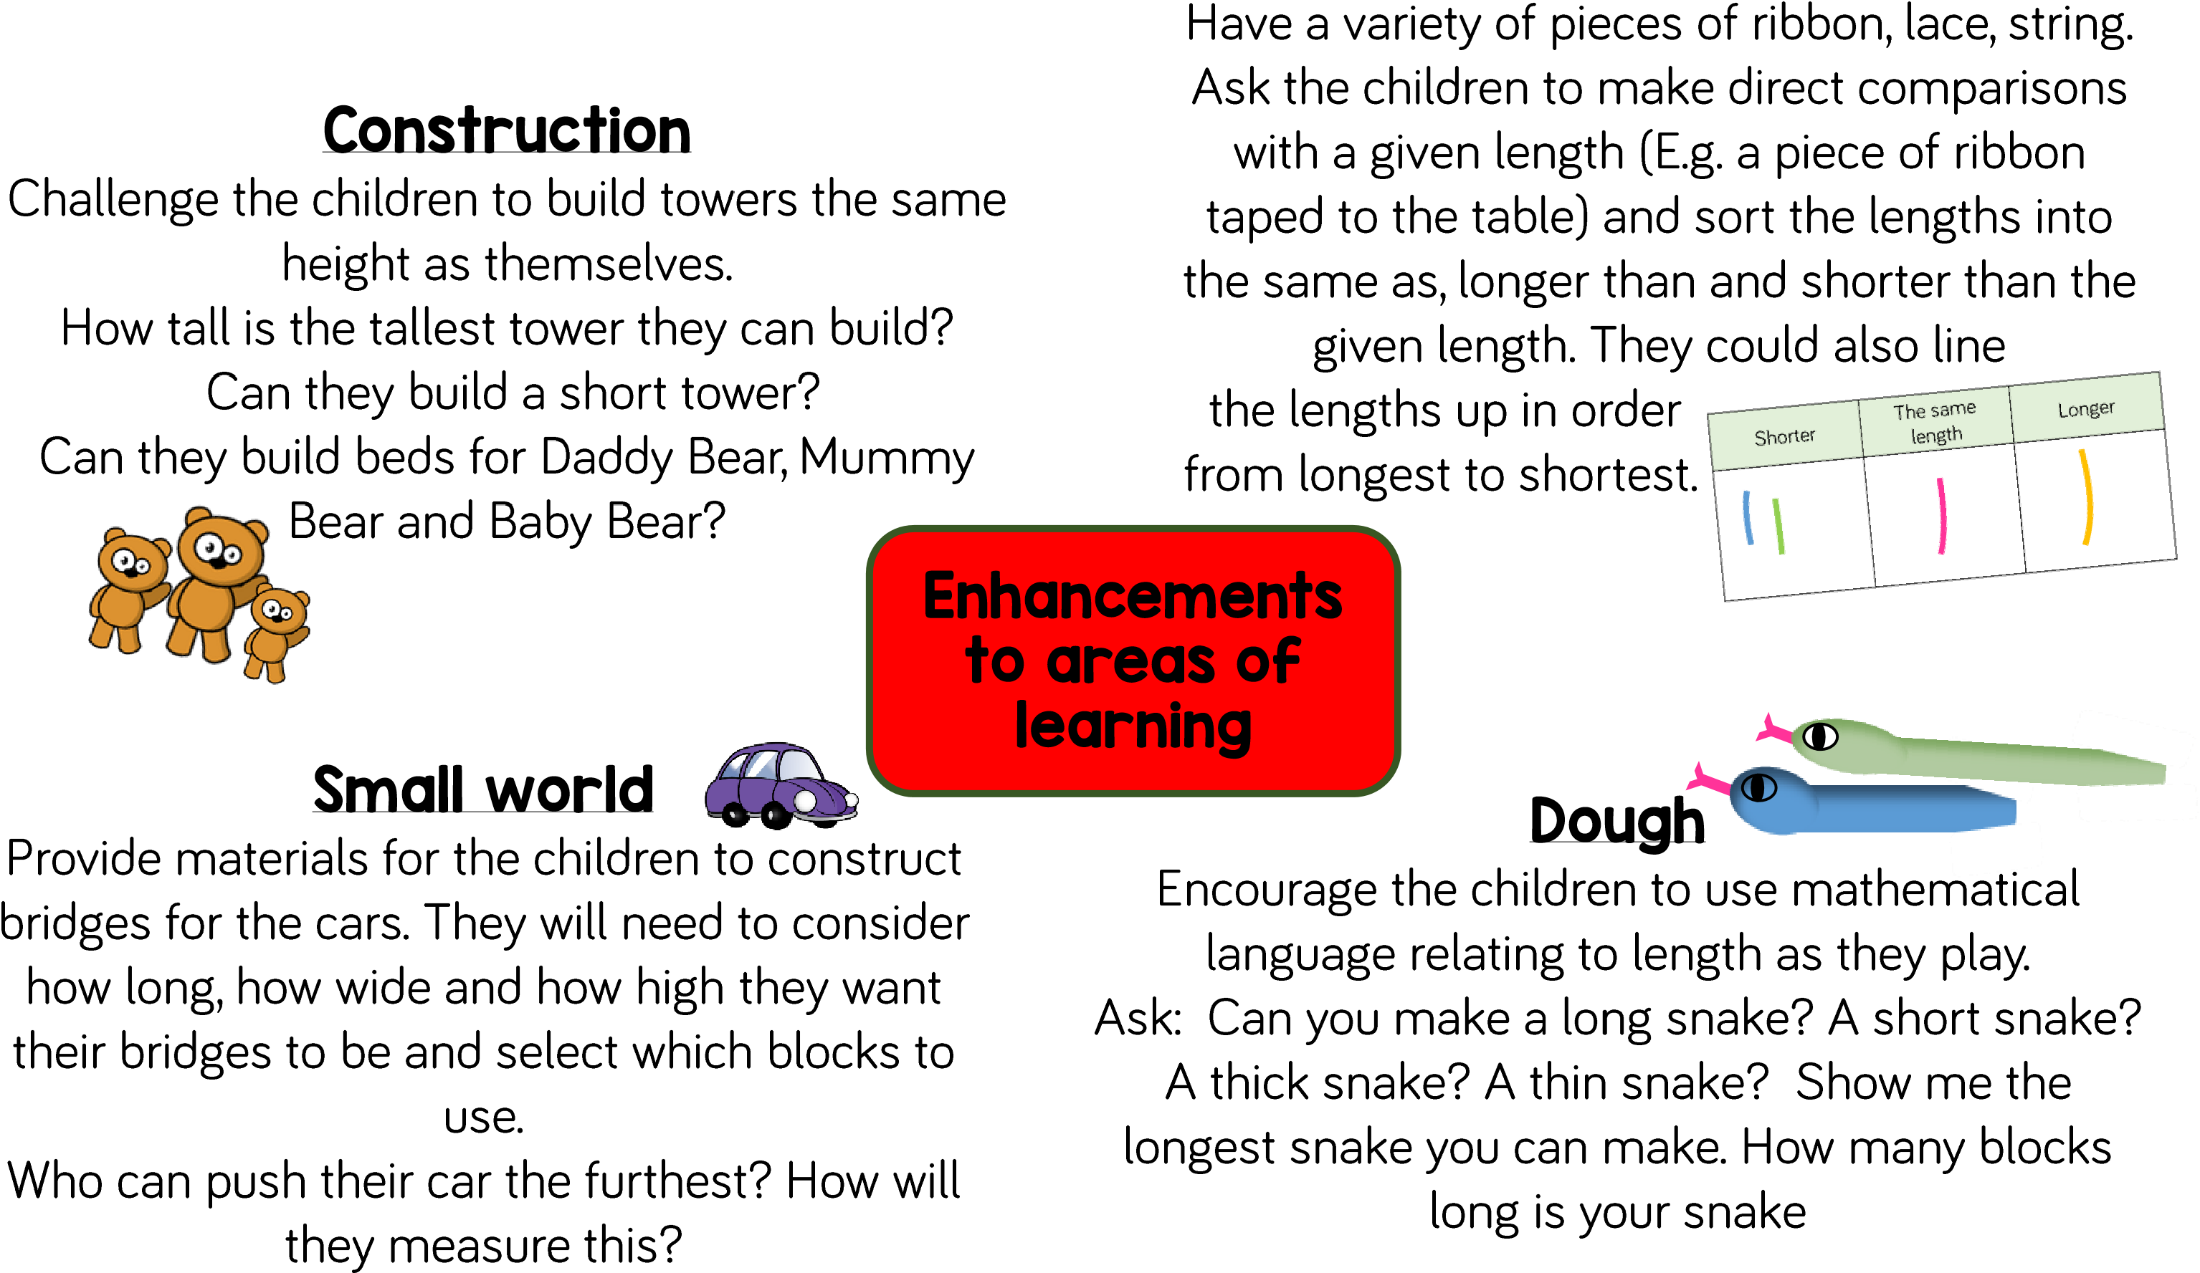 | - Read Short or tall it doesn’t matter at all  https://www.bing.com/videos/search?q=short+or+tall+doesn%27t+matterat+all+book&&view=detail&mid=66F42DD4C6267E670ED066F42DD4C6267E670ED0&&FORM=VRDGAR&ru=%2Fvideos%2Fsearch%3Fq%3Dshort%2520or%2520tall%2520doesn't%2520matterat%2520all%2520book%26qs%3Dn%26form%3DQBVDMH%26sp%3D-1%26pq%3Dshort%2520or%2520tall%2520doesn't%2520matterat%2520all%2520book%26sc%3D0-39%26sk%3D%26cvid%3D3015F65D54094F1F88DDE015FED7026C
Tues/Thur  For children in school this will be teacher led. | To be able to work out number problems to record an answer  To be able to measure carefully with non-standard measures  To be able to understand and use the language associated with length, height and distance | - Mental maths- use a piece of paper or a whiteboard to record your answer  - Revise doubles to 10 and beyond  - Revise half of to 10 and beyond  - Revise 1 more and 1 less to 10 and beyond  - Revise number problems to 10 and beyond  Questions can be based on the ability of your child. It is expected that all reception children should be able to work mentally up to 10.  - Show the children how to measure with a non-standard unit. | Independent activities  - Do the measuring worksheet | https://www.topmarks.co.uk/early-years/lets-compare

Home Learning

Day 1
Length- Draw round your foot. What is longer than, shorter than about the same length as your foot?

Measure some things with your feet e.g. the length of your front path, your patio, your living room. Compare your measurements with mum or dads. Are they the same?

Practise some mental maths.

Day 2
Distance- Build a ramp- roll the cars down the ramp- how far do they travel/- How are you going to measure it? Talk about the distances travelled. Which went the furthest distance. Can they order the cars in terms of distances travelled?
You could do the same with rolling balls towards a target on the ground, or play golf. Who is nearest, furthest away etc

Practise some written sums both adding up and taking away.

