Jed the Pirate 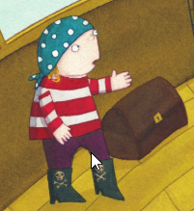
- Why did Jed not like being a pirate?

- What did Jed dream of?

- Draw a picture of Jed’s ‘pirate paraphernalia’.

- Who did Jed give his hat to?

- How did Jed free the sheep?

- Who did Jed meet at the farm?

- Write how the story ended.
