William Ransom School Golf Course
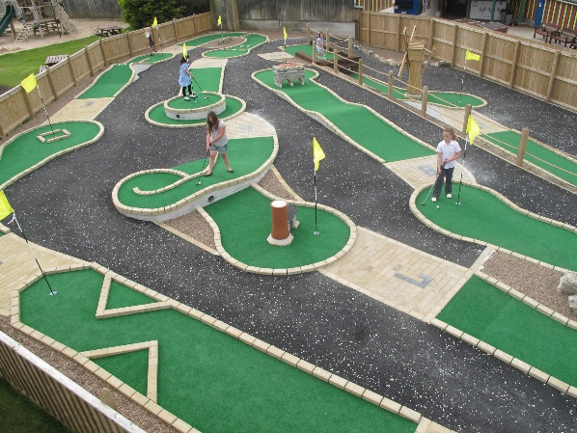
Mrs Driver has decided that William Ransom Primary School needs a mini- golf course as part of its facilities. She thinks the Muga would be the best place for it.

Your challenge is to design the course.
To complete the task and to design the best course possible you will need to:
- Think about your favourite Mini-golf courses (research if you need to)
- Create and present a proposal for your design
- Work out the area and perimeter of the Muga
- Create a scale drawing of your course
- Work out the area and perimeter of each hole
- Name your course and have a logo and slogan
- Work out the perimeter of the 2D shapes
Design requirements:
- There must be at least 6 holes on the course
- Each hole needs to be made out of squares and rectangles
- 7 different 2d shapes need to be included in the design as obstacles
- A path leading to each hole is required

