rt  Start |  | 12+3 | 13+3 | 19+0 | 15+5 | 10+3 | 9+3
7+2 |  | 17+3 | Addition to 20 School Bus Ride |  |  |  | 11+3
9+2 |  | 8+3 |  |  |  |  | 14+3
14+2 |  | 19+1 | 17+2 | 12+2 | 15+2 |  | 16+3
6+2 | 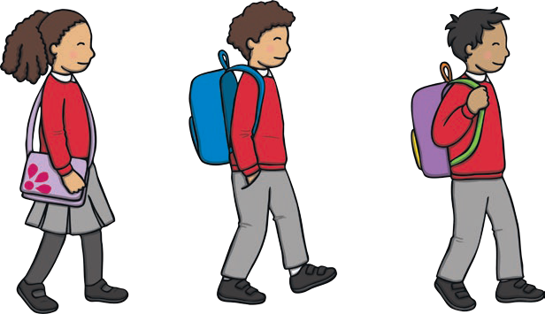 |  |  |  | 13+1 |  | 17+3
12+2 |  |  |  |  | 16+2 |  | 16+4
8+2 | 13+2 | 10+2 | 11+2 | 14+2 | 18+2 |  | Finish
twinkl.com

