Pirate Mania 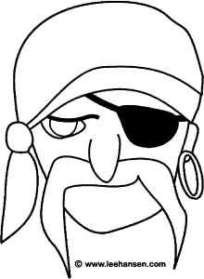

Roll the dice and draw here-game 1 | Points  Head=6  Hat=5  An eye patch=4  An eye =4  Ear=3 (need 2)  Earring=2 (only 1)  Nose=1  Mouth=1
 | Total=
Roll the dice and draw here-game 2 | Head=6  Hat=5  An eye patch=4  An eye =4  Ear=3 (need 2)  Earring=2 (only 1)  Nose=1  Mouth=1
 | Total =

