Can I label the Sikh Symbol, Khanda?

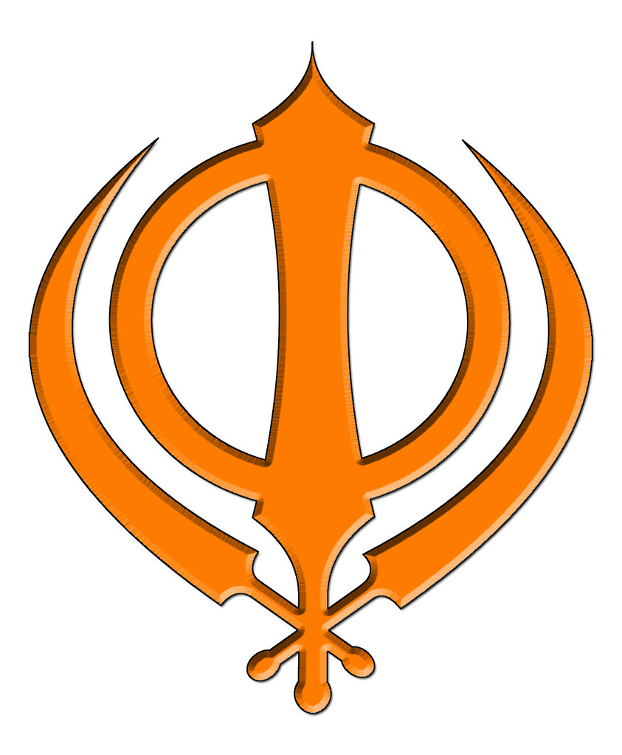
Miri Piri Chakar Khanda

