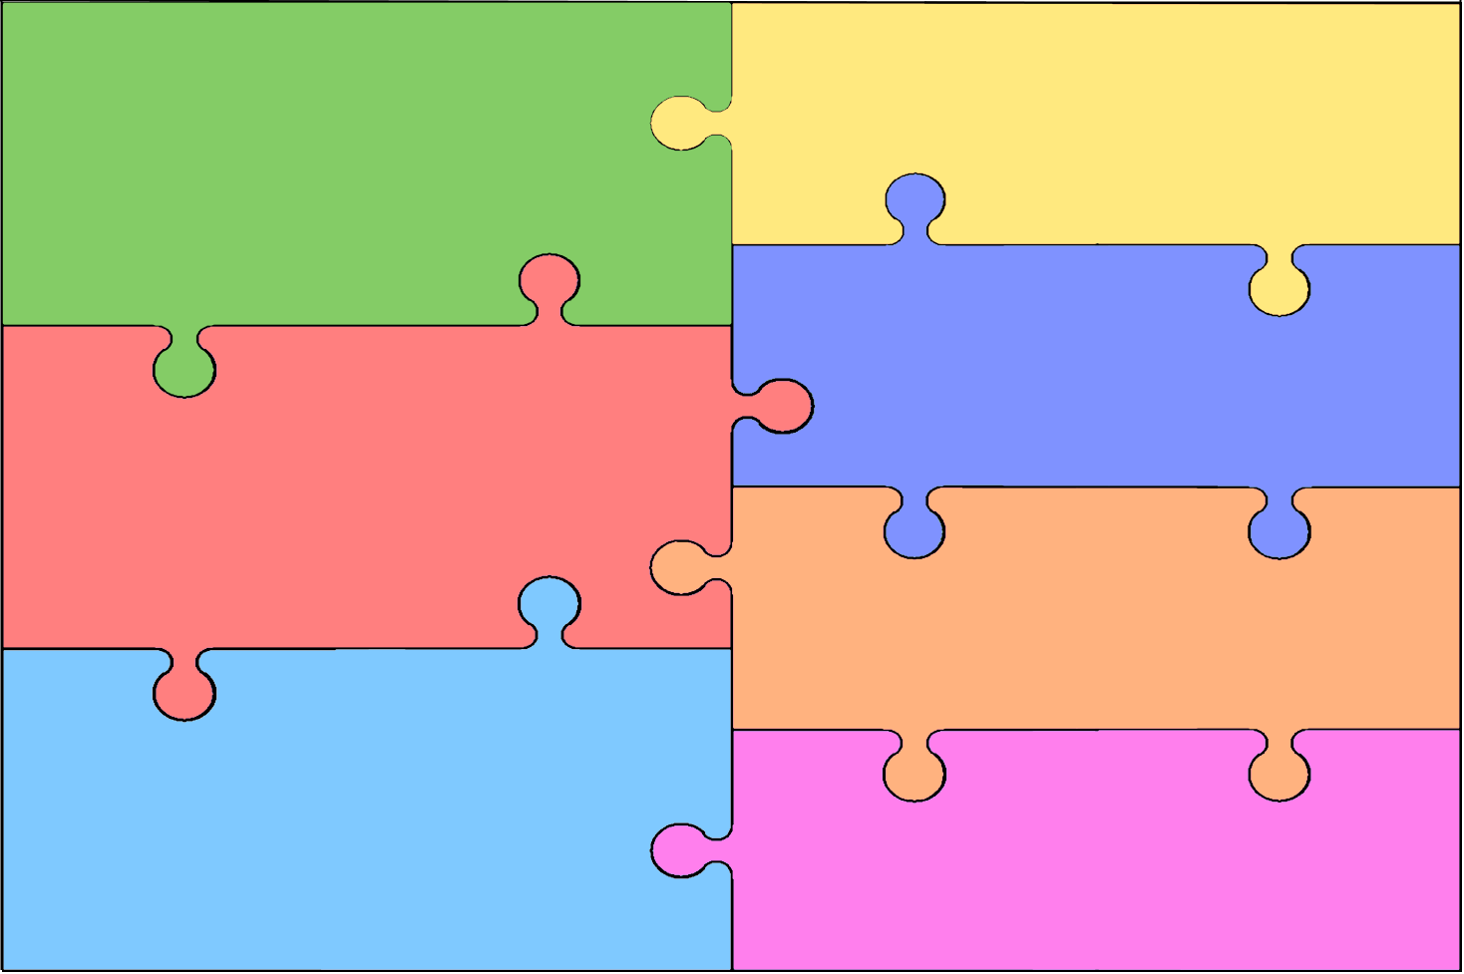
Curriculum Overview for Early Years Foundation Stage
Personal, Social & Emotional Development  - Building confidence to choose activities and discuss ideas  - Build awareness of needing help, and confidence to ask  - Confidence to speak in a group of familiar peers and to the whole school  - Working as part of a group, following rules where appropriate  - Forming positive relationships with peers and adults  - Playing co-operatively, taking turns | Literacy  Learn phonic sounds and how to write them correctly  Use phonics to decode and read simple sentences  Discuss what has been read  Use phonics knowledge to write simple words and sentences  Learn and use core reading vocabulary.
Mathematics
To use and understand number language
Recognition of numbers to 20
Count reliably with numbers up to 20
Use counting on and number knowledge for simple addition and
subtraction Begin to recognise and describe simple patterns
Use everyday language to talk about size, position, time , etc.
Use mathematical language to describe shapes and objects

Communication & Language

Listening attentively to instructions and stories
Following instructions to carry out activities
Expression of ideas, including real-life and fictional ideas
Using past, present and future forms of language

Understand the World
SCIENCE GEOGRAPHY COMPUTING RELIGIOUS EDUCATION
Our senses HISTORY Farms Learn how to use Celebrations
Planting - Directions a keyboard, mouse Faith Stories
Hyacinth & potatoes Historic celebrations Routes & journeys & basic functions Belonging to groups &
Living Things Guy Fawkes Familiar places Computer games communities
Tadpoles & butterflies Remembrance Day Our Houses Programming Values – moral messages
Birds – birdwatch Saints Days Homes Bee-bot from faith stories
Mini beasts Holidays in the past Holidays How to use People and places
Light & Dark Old toys The seaside a camera & Ipad that are special to us

Expressive Arts & Design
ART & DESIGN DESIGN & TECHNOLOGY MUSIC
Colour mixing Experiment with sound
Primary Colours Card making exploring pitch, duration,
Secondary colours Construction kits dynamics, timbre & structure
Textures Box Modelling Learn and sing songs to
Printing Weaving & Sewing support topic work.
Observational drawing Finger & stick puppets Listen to different types of
Collage Junk modelling music to gain an appreciation
Clay models Salt dough
Van Gogh & Matisse Cooking

Physical Development
Developing control and coordination of movement through dance and gymnastics
Develop gross motor skills by using games equipment.
To develop fine motor skills by handling equipment and tools for mark making including for writing
Learning about healthy diet and exercise
Managing their own hygiene and personal needs.

