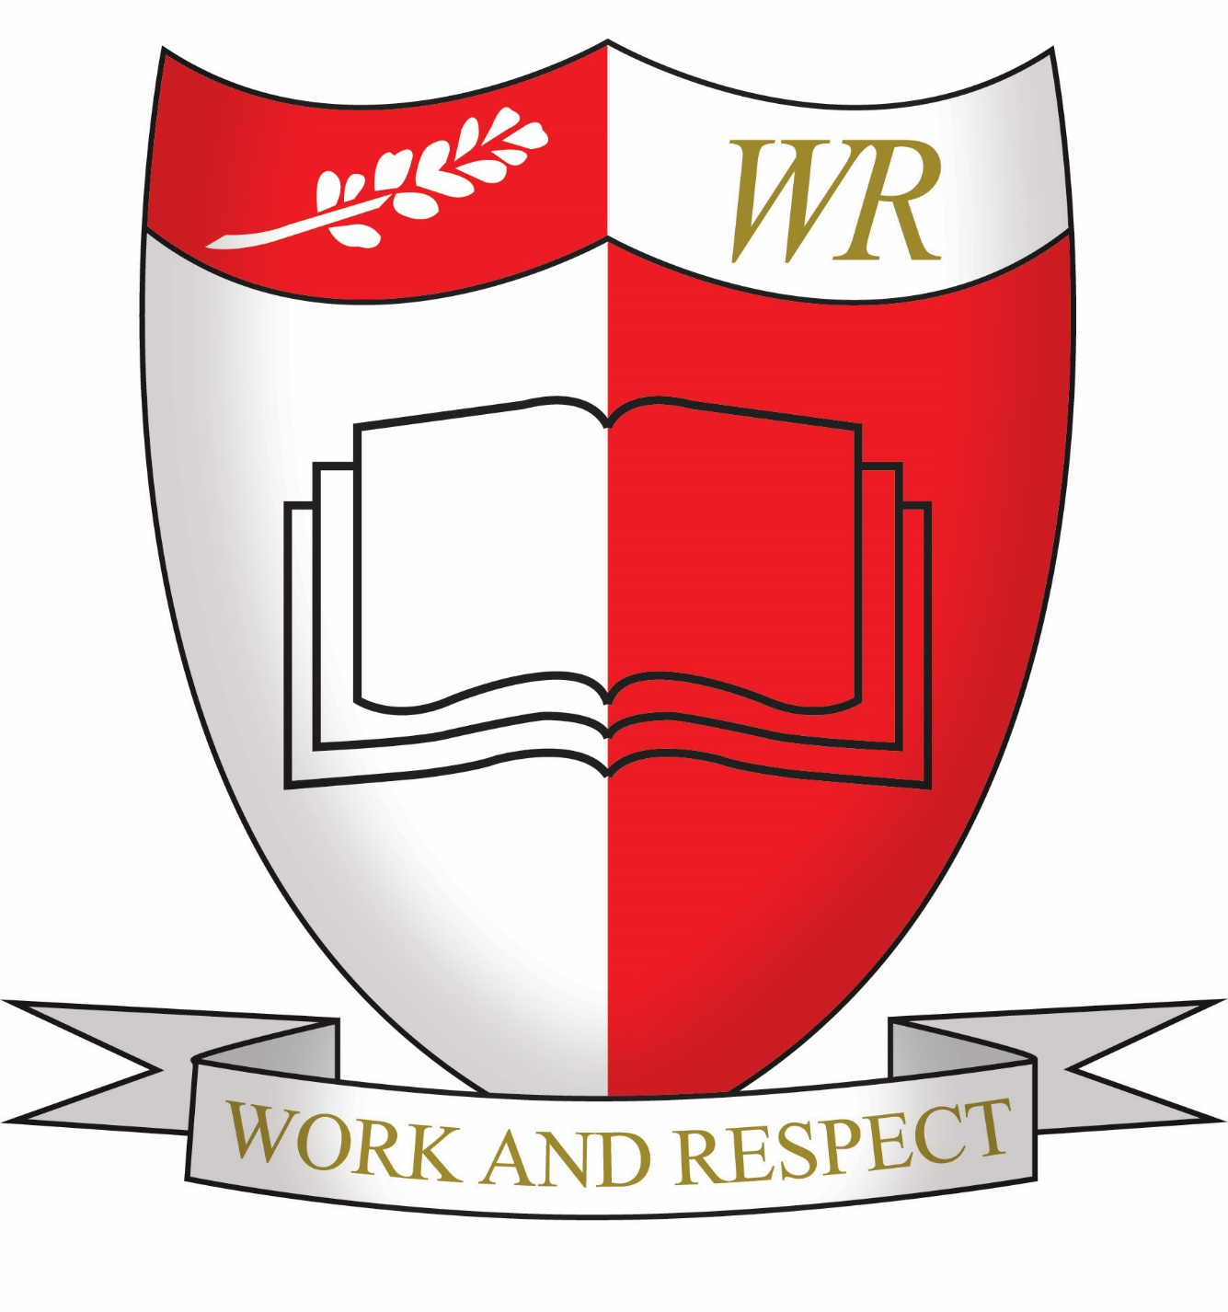

Mission Statement:

At William Ransom we are committed to providing our pupils with a safe and nurturing environment that will enable all children to reach their potential, academically, socially, physically and emotionally.
Our children are encouraged to be confident, self-motivated, resilient and independent learners and to develop a life-long zest for learning.

Remote education provision: Information for parents

William Ransom Primary School
MDriver

Remote education provision: information for parents
This information is intended to provide clarity and transparency for parents or carers about what to expect from remote education where national or local restrictions require entire cohorts (or bubbles) to remain at home.
For details of what to expect where individual pupils are self-isolating, please see the final section of this document.

The remote curriculum: what is taught to pupils at home
A pupil’s first day or two of being educated remotely might look different from our standard approach, while we take all necessary actions to prepare for a longer period of remote teaching.

What should my child expect from immediate remote education in the first day or two of pupils being sent home?

All classes are ready with a bank of resources to draw upon should remote education be needed at short notice. This will involve worksheets and activities that are paper based to allow staff time to upload work to Google Classroom. If necessary this work can be uploaded to the school website so everyone can see it and access it straight away.

Following the first few days of remote education, will my child be taught broadly the same curriculum as they would if they were in school?

After the first few days all work will be uploaded to Google Classroom.
This work will follow the school’s curriculum and if there are children in school, they will follow the same work.
We teach the same curriculum remotely as we do in school.
There may be occasions where the order subjects are taught might be altered if it is felt that a particular area of work demands face to face with a teacher. This depends on the age of the children concerned.

Remote teaching and study time each day

How long can I expect work set by the school to take my child each day?
We expect that remote education (including remote teaching and independent work) will take pupils broadly the following number of hours each day:
EYFS | Approximately 1.5 hours
Key Stage 1 | Approximately 3 hours
Key Stage 2 | Approximately 4 hours

Accessing remote education

How will my child access any online remote education you are providing?

All classes are using Google Classroom as their preferred learning platform. This was introduced in January 2021 and is a completely new way of working for all concerned.
All children have been given their user name and password to be able to access Google Classroom and parents have been given access to digital films showing them what Google Classroom can do.
Teachers will upload activities for Maths, English and foundation subjects which children can access in whatever way suits the device they are working on.
Initially there may be a time when tasks are also uploaded to the school website to ensure coverage for all, but ultimately this would only be used in an emergency.

If my child does not have digital or online access at home, how will you support them to access remote education?
We recognise that some pupils may not have suitable online access at home. We take the following approaches to support those pupils to access remote education:
In September 2020 we sent a survey out to all parents to ascertain who needed support with access to the internet or to new devices. This indicated to us that 100% of our pupils had access to the internet. There are more issues with the number of children accessing one device. Through the government scheme of ‘laptops for schools’ we applied for and got 1 laptop for a vulnerable child who has no means accessing any of his work online. At the start of national lockdown in January 2021, we wrote to all parents again to ask if they considered their child to be disadvantaged with their lack of devices and we have allocated school laptops to those children who needed them.

How will my child be taught remotely?

We use a combination of the following approaches to teach pupils remotely:
There is a difference between digital learning and remote learning. Digital learning is just part of what we offer in remote learning. The use of Google Classroom is simply a platform to share the activities we want children to complete for their remote learning.
In EYFS it is hoped that children will read with an adult every day, they will do some kind of writing every day and some kind of number work every day. They are not expected to be able to work unsupervised and therefore the times that they work will depend heavily upon other children in the family and parents’ work commitments.
In Key Stage 1 there will be English and Maths set for every day. These are the most important subjects for home learning. Foundation subjects are also set for those children who are engaging well with their work and motivated to do more. Again it is recognised there will be a limit to what the children can achieve unsupervised so timings for the day cannot be too rigid.
In Key Stage 2 Maths and English tasks will be set for the week, with the amount of independent work determined by the child’s ability. The lessons will be linked and follow at set scheme of work. Foundation subjects will be set for a week with the expectation that they will be completed across the course of the week.
There will a range of approaches used to teach remotely.
- recorded teaching (e.g. Oak National Academy lessons, video/audio recordings made by teachers)
- printed paper packs produced by teachers (e.g. workbooks, worksheets)
- live teaching (online lessons - as starters for the start of the lesson)
- commercially available websites supporting the teaching of specific subjects or areas, including video clips or sequences
- long-term project work and/or internet research activities
As pupil and teacher confidence with GC grows, some staff may feel it is appropriate to introduce some more elements of live lessons (to go with their current regular class sessions). These live or recorded sessions could be introductions to lessons or plenary sessions. This will be reliant on availability of staff due to the high number of keyworker children in some year groups and teachers’ own family circumstances.
During a long term period of lockdown where children cannot see their teachers of their friends, each class will organise regular Zoom or Google Meets for their classes. These could take the form of a starter for a lesson or a well being session to check up on mental health issues. It will depend on the age of the children; younger children might use it for Show and Tell whilst older children would use it for sharing something they had written.
My child has Special Educational Needs, how will they be supported?
All class teachers and the Special Needs Co-ordinator, Diana Delaney, will be in close contact with parents of our special needs children to see if they have any particular needs. All children with an EHCP will be offered a place in school if the school is open for some children. Other children who are on the SEN register may come into school whilst others may prefer to keep their children at home due to infection levels.
Teachers and teaching assistants work closely with these children, ensuring there is work available which they can access. They will arrange one to one zoom calls to check in with these children from a well-being point of view and they will work with them on different aspects of their work.
The SENCo works closely with these parents and she monitors children’s engagement and their progress. She is always willing to talk to parents to attempt to alleviate parents high levels of stress and anxiety.

My child is the only one in class who has to isolate. Can I expect remote learning?
If your child has received a positive test result or is in close contact with someone in self isolation they will need to remain away from school.
In this instance it is unlikely we would use Google Classroom to set work, work packs would be assembled and we would find a way to get the work to the family.
The work would follow the curriculum taught in school but there would not be an opportunity to offer links into the class as the teachers would be teaching full time.

