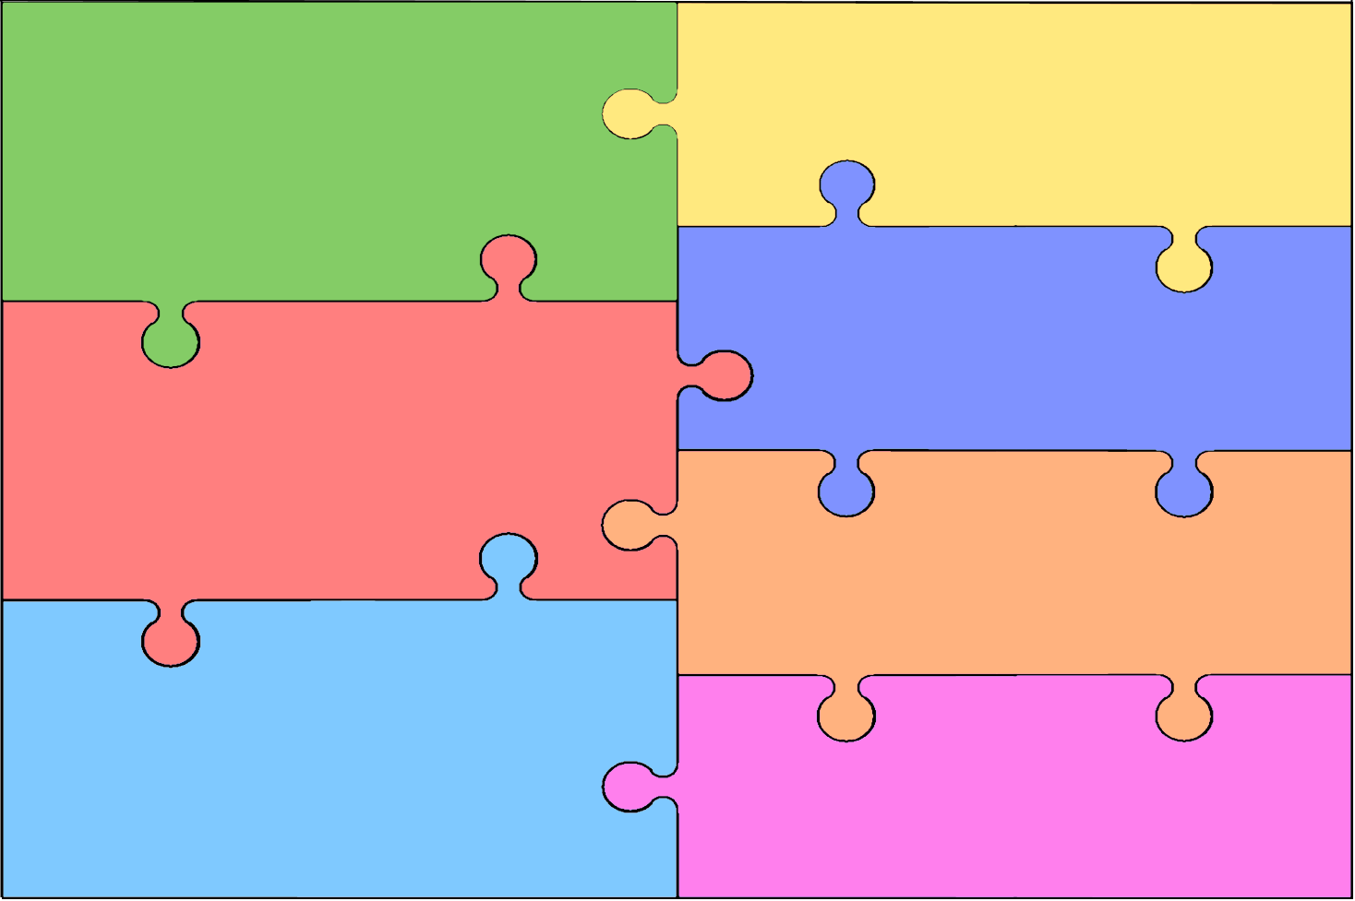
Reception Development Matters Statements. These are used to design the curriculum for Reception
Personal, Social & Emotional Development  Children will:  See themselves as a valuable individual and build constructive and respectful relationships.  Express their feelings and consider the feelings of others.  Show resilience and perseverance in the face of challenge.  Identify and moderate their own feelings socially and emotionally.  Think about the perspective of others.  Manage their own needs. Including personal hygiene.  Know and talk about the different factors that support their overall health and wellbeing:  regular physical activity toothbrushing  sensible amounts of screen time having a good sleep routine  healthy eating being a safe pedestrian | Literacy  Children will:  -Read individual letters by saying the sounds for them.  -Blend sounds into words, so that they can read short words made up of known letter-sound correspondences.  -Read some letter groups that each represent one sound and say sounds for them  -Read a few common exception words matched to the school’s phonic programme.  -Read simple phrases and sentences made up of words with known letter-sound correspondences and, where necessary, some exception words.  -Re-read books to build up their confidence, fluency, understanding and enjoyment.  -Form lower-case and capital letters correctly.  -Spell words by identifying the sounds and the writing the sound with letter/s.  -Write short sentences with words with known letter-sound correspondences using a capital letter and full stop.  -Re-read what they have written to check that it makes sense.
Mathematics
Children will:
-Count objects, actions and sounds and subitise.
-Link the numeral with its cardinal number value.
-Count beyond 10 and compare numbers
-Understand the ‘one more than/one less than’ relationship between consecutive numbers.
-Explore the composition of numbers to 10.
-Automatically recall number bonds for numbers 0-5 and some to 10.
- Select, rotate and manipulate shapes to develop spatial reasoning skills.
-Compose and decompose shapes so that children recognise a shape can have other shapes within it, just as numbers can.
-Continue, copy and create repeating patterns and compare length, weight and capacity.

Communication & Language
Children will:
-Understand how to listen carefully and learn new vocabulary which they will use through the day.
-Ask questions to find out more and to check they understand what has been said to them.
-Articulate their ideas and thoughts in well-formed sentences and connect one idea to another using a range of connectives.
-Describe events in some detail and use talk to help solve problems, organise thinking and to explain how things work and why they might happen.
-Develop social phrases and engage in story time. They will listen to and talk about stories.
-Retell stories, some as exact repetition and some in their own words.
-Use new vocabulary in different contexts and listen carefully to rhymes and songs.
-Engage in non-fiction book and talk about the text to develop a deep familiarity
with new knowledge and vocabulary.

Physical Development
Children will:
-Revise and refine movements they have already acquired; rolling, crawling, walking, jumping, running, hopping, skipping, climbing.
-Progress towards a more flunet style of moving with developing control and grace.
-Develop overall body strength, co-ordination, balance and agility needed to engage successfully with future physical education sessions (eg: dance, gymnastics, swimming).
-Develop their small motor skills so that they can use a range of tools competently, safely and confidently. This includes; pencils for drawing and writing, paintbrushes, scissors, knives, forks and spoons.
-Use their core muscle strength to schieve a good posture when sitting at a table or sitting on the floor.
-Combine different movements with ease and fluency.
-Confidently and safely use a range of large and small apparuts indoors and outdoors, alone and in a group.
-Develop overall body strength, balance, co-ordination and agility.
-Develop the foundations of a handwriting style which is fast, accurate and efficient.
-Further develop the skills they need to manage the school day: lining up and queuing and mealtimes.

Understand the World
Talk about members of their immediate family and community and name and describe people who are familiar to them.
Comment on images of familiar situations in the past.
Compare and contrast characters from stories, including figures from the past.
Draw information from a simple map.
Understand that some places are special to members of the community.
Recognise that people have different beliefs and celebrate special times in different ways.
Recognise some similarities and differences between life in this country and life in other countries.
Explore the natural world around them and describe what they see, hear and feel whilst outside.
Recognise some environments that are different to the one in which they live.
Understand the effect of changing seasons on the natural world around them.

Expressive Arts & Design
-Explore, use and refine a variety of artistic effects to express their ideas and feelings.
-Return to and build on their previous learning, refining ideas and developing their ability to represent them
-Create collaboratively, sharing ideas, resources and skills.
-Listen attentively, move to and talk about music, expressing their feelings and responses.
-Watch and talk about dance and performance art, expressing their feelings and responses.
-Sing in a group or on their own, increasingly matching the pitch and following the melody.
-Develop storylines in their pretend play.
-Explore and engage in music making and dance, performing solo or in groups.

