Curriculum Overview for Cherry & Chestnut
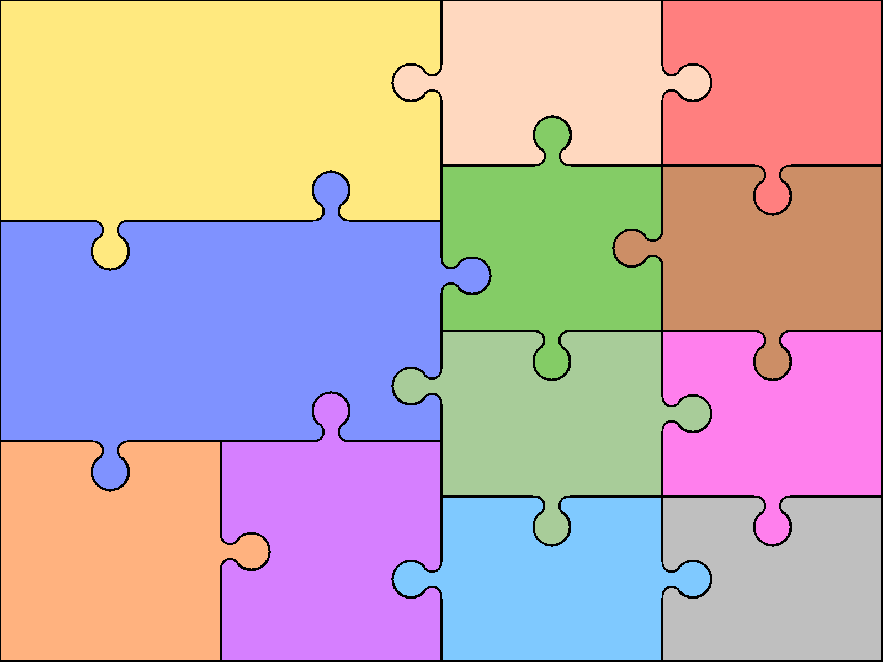  Reading  Read a broad range of genres  Recommend books to others  Make comparisons within/across books  Support inferences with evidence  Summarising key points from texts  Identify how language, structure, etc. contribute to meaning  Discuss use of language, inc. figurative  Discuss & explain reading, providing reasoned justifications for views | English  Writing  Use knowledge of morphology & etymology in spelling  Develop legible personal handwriting style  Plan writing to suit audience & purpose; use models of writing  Develop character & setting in narrative  Select grammar & vocabulary for effect  Use a wide range of cohesive devices  Ensure grammatical consistency |  | Grammar  Use appropriate register/ style  Use the passive voice for purpose  Use features to convey & clarify meaning  Use full punctuation  Use language of subject/object  Speaking & Listening  Use questions to build knowledge  Articulate arguments & opinions  Use spoken language to speculate,  hypothesise & explore  Use appropriate  register & language | Art  Charles Rennie Mackintosh  A Sense of Watercolour | Computing  Online Safety  Blogging  Text adventures  Quizzing
 |  |  |  | Design & Technology  Funky furnishings (textiles)  Marble Run (structures)  Electrical systems | Geography  Trade & Economics  Extreme weather: When weather makes the news
Number/Calculation  Secure place value & rounding to 10,000,000, including negatives  All written methods, including long division  Use order of operations (not indices)  Identify factors, multiples & primes  Solve multi-step number problems  Algebra  Introduce simple use of unknowns | Mathematics  Geometry & Measures  Confidently use a range of measures & conversions  Calculate area of triangles / parallelograms  Use area & volume formulas  Classify shapes by properties  Know and use angle rules  Translate & reflect shapes, using all four quadrants  Data  Use pie charts  Calculate mean averages |  | Fractions, decimals & percentages  Compare & simplify fractions  Use equivalents to add fractions  Multiply simple fractions  Divide fractions by whole numbers  Solve problems using decimals & percentages  Use written division up to 2dp  Introduce ratio &  proportion
 |  |  |  | Modern Languages  School  Time  Music  Fashion  French Newspapers  Towns | Music  ‘Happy’  Classroom Jazz  A New Year carol  ‘You’ve got a friend’  Music and me  Reflect, rewind and replay
Science  Light  Animals including humans  Living things and their habitats  Evolution and inheritance  Electricity |  | History  WW1  Britain Since 1930  Ancient Greece
 |  |  |  | Physical Education  Dance  Gym/Yoga Basketball/Netball  Hockey/ Lacrosse Athletics  Cricket/ Rounders | Religious Education  Creation stories  Ultimate questions  Identity and belonging  Human responsibility and value

