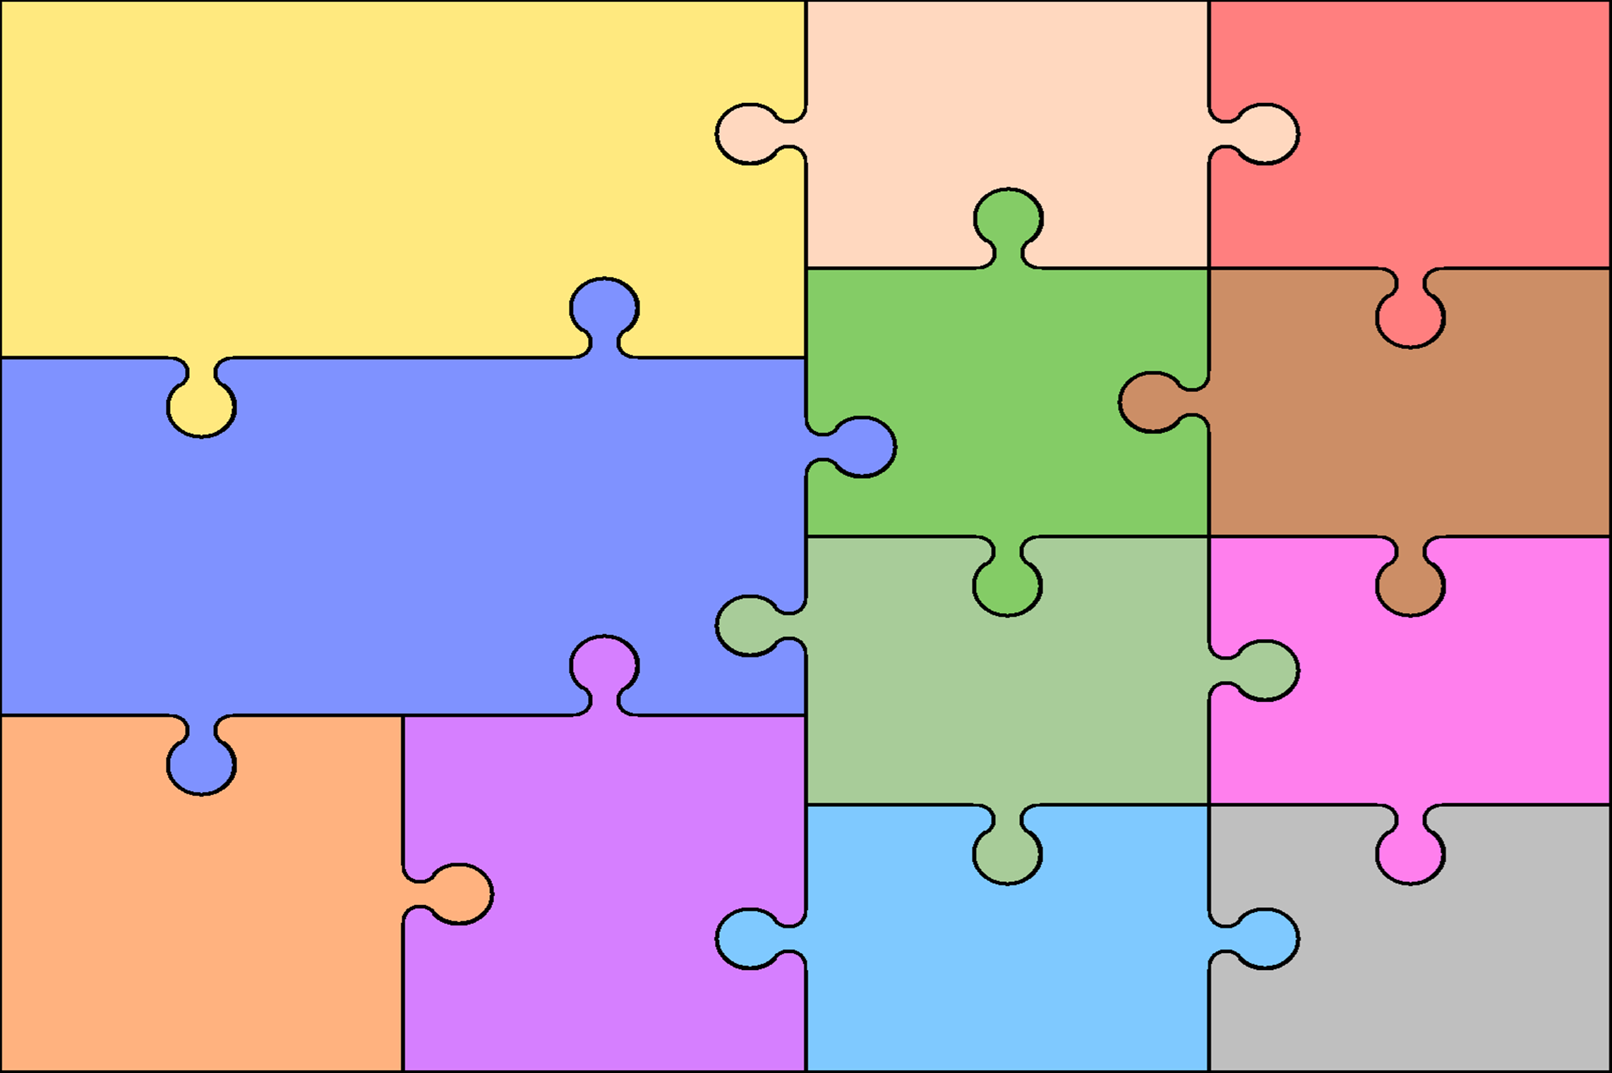
Curriculum Overview for Year 3
Reading  Use knowledge to read ‘exception’ words  Read range of fiction & non-fiction  Use dictionaries to check meaning  Prepare poems & plays to perform  Check own understanding of reading  Draw inferences & make predictions  Retrieve & record information from non-fiction books  Discuss reading with others | English  Writing  Use prefixes & suffixes in spelling  Use dictionary to confirm spellings  Write simple dictated sentences  Use handwriting joins appropriately  Plan to write based on familiar forms  Rehearse sentences orally for writing  Use varied rich vocabulary  Create simple settings & plot  Assess effectiveness of own and others’ writing |  | Grammar  Use range of conjunctions  Use range of nouns & pronouns  Use perfect tense  Use time connectives  Introduce speech punctuation  Know language of clauses  Speaking & Listening  Give structured descriptions  Participate activity in conversation  Consider & evaluate different  viewpoints | Art & Design  Colour  3D models  Printing  Textiles  Drawing | Computing  Coding  Online Safety  Spreadsheets  Touch typing  Email  Databases  Simulations  Graphing  Presenting
 |  |  |  | Design & Technology  Moving Monsters  Pencil Cases  Food, glorious food! | Geography  UK  Europe  Mountains
Autumn  Place Value  Addition and Subtraction  Multiplication and Division | Mathematics  Spring  Multiplication and Division  Money  Statistics  Length and Perimeter  Fractions |  | Summer  Fractions  Time  Properties of shape  Mass and Capacity
 |  |  |  | Modern Languages  French  Greetings  Numbers  Days / Months  Classroom objects  Family  Pets  Colours  Physical Education  Hockey Table Tennis  Yoga Athletics  Netball Tennis  Dance Rounders  Gym Tag Rugby | Music  Let your spirit fly  Glockenspiel Stage 1  Three Little Birds  The Dragon Song  Bringing Us Together  Reflect, Rewind and Replay  Religious Education  Religious Festivals  Religious symbols  Islam – Beliefs and Practices  Christianity - Key Figures & Stories  Special Places of worship
Science  Animals Including Humans  Rocks & Soils  Plants  Light  Forces and Magnets |  | History  Prehistory  Stone Age  Bronze Age  Iron Age  William Ransom  Ancient Egypt

