Name ________________________________________ Year 5 William Ransom School
Working TOWARDS THE EXPECTED STANDARD
 |  |  | AUTUMN |  | SPRING |  | SUMMER
Can write for a range of purposes and audiences
Can use paragraphs to organise ideas
Can describe characters and settings in narratives
In non-narrative, can structure the writing with headings, subheadings, bullet points
Can use co-ordinating conjunctions (for, and, nor, but, or, yet, so)
Can use subordinating conjunctions (although , after, as when, if, that, even though, because, etc)
Can use mostly correctly: |  | Capital letters and full stops
 |  | Question marks
 |  | Exclamation marks
 |  | Commas for lists
 |  | Apostrophes for contraction
Can spell most words correctly from the Year 3/4 spelling list
Can write legibly
Working at the EXPECTED STANDARD
Can write for a range of purposes and audiences
Can draft and edit written work
Can organise writing into paragraphs
Can use modal verbs to indicate possibility eg might, should, will, must, could, would
Can describe settings, character and atmosphere eg expanded noun phrases, similes/metaphors, personification, onomatopoeia
Can use verb tenses correctly and consistently throughout most writing
Can use relative clauses using who, which, where, when, whose, that or an implied (eg omitted) relative pronoun
Can build cohesion within and across paragraphs using: | Co-ordinating conjunctions (for, and, nor, but, or, yet, so)
 | A good range of subordinating conjunctions (although , after, as when, if, that, even though, because, until, unless, since)
 | Adverbials and prepostion phrases Eg As the clock struck midnight, the shadow moved across the graveyard.
 | Pronouns to avoid repetition Eg John kicked the ball. John scored. John kicked the ball and he scored.
Can use correctly most of the time: | Capital letters and full stops
 | Question marks and exclamation marks
 | Commas for lists
 | Commas for clauses
 | Commas for fronted adverbials
 | Apostrophes for contractions (can’t)
 | Apostrophes for possession (Lucy’s)
 | Brackets, commas and dashes for parenthesis
 | Inverted commas for direct speech
Can spell most words from the Year 3/4 spelling list correctly
Can spell some words from the Year 5/6 spelling list correctly and use a dictionary to check the spelling for more ambitous words
Can use legible, joined handwriting
Working at GREATER DEPTH within the expected Standard
Can write effectively and coherently for different purposes, drawing on their reading to inform eg rhetorical questions, interactions between characters, range of sentence constructions and types
Can choose precise and effective vocabulary according to the purpose and audience and adapt this when editing to improve effect
Can show the difference between formal and informal writing (eg contractions in speech, punctuation and sentence construction)

Year 3/4 Words
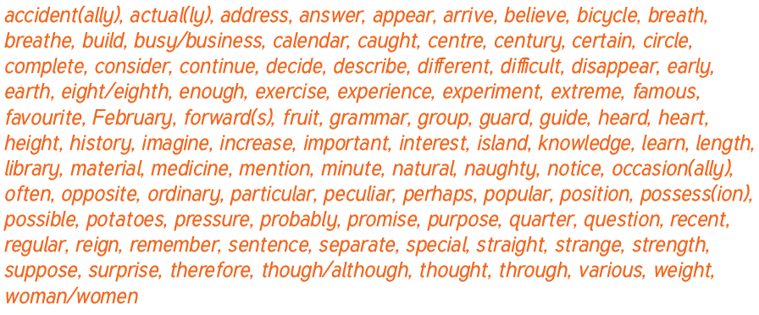
Year 5/6 Words
