Name ________________________________________ Year 6 William Ransom School
Working TOWARDS THE EXPECTED STANDARD
 |  | AUTUMN |  | SPRING |  | SUMMER
Can write for a range of purposes
Can use paragraphs to organise ideas
In narratives, can describe settings and characters
In non-fiction, can use simple devices to structure the writing and support the reader (eg headings, sub-headings, bullet points)
Can use mostly correctly: | Capital letters and Full Stops
 | Question Marks
 | Commas in a list
 | Apostrophes for contraction
Can spell most words from the 3/4 spelling list correctly
Can spell some words from the 5/6 spelling list correctly
Can write clearly and legibly
Working at the EXPECTED STANDARD
Can write for a range of purposes and audiences choosing language that shows good awareness of the reader (eg 1st person in a diary, direct address in instructions and persuasive writing)
In narratives, can describe settings, characters and atmosphere
Can include dialogue to convey character and advance the action (eg With a psychotic smirk, the witch whispered: ‘I have a gift for her too.’ She edged towards the crib. The crowd gasped in fear.
Can select vocabulary and grammatical structures that reflect what the writing requires (doing this mostly appropriately) | Contracted form in dialogue
 | Passive Verbs (to affect how information is presented)
 | Modal Verbs
Can use a range of devices to build cohesion within and across paragraphs | Co-ordinating conjunctions  (eg for,and,nor,but,yet,so)
 | Subordinating conjunctions (eg although, after, as, when,if,that,even though, because, until, unless,since)
 | Adverbials
 | Pronouns/synonyms to avoid repetition
Can use verb tense correctly and consistently throughout
Can use KS2 punctuation mostly correctly | Inverted Commas and the comma after the reporting clause John said, “…
 | Apostrophes for possession
 | Commas for fronted adverbials
 | Commas for clauses
 | Commas for clarity
 | Brackets
 | Dashes
 | Semi-colons
 | Colons
 | Hyphens
Can spell most Y5/6 words correctly and use a dictionary for more ambitious words
Working at GREATER DEPTH within the expected Standard
Can select the appropriate form and draw independently on what they have read as a model for their own writing (eg literary language, characterisation, structure)
Can distinguish between the language of speech and register and choose the appropriate register
Can exercise an assured and conscious control over levels of formaility through manipulating grammar and vocabulary to achieve this
Use the full range of KS2 punctuation correctly and precisely (when necessary to enhance meaning and avoid ambiguity
Year 3/4 Spelling List
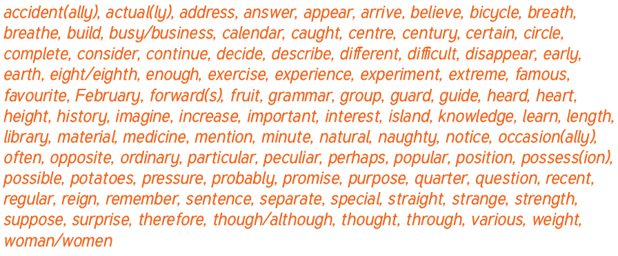

Year 5/6 Spelling List
