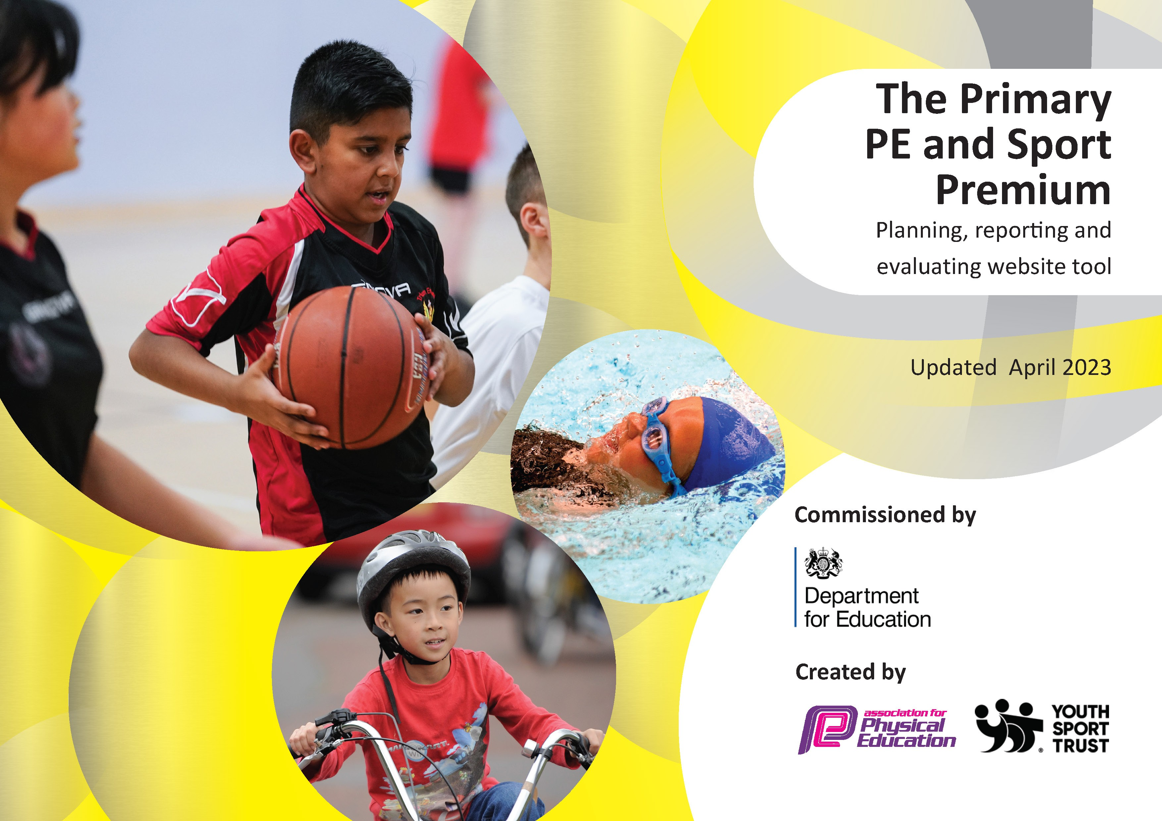

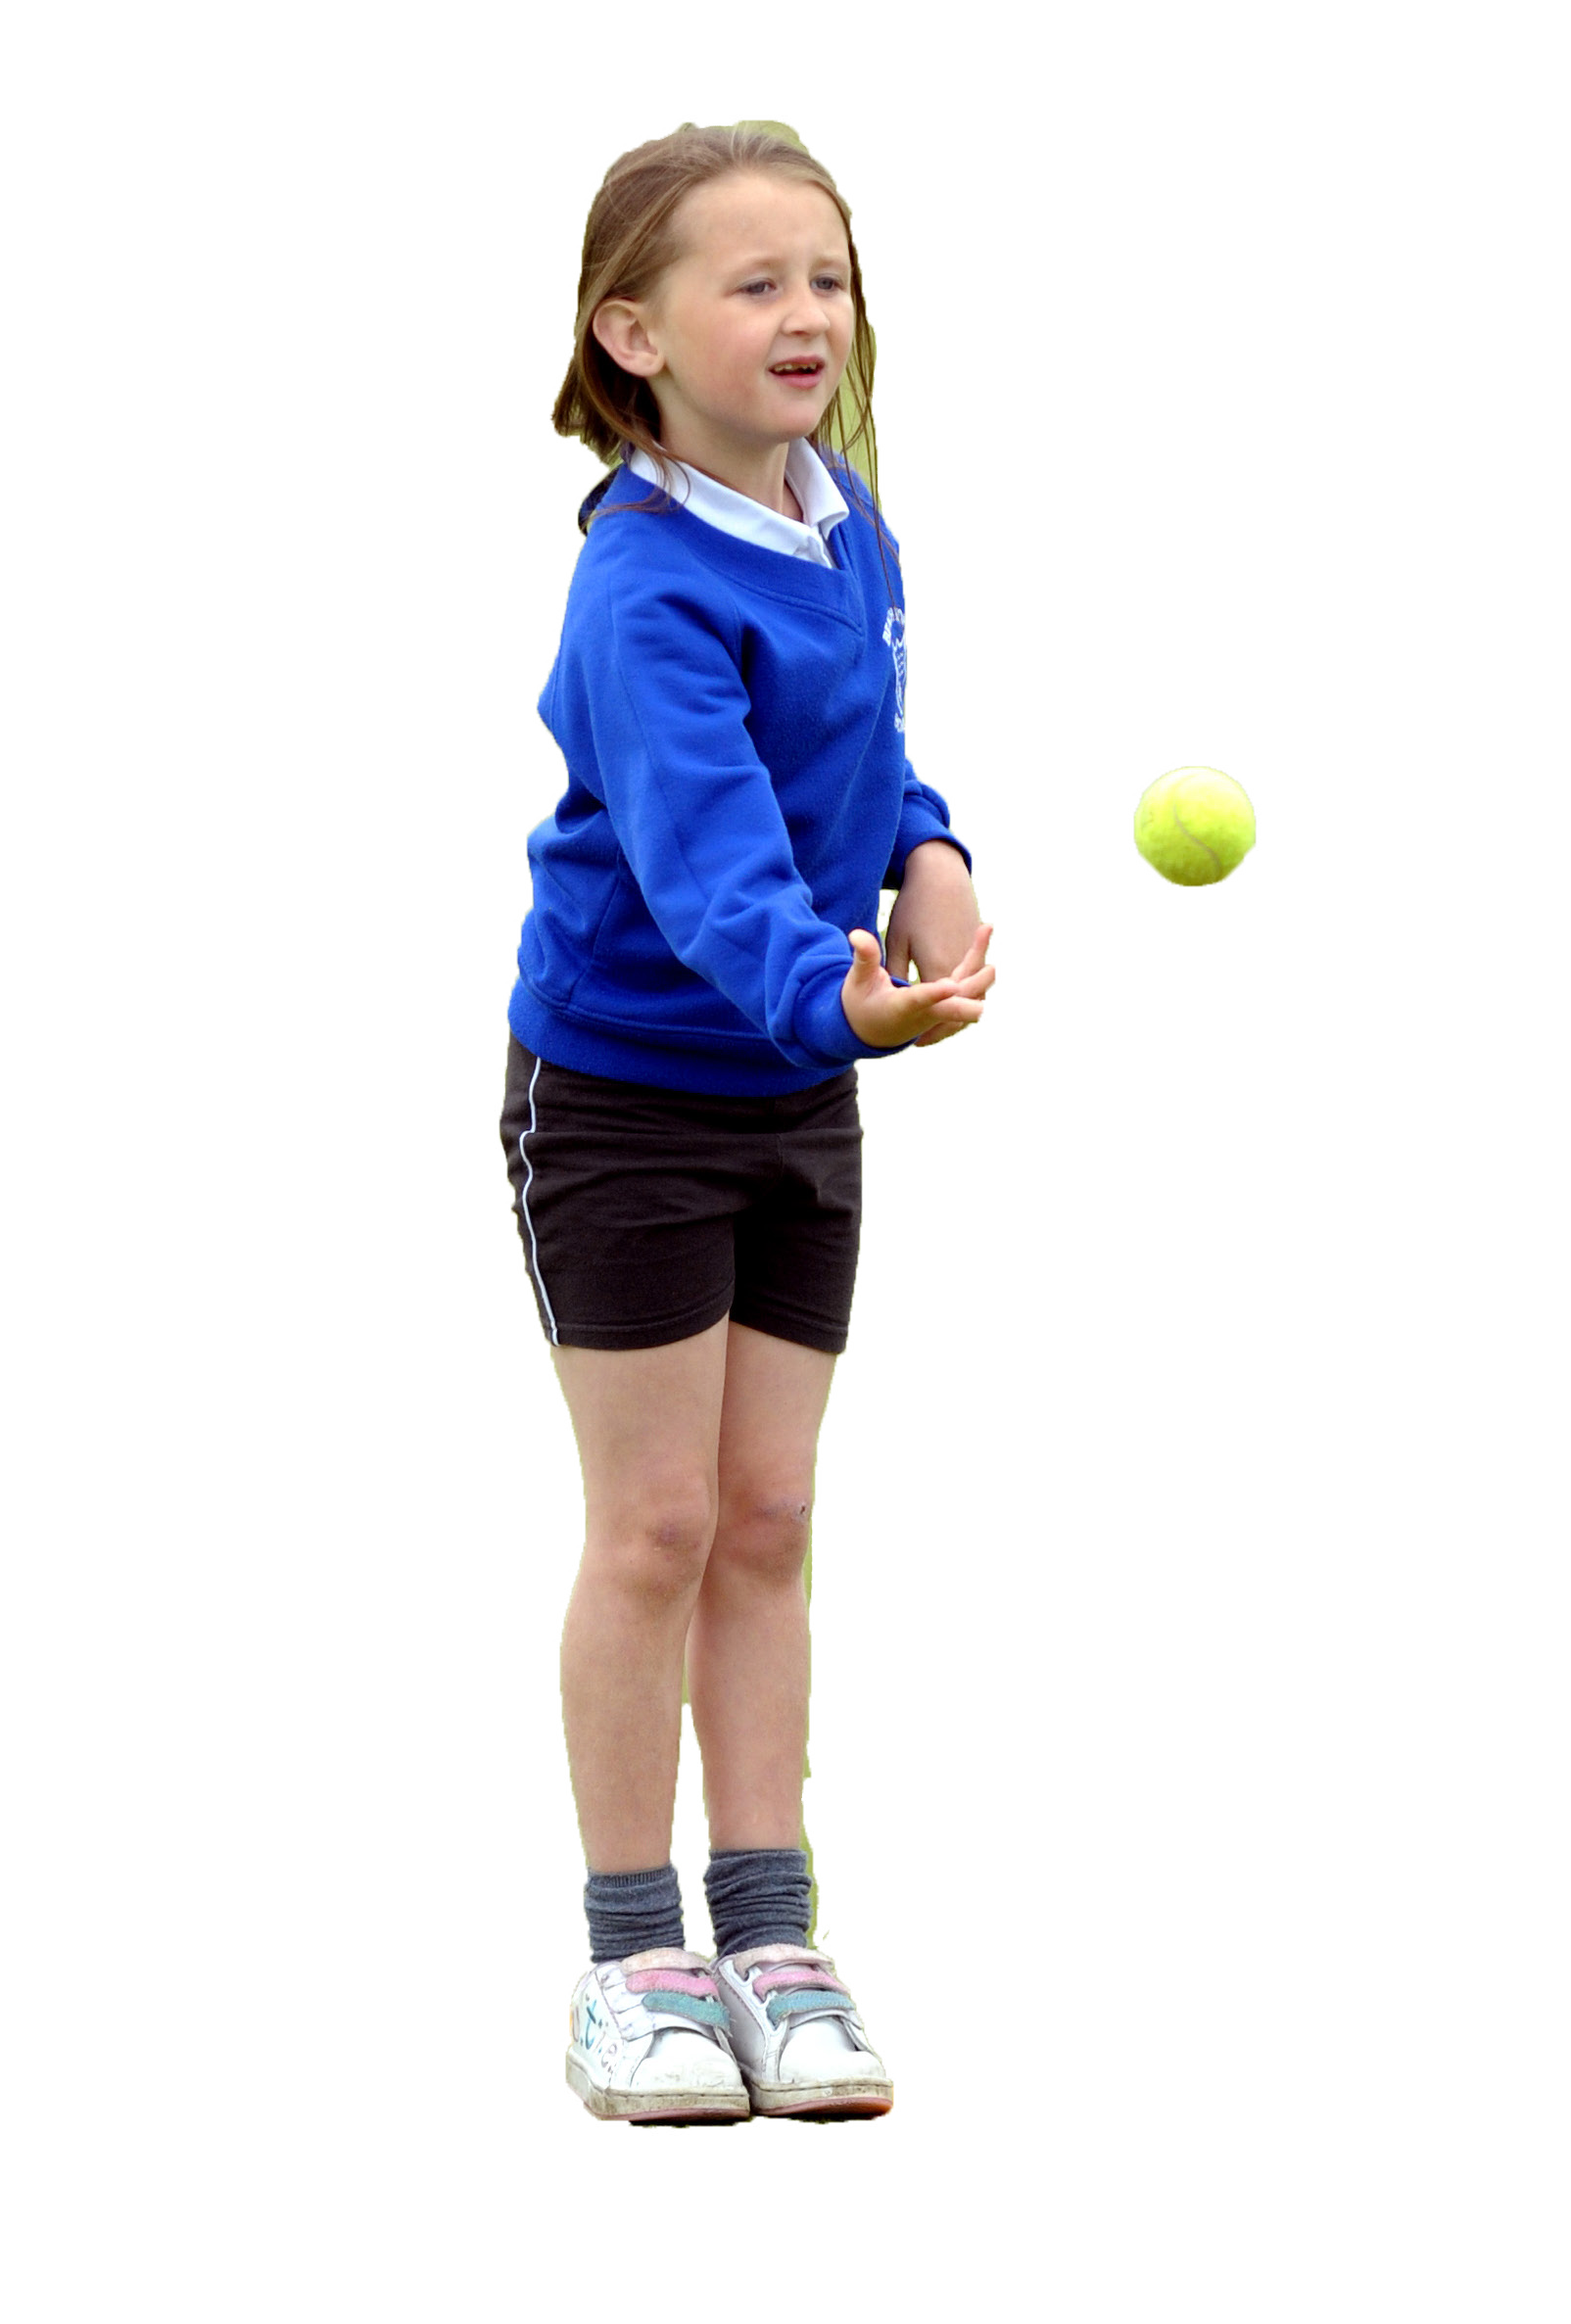
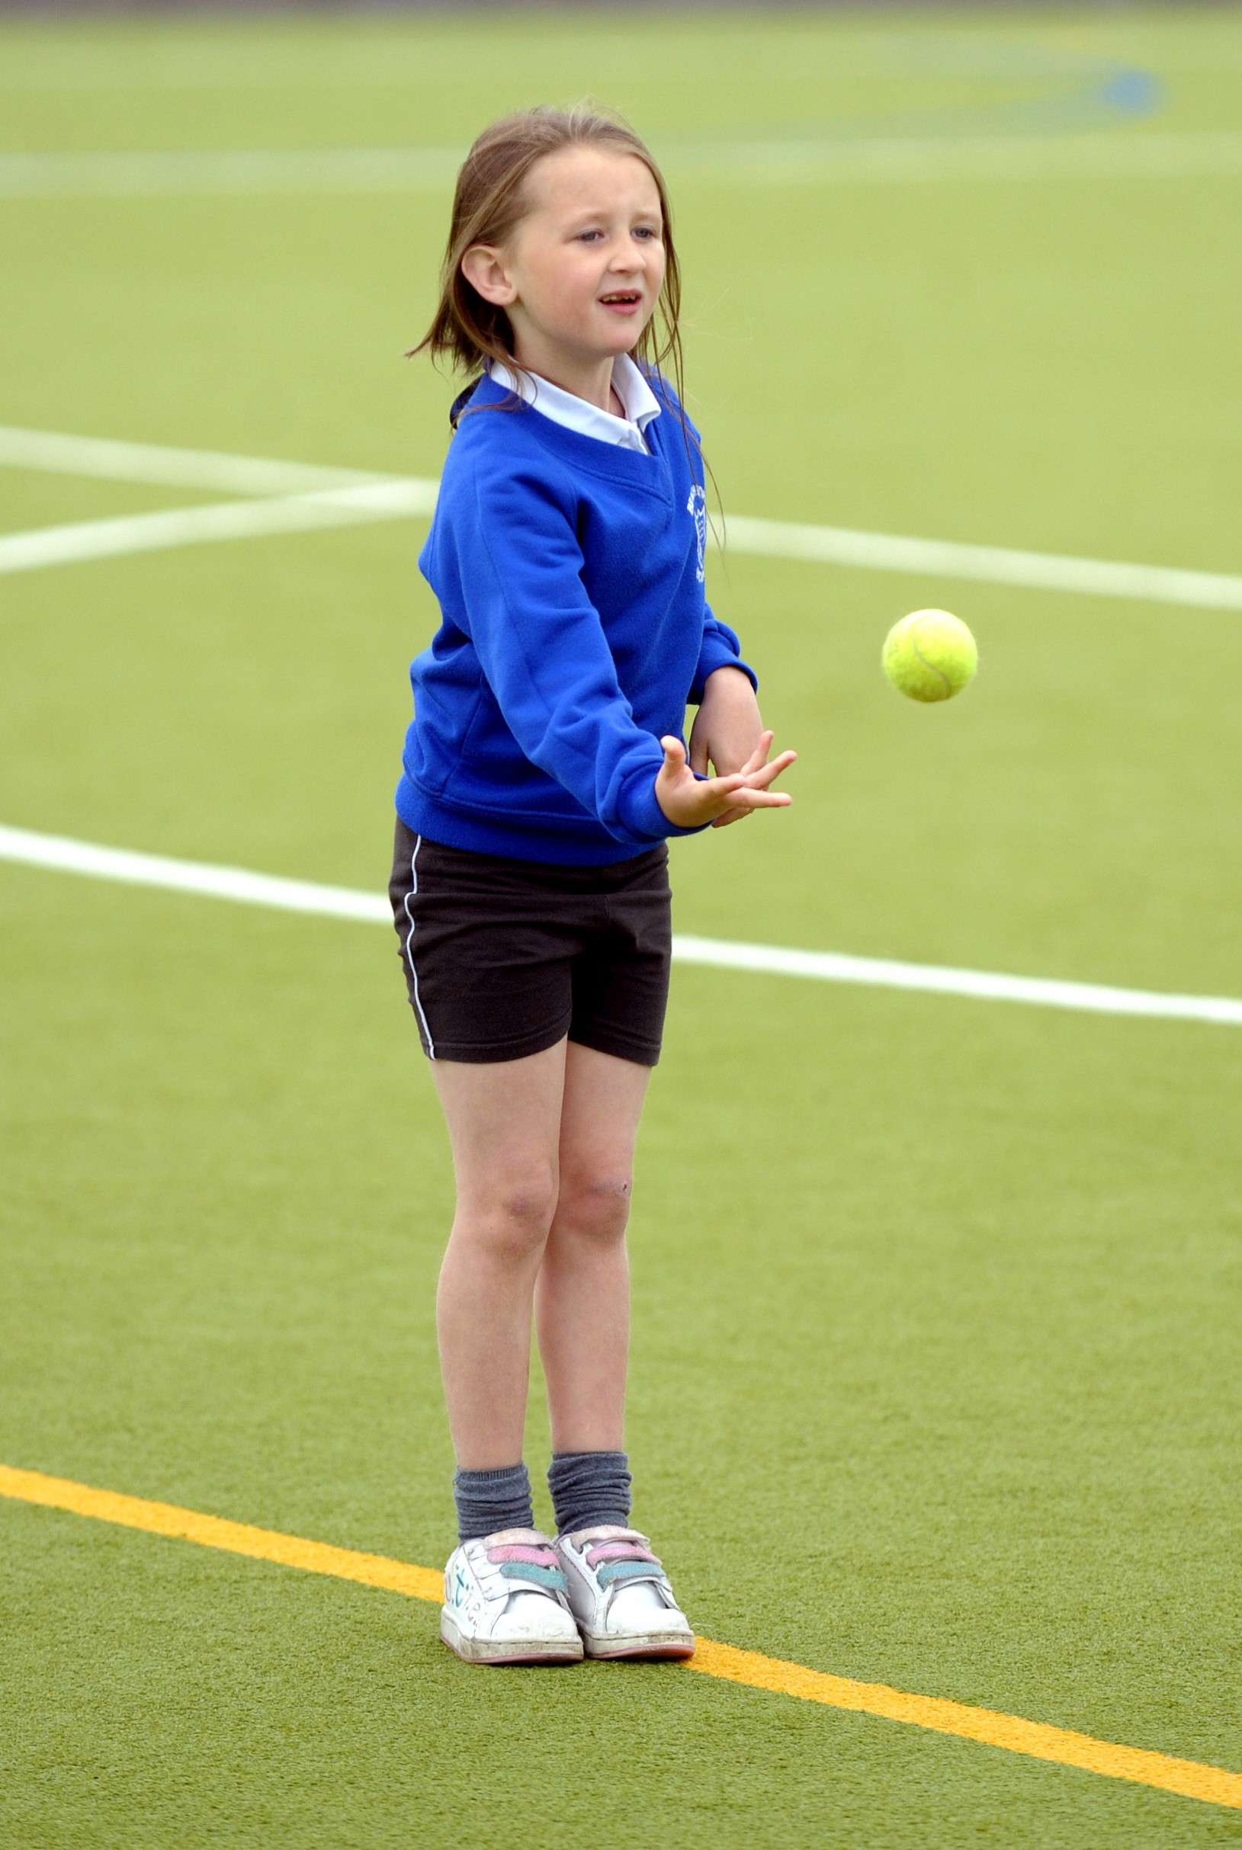

It is important that your grant is used effectively and based on school need. The Education Inspection Framework makes clear there will be a focus on ‘whether leaders and those responsible for governors all understand their respective roles and perform these in a way that enhances the effectiveness of the school’.

Under the Quality of Education Ofsted inspectors consider:
Intent - Curriculum design, coverage and appropriateness
Implementation - Curriculum delivery, Teaching (pedagogy) and Assessment
Impact - Attainment and progress

To assist schools with common transferable language this template has been developed to utilise the same three headings which should make your plans easily transferable between working documents.

Schools must use the funding to make additional and sustainable improvements to the quality of Physical Education, School Sport and Physical Activity (PESSPA) they offer. This means that you should use the Primary PE and sport premium to:

- Develop or add to the PESSPA activities that your school already offer
- Build capacity and capability within the school to ensure that improvements made now will benefit pupils joining the school in future years
- The Primary PE and sport premium should not be used to fund capital spend projects; the school’s budget should fund these.

Pleasevisitgov.ukfortherevisedDfEguidanceincludingthe5keyindicatorsacrosswhichschoolsshoulddemonstrate animprovement.Thisdocumentwillhelpyoutoreviewyourprovisionandtoreportyourspend.DfEencouragesschools to use this template as an effective way of meeting the reporting requirements of the Primary PE and Sport Premium.

We recommend you start by reflecting on the impact of current provision and reviewing the previous spend.

Schools are required to publish details of how they spend this funding, including any under-spend from 2021/2022, as well as on the impact it has on pupils’ PE and sport participation and attainment. All funding must be spent by 31st July 2023.

We recommend regularly updating the table and publishing it on your website throughout the year. This evidences your ongoing self-evaluation of how you are using the funding to secure maximum, sustainable impact. Final copy must be posted on your website by the end of the academic year and no later than the 31st July 2023. To see an example of how to complete the table please click HERE.
Created by: Supported by:

Details with regard to funding
Please complete the table below.

Total amount carried over from 2021/22 | £ 0.00
Total amount allocated for 2022/23 | £19590
How much (if any) do you intend to carry over from this total fund into 2023/24? | £6613
Total amount of funding for 2023/23. To be spent and reported on by 31st July 2023. | £ 12977
Swimming Data
Please report on your Swimming Data below.

Meeting national curriculum requirements for swimming and water safety.

N.B. Complete this section to your best ability. For example you might have practised safe self-rescue techniques on dry land which you can then transfer to the pool when school swimming restarts.
Due to exceptional circumstances priority should be given to ensuring that pupils can perform safe self rescue even if they do not fully meet the first two requirements of the NC programme of study
What percentage of your current Year 6 cohort swim competently, confidently and proficiently over a distance of at least 25 metres?  N.B. Even though your pupils may swim in another year please report on their attainment on leaving primary school at the end of the summer term 2022.  Please see note above | 82%
What percentage of your current Year 6 cohort use a range of strokes effectively [for example, front crawl, backstroke and breaststroke]?  Please see note above | 80%
What percentage of your current Year 6 cohort perform safe self-rescue in different water-based situations? | 73%
Schools can choose to use the Primary PE and sport premium to provide additional provision for swimming but this must be for activity over and above the national curriculum requirements. Have you used it in this way? | No

Action Plan and Budget Tracking
Capture your intended annual spend against the 5 key indicators. Clarify the success criteria and evidence of impact that you intend to measure to evaluate for pupils today and for the future.

Academic Year: 2022/23 | Total fund allocated: | Date Updated:
Key indicator 1: The engagement of all pupils in regular physical activity – Chief Medical Officers guidelines recommend that primary school pupils undertake at least 30 minutes of physical activity a day in school |  |  |  | Percentage of total allocation:
 |  |  |  | 12%
Intent | Implementation |  | Impact
Your school focus should be clear what you want the pupils to know and be able to do and about  what they need to learn and to  consolidate through practice: | Make sure your actions to achieve are linked to your intentions: | Funding allocated: | Evidence of impact: what do pupils now know and what can they now do? What has changed?: | Sustainability and suggested next steps:
To provide a new netball court to be marked out, allowing a new Year 5 netball club to be run this year. | Court markings | £1200 | New netball club for Year 5 ran – 40/60 children in the year attended. | Continue this club next year.
To improve markings on the daily mile track around the school grounds allowing for improved daily use of the track by all pupils. | Track markings adjusted | £1000 | Children are all able to access the daily mile track in a safer and more efficient manner, allowing for more children to use on a daily basis. | Continued use.
To provide children the opportunity to take part in half a years dance training and entry into the County Dance Festival. | Membership purchased to allow children to enter the festival and travel expenses to get them to events. | £155 | Half a year’s dance opportunity for children in KS2. | Membership continues for next year – allowing a new class next term.  Transition for Year 6 children – getting to know dance new teacher at their Secondary school allowing for continued participation in dance after their transition.
Key indicator 2: The profile of PESSPA being raised across the school as a tool for whole school improvement |  |  |  | Percentage of total allocation:
 |  |  |  | 16%
Intent | Implementation |  | Impact
Your school focus should be clear what you want the pupils to know and be able to do and about  what they need to learn and to  consolidate through practice: | Make sure your actions to achieve are linked to your intentions: | Funding allocated: | Evidence of impact: what do pupils now know and what can they now do? What has changed?: | Sustainability and suggested next steps:
To improve wellbeing through enhancing opportunities for active participation during lunchtime. | External professionals provided lunchtime audit of school and detailed report to improve current lunchtime set up.  New equipment purchased to encourage increased participation as suggested in the report. | £3063 | Children’s well being improved during lunchtimes.  Children are more physically active during the lunchbreak. | Whole new lunchtime system to carry on next year.

Key indicator 3: Increased confidence, knowledge and skills of all staff in teaching PE and sport |  |  |  | Percentage of total allocation:
 |  |  |  | 18%
Intent | Implementation |  | Impact
Your school focus should be clear | Make sure your actions to | Funding | Evidence of impact: what do | Sustainability and suggested
what you want the pupils to know | achieve are linked to your | allocated: | pupils now know and what | next steps:
and be able to do and about | intentions: |  | can they now do? What has
what they need to learn and to |  |  | changed?:
consolidate through practice:
Coaches in activities new to the school to come in and lead sessions for children and show staff how to deliver these. | Sessions led in Quiddich and skipping. All children and teachers took part. | £1435 | All children experienced exciting fitness sessions. Many children purchased their own skipping ropes following the event to carry on at home. Skipping is now a key activity at lunchtimes.  Quiddich is now part of a Year 4 extra-curricular club, running weekly. | Skipping to continue as an alternative to the daily mile and increase the amount of physical activity children are doing on a daily basis.  Quiddich equipment allows the successful club to continue next year.
NHSSP Membership purchased allowing staff to access various CPD trainings. | Membership purchased. | £1250 | 2 KS2 staff members attended tennis training.  2 Year 4 teachers upskilled through Partnership Leader taking PE sessions / team teaching. | Purchasing this membership again next year to access further CPD.
2 members of staff to attend Hertfordshire PE Conference | 2 members of staff attended training | £710 | Staff came away with lots of new ideas and contacts to improve the PESS across the school.  PE leads able to positively adjust school’s PE curriculum following useful conference training seminars. | New clubs formed as a result of meeting suppliers / new ideas.  Will attend again next year if run due to how useful it was.
Key indicator 4: Broader experience of a range of sports and activities offered to all pupils |  |  |  | Percentage of total allocation:
 |  |  |  | 14%
Intent | Implementation |  | Impact
Your school focus should be clear | Make sure your actions to | Funding | Evidence of impact: what do | Sustainability and suggested
what you want the pupils to know | achieve are linked to your | allocated: | pupils now know and what | next steps:
and be able to do and about | intentions: |  | can they now do? What has
what they need to learn and to |  |  | changed?:
consolidate through practice:
NHSSP Membership purchased, allowing entry into various festivals and tournaments. | Membership purchased.  Competitions entered. | £1250 | 10 competitions entered as part of the membership.  Children in years 1,2,3,4,5,6 have taken part in these events.  Sessions at Secondary schools have allowed Year 6 transition opportunities. | Purchasing this membership again next year.
To provide an alternative extra-curricular activity club. | New Harry Potter club run allowing for numerous children to attend weekly in Summer term. | £1080 | Successful club run for Year 4 children, many of which have not attended any other club this year. | Club to run again next year.  Equipment to be used in other events next year eg: Inter-house Quiddich.
To provide a day for EYFS and KS1 to engage a variety of addition physical activities. | Day run for all children in EYFS and KS1 including archery, team building and assault courses. | £350 | 180 children took part in a very physical and exciting session of physical activity. | Run again next year.

Key indicator 5: Increased participation in competitive sport |  |  |  | Percentage of total allocation:
 |  |  |  | 20%
Intent | Implementation |  | Impact
Your school focus should be clear | Make sure your actions to | Funding | Evidence of impact: what do | Sustainability and suggested
what you want the pupils to know | achieve are linked to your | allocated: | pupils now know and what | next steps:
and be able to do and about | intentions: |  | can they now do? What has
what they need to learn and to |  |  | changed?:
consolidate through practice:
NHSSP Membership purchased, allowing entry into various festivals and tournaments. | Membership purchased.  Competitions entered. | £1250 | 10 competitions entered as part of the membership.  Children in years 1,2,3,4,5,6 have taken part in these events. | Purchasing this membership again next year.
To purchase school branded kit for adults and children to wear at competitions | Kit purchased | £1742 | Whole new girls football squad kit purchased to allow more girls to compete in football.  Kits purchased, allowing 8 adults to accompany children to sporting events | Kits to be wore next season.
New equipment purchased to allow for a new football club to be set up.  Pitch improvements | New posts and balls purchased.  New football pitch created and marked | £988 | New football pitch used this season.  Additional football club provided for lower ability children to take part and compete. | New club to continue running next year.

Signed off by
Head Teacher: | Mary Driver
Date: | 12.07.23
Subject Leader: | Marie Herbert
Date: | 12.07.23
Governor: | Perry Maranian
Date: | 12.07.23

